Week 4 – The Week of August 15 to August 21, 2022

Lessons 1 to 3 –
A Call to Action on
Child Slavery & Chocolate

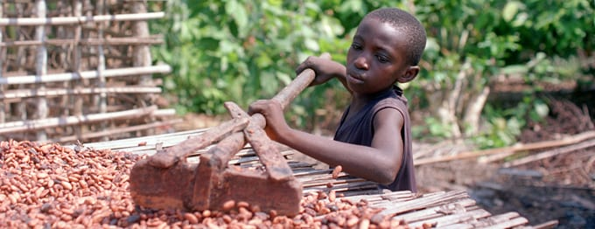

Success Criteria
Students will become familiar issues with the production of cacao in parts of Africa – specifically the use of child slave and indentured labour that is still being used to produce cacao, and social actions that are underway to stop it.

Lesson 1, Task 1:

Go to the website, https://www.slavefreechocolate.org/
It is an example of a group that is taking action to try and reduce or eliminate child slavery and indentured servitude.

Look up the definition of ‘indentured servitude’ and write it in your Red Book.

On the website, slavefreechocolate, what social actions are they trying to get people to do?

Do you think this could be effective? Explain your answer.

Write a brief summary of the position taken by Nestlé? The company wrote in part – “In June 2021, the Supreme Court agreed there is no basis for this lawsuit to proceed against Nestlé. Nestlé never engaged in the egregious child labor alleged in this suit…”

Write a summary of the position of slavefreechocolate as to why they believe Nestlé should be held responsible for child labour abuses that are happening in the production of cacao.

Task 2: Make a list of other social actions you could take to raise the issue of child labour abuses in developing countries. For instance, you could write letters to Members of Parliament or start a petition.

Possible Action Hoped for Outcomes

Week 4 Lesson 2

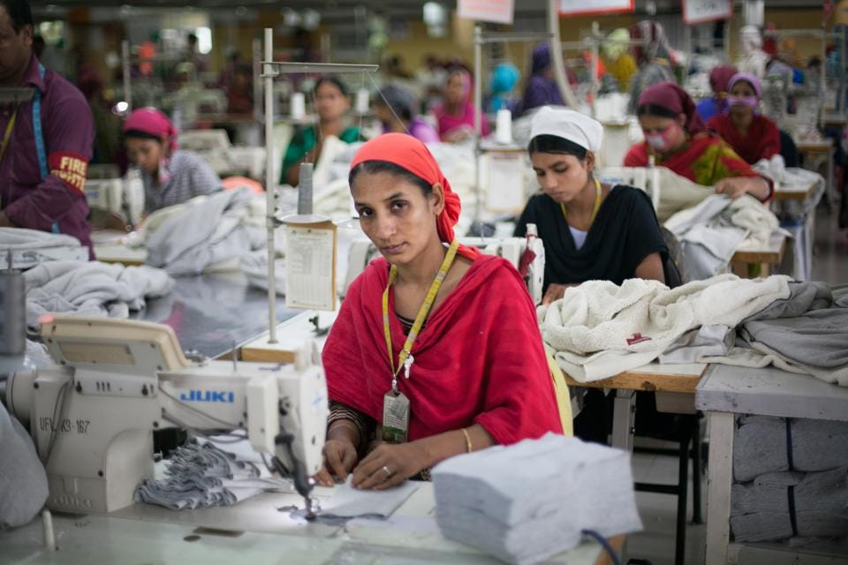
Social Action II: The Garment Industry

In this lesson we are going to begin our look at the garment industry and how it exploits (misuses/takes advantage of) workers. Let’s begin with the issue of ‘fast fashion’ which is driving the industry.

Task 1: Write the following definition of ‘fast fashion’ in your books.

Fast fashion has three main components: it's cheap, trendy and disposable. It makes purchasing clothes on impulse easy and affordable. Shoppers are encouraged to update their wardrobes regularly throughout the year to keep up with ever-changing trends.
Task 2: The class is going to break up into 6 different groups.

You will read the article, ‘What is Fast Fashion Anyway’ by Audrey Stanton.

You will have the rest of the class period to put together a 2-minute presentation on 1 of the 6 sections of the reading. You can write it in your books or create a 1-side powerpoint that covers the key information on your section.

Week 4 Lesson 3

One-slide Powerpoint Presentations or Notebook presentations on the Fast Fashion Industry. During each presentation, the rest of the class will be expected to write down at least 3 key takeaways from each presentation.

