Week 3 – The Week of August 8 to 14, 2022

Myths about Climate Change
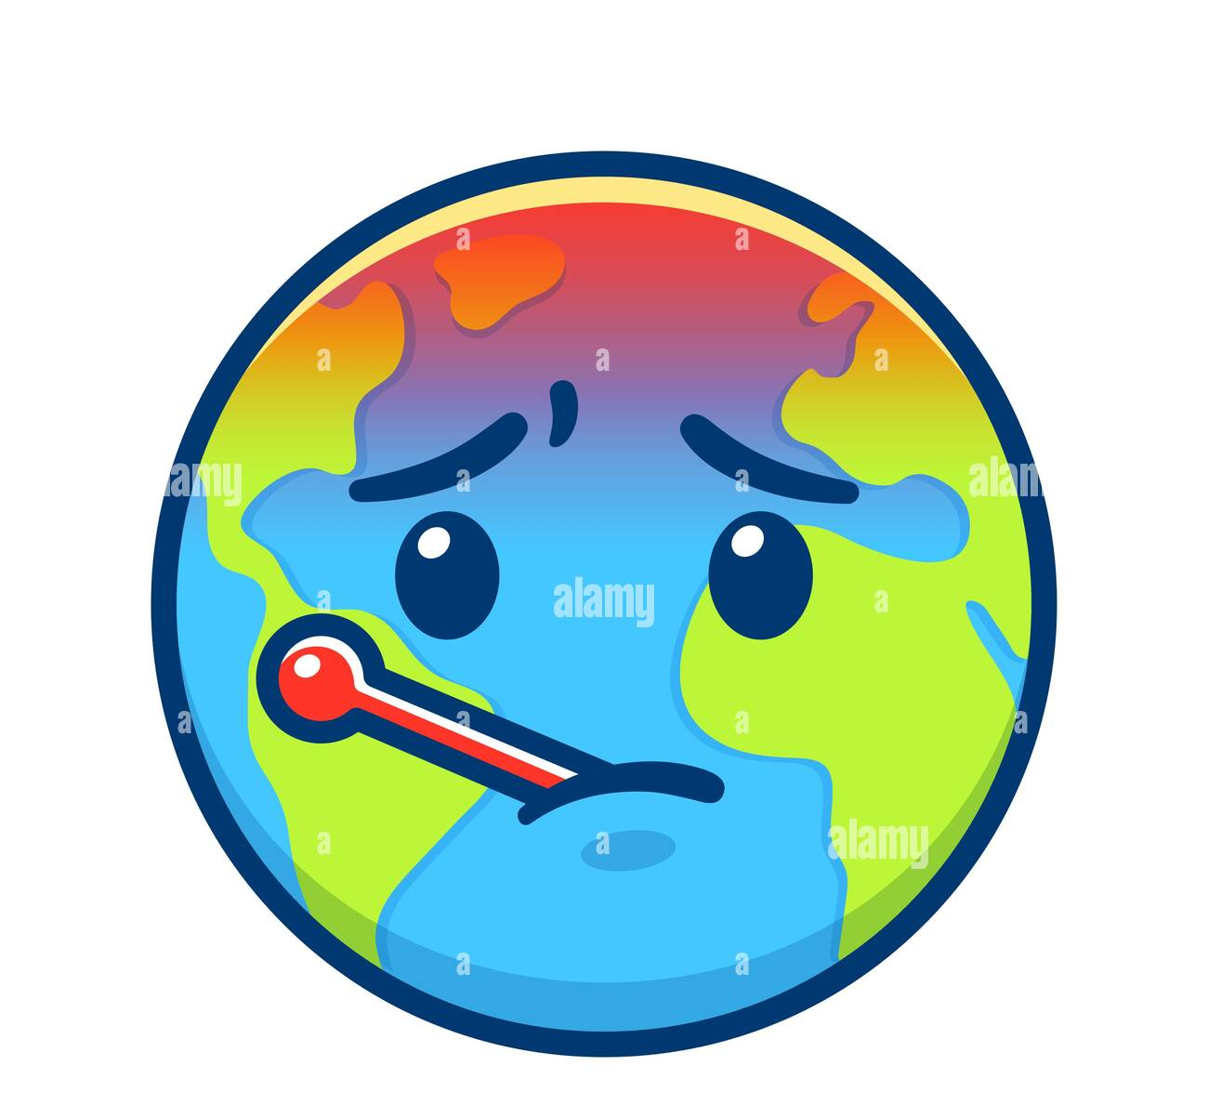

Success Criteria

Students will become familiar with key myths that surround the concept of global warming and climate change and be able to explain one or two to their classmates in the form of a very short Powerpoint presentation.

Activities:
1. Reading
2. Writing
3. Class Discussion
4. Critical Thinking

Lesson 1: Preparing your Class Presentations

Students will be working in their groups, creating a short Powerpoint presentation on their chosen climate change myth, following on with what you began last class. All of the information that you will need, will be under your chosen myth on the Skeptical Science website. All students in each group will participate in the class presentation.

Remember, at the end of your Powerpoint, you are going to include 3 short dot-point take-aways for other students to write down in their Red Books.

Lessons 2 and 3:
Group presentations on Climate Change Myths

Each group will e-mail me their presentation prior to class and be ready to present on the day. If a group member is absent, you will present regardless.

