Week 3 – The Week of August 8 to August 14, 2022

Lessons 1 to 3 –
The Production of Cacao

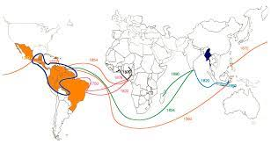

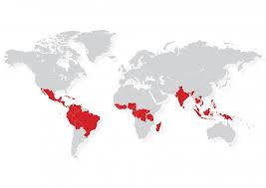

Success Criteria
Students will become familiar with the notion of cash crops, will be able to identify major cash crops associated with several developing countries, and will be able to identify the origins of the cacao plant and how it spread around the world.

Lesson 1, Task 1:

Read the article ‘Counting on Cacao – What is a Cash Crop’ and ‘So, Where does Cacao come from?’ Answer the questions that follow the reading (in your Red Books).

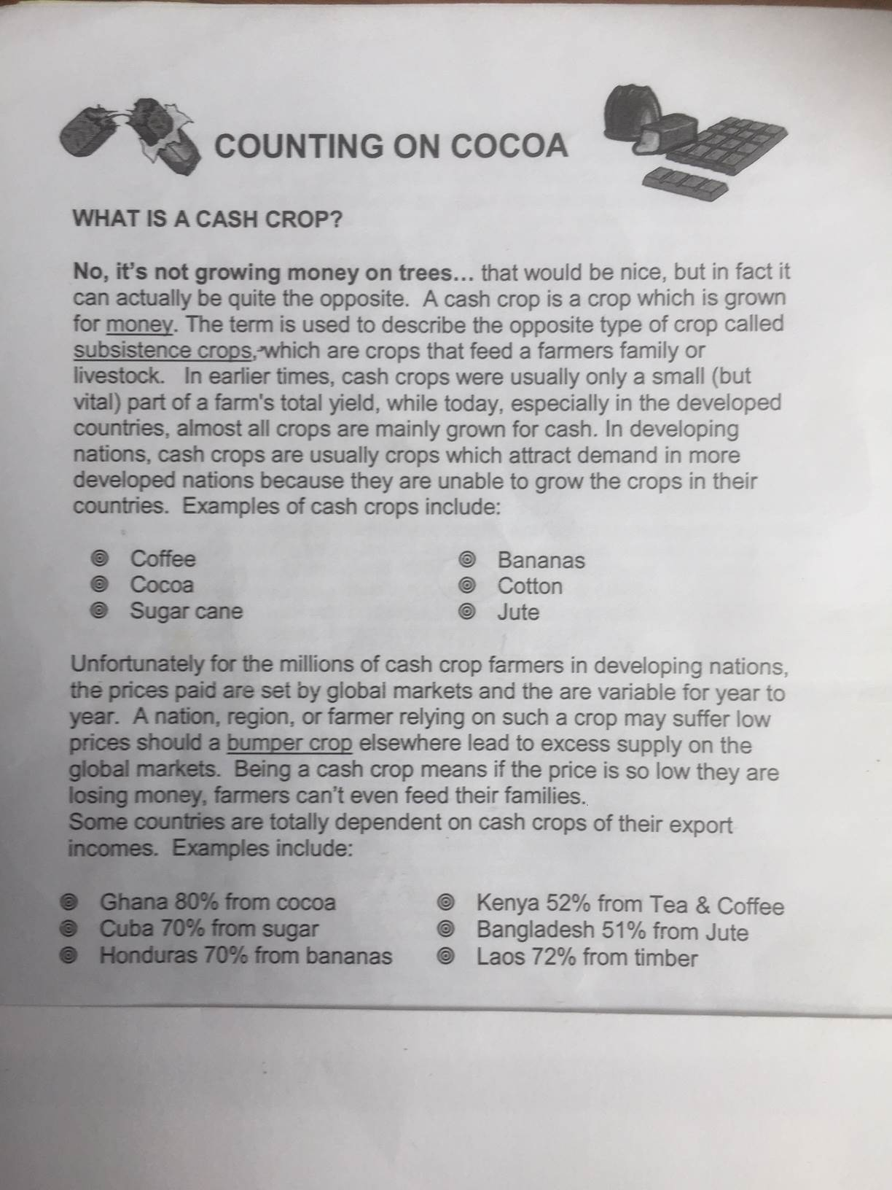
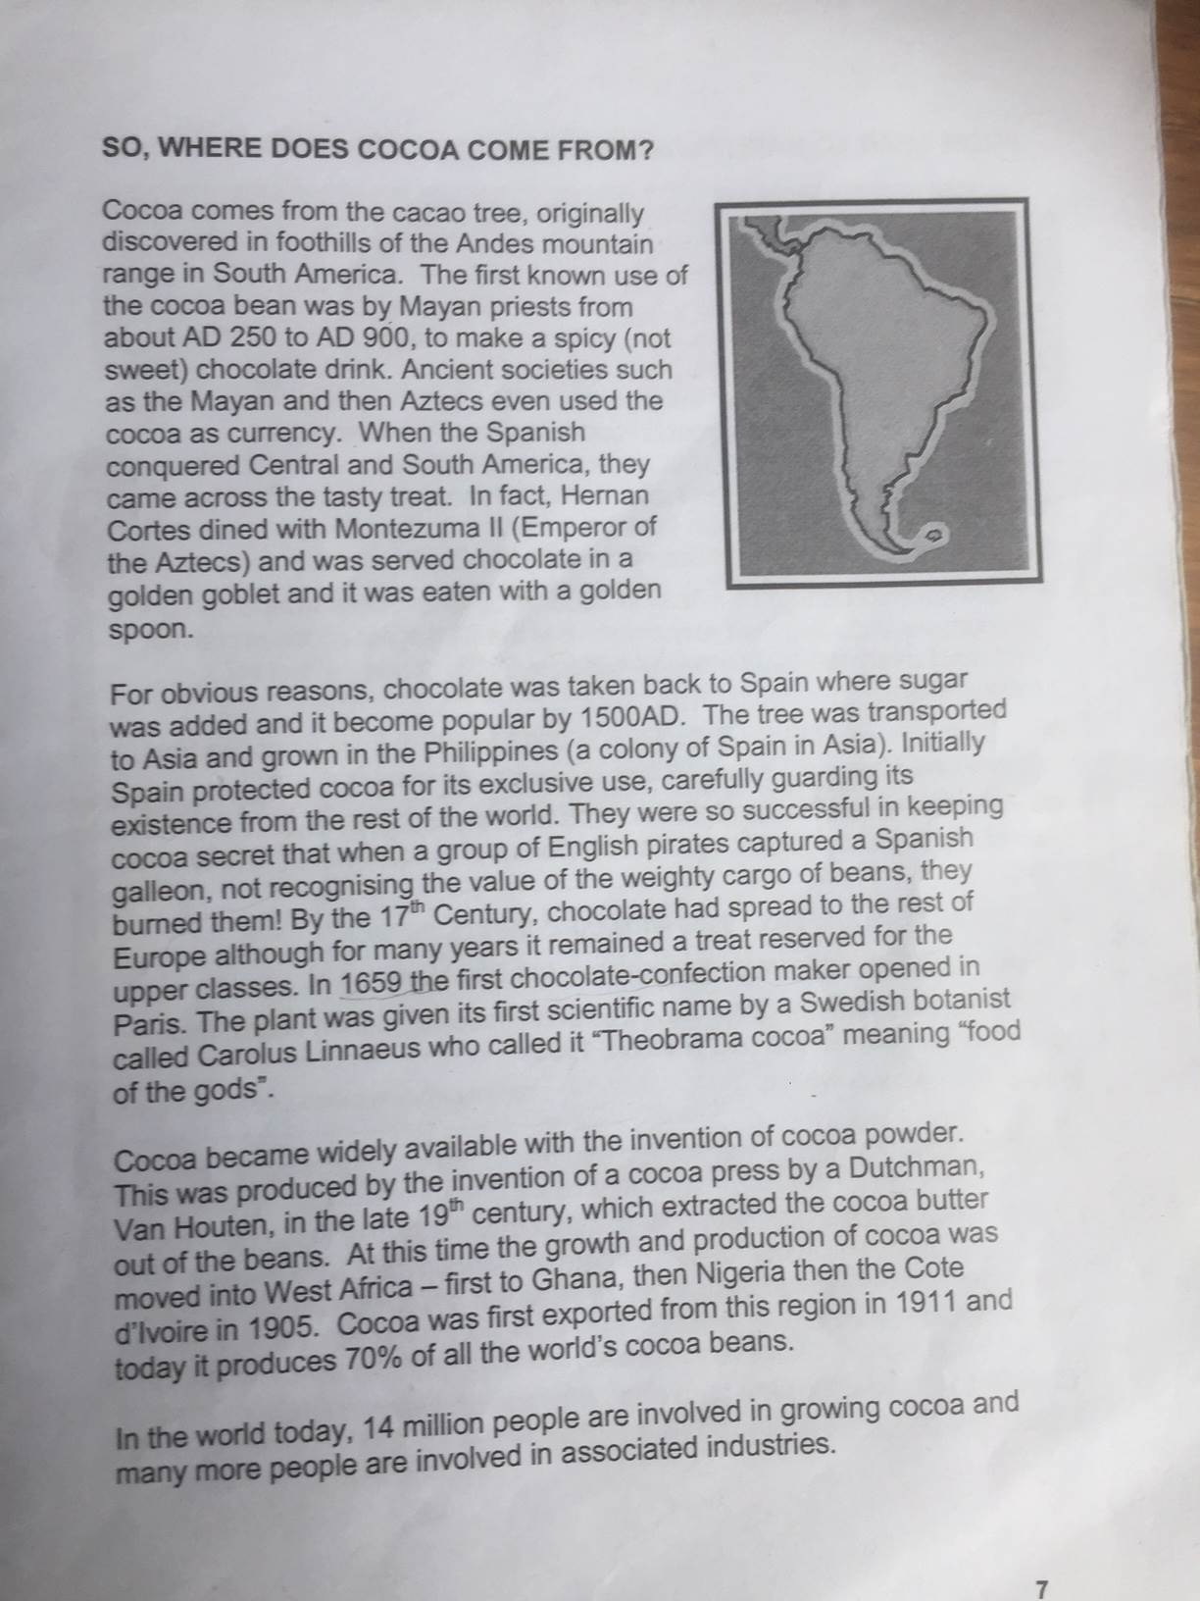

Questions from readings to be answered in your Red Books – write the question out – you can shorten some questions by rewriting in your own words:

1. How have the number of cash crops changed over time?
2. What are three examples of cash crops?
3. How is the price a farmer is paid determined?
4. Why would this price change?
5. What are three countries that largely rely on cash crops? Why is this dangerous?
6. When and where was the cacao tree discovered and used to produce chocolate?
8. Name two ancient societies that used cacao for money.
9. Which Empire spread chocolate around the world by planting cacao trees in their colonies?
10. By what century had chocolate spread throughout Europe?
11. In what part of the world are most cacao beans grown?
12. How many people worldwide are involved in the cacao industry?

Go to the CIA World Factbook and list the 5 major exports of Ghana.

Week 3 Lesson 2:

Today we will look at how cacao is harvested. We will watch the video clip: Cocoa Fruit Harvesting - Cocoa bean Processing at:
https://www.youtube.com/watch?v=v7BfQC6KbBw (7:08 sec.).

Create a summary of the steps in the process of how cacao goes from tree to the store bag ready to be shipped. What happens at each stage, who is involved, what are they doing? Include information from the video and from the following website which has an excellent summary and great photos showing what is happening at each stage (https://www.cocoalife.org/in-the-cocoa-origins)
Create
1. Cacao pods are grown on a cacao tree and cut down with a machete Image here

2. Removal of seeds Image

3. Drying process Image

4. Bagging Image

Week 3 Lesson 3

Why Co-operatives are an Important tool Against Poverty for Poor Farmers

Task 1: Read the article: ‘Forming a Cooperative.’

- What is a cooperative?
- What values do its members believe in?
- Why have many cacao farmers in Africa formed cooperatives?

Task 2: Go to the site: https://www.fairtrade.org.uk/farmers-and-workers/cocoa/kuapa-kokoo-ghana/
This site looks at how farmers in Ghana have formed cooperatives.
Answer the following questions:

1. What is Kuapa Kokoo?

In your own words, create a series of dot-points on how Kuapa Kokoo has helped cacao farmers in Ghana to be able to have better lives for themselves and their families. Create your key points under the headings that appear below. Write as many points as you can. DO NOT copy word for word; rewrite in your own words. I have done the first section as an example:

1. Community

- Bought 51 corn mill machines
- Machines to shell nuts
- Machines to extract garri (a creamy flour made from the root of the cassava plant)
- Bought cutlasses (curved swords) to be used in harvesting
- Built 2 daycare facilities

2. Health

3. Education

4. Farmer Support

Task 3: On the website, https://www.fairtrade.org.uk/farmers-and-workers/cocoa/kuapa-kokoo-ghana/
it lists many different campaigns that are underway to help farmers with a variety of fair trade items. Make a list of the different products below. I have started by naming two items on the list:

1. Coffee farmers

2. Cotton farmers

3.

4.

5.

6.

