Week 2 – The Week of August 1 to August 7, 2022

Lessons 1 to 3 –
Trade and New Zealand

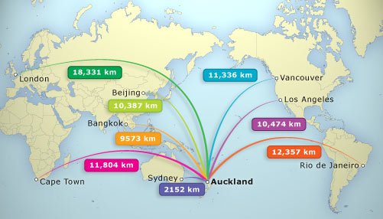

Success Criteria
Students will gain a basic understanding of the 3 main types of trade and where New Zealand fits into the larger picture of globalism. At the end of the week, they will be able to name the New Zealand’s major imports and exports.

Lesson 1, Task 1: Write down the 3 sectors of any economy:

  - 1. The Primary Sector – this includes the extraction and harvesting of products from the earth (raw materials).

Examples: farming, forestry, fishing, mining.

  - 2. The Secondary Sector – this includes the manufacturing of finished goods.

Examples: turning wool into clothes, turning wood into furniture, etc.

  - 3. The Tertiary Sector (Service Sector) – this includes services provided to the general population or businesses.

Examples: transportation, restaurants, media, doctor, lawyers, bankers.
Task 2: We will go over the Reading in class on ‘New Zealand’s Changing Face of Trade.’

Class Discussion on the Reading. Here is the reading below:

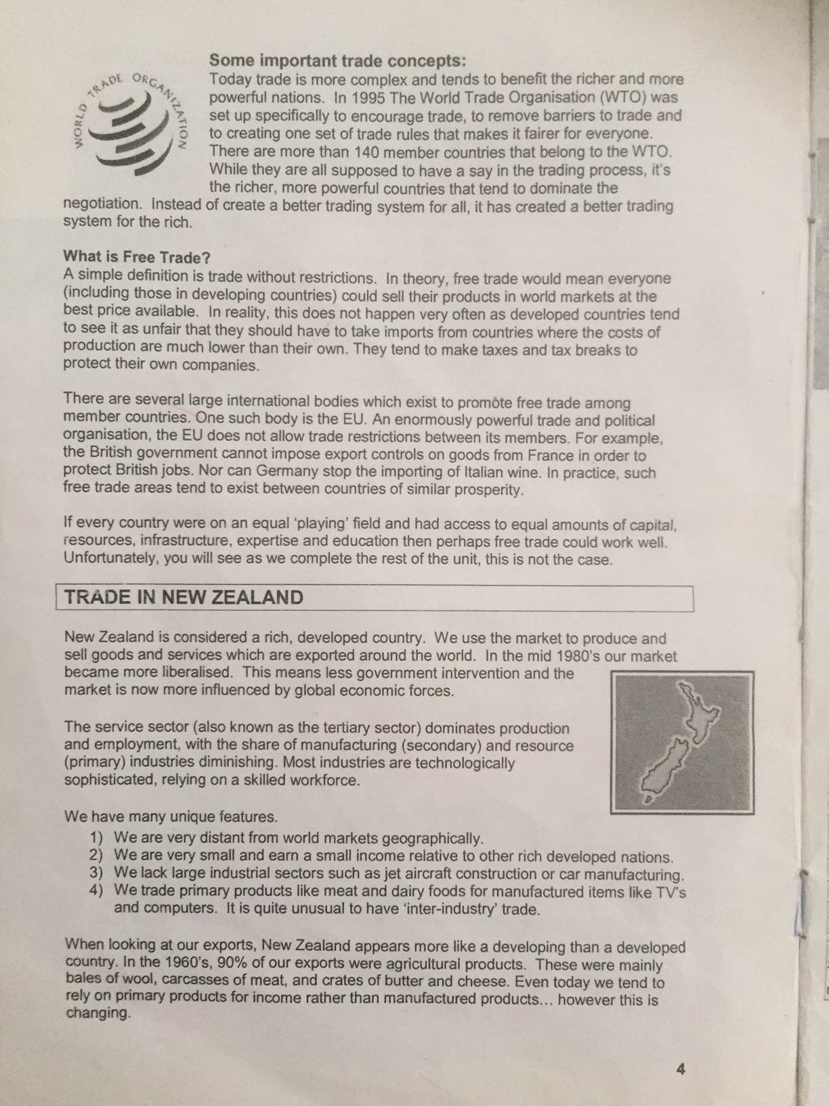
Key points about New Zealand in the reading to write down in your Red Books that we will discuss –

- Developed Country

- We have many unique features.

- We are very distant from world markets (geographically isolated).

- We are very small and earn a small income relative to other rich developed nations.

- We lack large industrial sectors such as jet aircraft construction or car manufacturing.

- We trade primary products like meat and dairy foods for manufactured items like TV’s and computers. It is quite unusual to have ‘inter-industry’ trade.

Task: Go to The CIA World Factbook online.

Look up New Zealand
Go to the section labeled Economy and answer the following questions:

1. What are New Zealand’s main imports. List them.

2. What are New Zealand’s main exports. List them.

3. Create a percentage bar graph of New Zealand’s top 4 export partners (you will find this information under ‘Export Partners’ in the ‘Economy Section.’

Remember to Use a Ruler
Use even increments with a suitable scale
Label the x and y axes
Include a specific Title

Lesson 2: To become familiar with Key Features of New Zealand

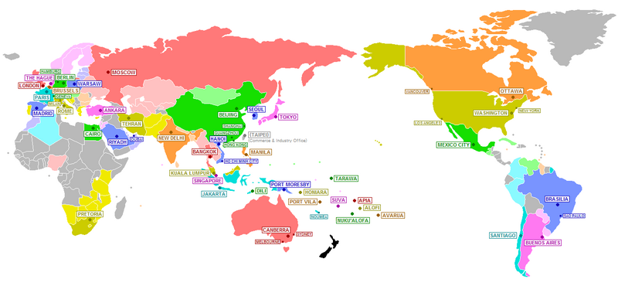

Go to the CIA World Factbook under New Zealand.

For each Section listed below, write into your Red Books at least 2 Key pieces of information on New Zealand and how this information impacts on our economy. The first one has been done for you.

Geography: New Zealand has over 5 million people. Just over 43% of the land is used for agricultural purposes.
Impact on Economy: Due to the small population we have job shortages in certain areas. New Zealand is located far from the rest of the world, we are isolated which results in many items being expensive as they need to be shipped or flown in.

People and Society

Environment

Economy

Energy

Communications

Transportation

Military and Security
Lesson 3: Access the Powerpoint titled ‘Chocolate.’

Write down Week 2 Lesson 3 – the Production of Chocolate – then follow the instructions. Make sure you write the information to your Red Books.

