Week 2 – The Week of August 1 to 7, 2022

Lessons 1 & 2:

Climate Change and Critical Thinking:
Evaluating the Evidence

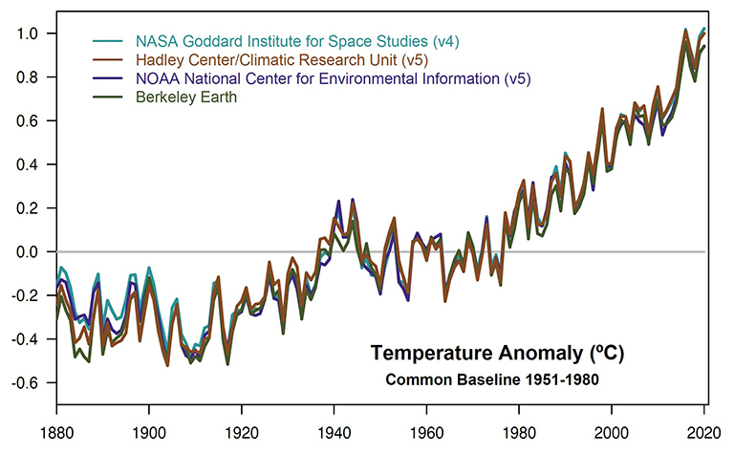

Success Criteria
Students will gain familiarity with the scientific evidence for global warming and why it is now accepted as a fact by the mainstream scientific community that human beings are responsible for global temperature rises in the world. By the end of this week, they will be able to cite key scientific findings that confirm the existence of global warming beyond any reasonable doubt.

Activities:
1. Reading
2. Writing
3. Class Discussion
4. Critical Thinking

Task 1:
Students will break up into small groups of 3 or 4, and go to the following Reading on the website ‘Skeptical Science’ at: https://skepticalscience.com/argument.php

In their groups students can take turns reading it out loud, then discussing and answering the questions.

Read about the following on climate change myths and answer the corresponding questions for Myths 6, 10, 20 and 23. Each person working in a group must write the full response into their books.

Example:

I am going to provide an example question for students in class to follow. Please write this example into your books. Notice how I have written the responses in complete sentences. WRITE THIS EXAMPLE IN FULL INTO YOUR RED BOOK.

Myth #4: “There is no consensus.”

a. Define the word ‘consensus.’
The word consensus can be defined as a general agreement on something.

b. Use ‘consensus’ in a sentence as it relates to climate change and underline the word.
There is a consensus among climate scientists that global warming is caused by humans.

c. Why have most scientists who study climate change, stopped arguing?
Most scientists who study climate change have stopped arguing because the evidence for climate change is overwhelming

d. Identify a conclusion drawn by the seven climate change studies.
Based on the seven climate change studies, 97% of climate change scientists agree that global warming is real.

e. What is the ‘consensus gap?’
The ‘consensus gap’ is the difference between the public perception on global warming and the reality as outlined by scientists.
* * * *
Now I want you to write out an answer the questions to myths 6, 10, 20 and 23.

Myth #6: “Models are unreliable.”

a. What is hindcasting?

b. How has hindcasting helped to prove the reality of global warming?

c. Why are mainstream climate models of forecasting temperatures, considered to be a reliable indicator of global warming?
* * * *

Myth #10: “Antarctica is gaining ice.”

a. Why should we be skeptical of the claim that because Antarctica is gaining sea ice, it is evidence against global warming? (hint: there are 2 types of ice).

You may also wish to click into the 2019 article that is critical of the study, to aid your case: https://www.forbes.com/sites/kevinanderton/2019/02/21/ice-gains-in-some-parts-of-antarctica-arent-offsetting-its-losses-infographic/#4bcd63ac7030

* * * *

Myth #20: “Glaciers are growing.”

a. Summarise in dot-point form, the key parts of this myth.

* * * *

Myth #23: “It’s freaking cold.”

a. Write a summary, in the form of a paragraph, on the main points in this section.

Choose two more myths and write at least 4 questions and answers for them. Myth #____ and Myth #____

Complete this lesson in Class in your collaborative groups.

Lesson 3: Short Class Presentations

Each group is to pick one more myth from the Skeptical Science website that we have not yet done (https://skepticalscience.com/argument.php) and create a Powerpoint that summarizes the myth and raises at least four questions and answers about it. Your presentation should be 3-minutes long. The more ambitious groups may try to cover 2 myths. We will do this over 2 class periods.

Today’s Task: You choose the myth, read about it and begin planning out your Powerpoint. You will also work on your Powerpoint during next class as well. Each group will get in front of the class for classes 2 and 3 next week and discuss your myth. At the end of your presentation you should give 3 short dot-points that are key takeaways for students to know and the students in the audience will write these into their read books under the heading of your presentation.

