Week 1 – The Week of July 25 to July 31, 2022

Lessons 1 to 3 –
An Introduction to Fair Trade

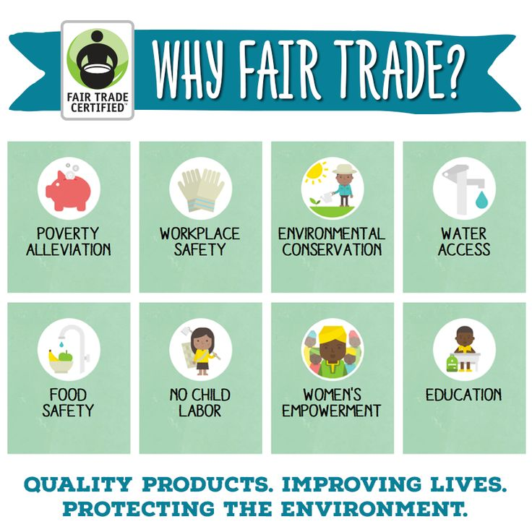

Success Criteria
Students will gain a basic understanding of the concept of Fair Trade, be able to explain how it helps disadvantaged people around the world. They will also become familiar with issues related to fair trade – in a broad sense. They will be able to list these key issues at the end of the week and be able to recite the definitions of key vocabulary words.

Activities:
1. Reading
2. Writing
3. Class Discussion

Class Discussion on the following key points:

- How many students have heard of fair trade?

- Of these, how many can honestly say they know what it means?

- How many people in this room have bought fair trade products?

Task 1: Set up Red Books. Open your books up to 2 blank pages. Write down the unit title at the top of a blank page of your Red Book. One-third of the way down the page, draw a line across the page. Above the line write the words ‘Fair Trade’ in large letters. Below the line write the 7 Unit Outcomes that appear below:

Learning Outcomes:
As you write these outcomes into your books, feel free to shorten them – I have given examples of how I would shorten some.

Students will be able to understand

1. Understand what fair trade means and important features of it such as markets, trade routes and globalization

2. Understand what cash crops are and how changes to these markets can have severe consequences for people and their communities

3. Understand the positive impact that co-operatives have on poor farmers and their livelihoods

4. Understand how Fair Trade is an innovative way to promote economic growth and security for farming communities

5. Understand what sweatshops are and the impact of the fashion industry on different groups of people globally

6. Understand what students can do to address trade injustices and make a difference using their new knowledge

7. Be familiar with a case study on one particular fair trade item (e.g., cacao) and the social and economic issues that are associated with it.
Task 2: Watch the video on Fair Trade footballs. We will do this as a class at: https://www.youtube.com/watch?v=wTrFOLLvlGs

Class Discussion:

How many students were aware of trade footballs?

In what ways has fair trade helped the people in the video?

Has anyone ever seen or bought a Fair Trade football or know someone who has?

Task 3: As a class we will watch the clip – “A Brief History of Fair Trade,” at: https://www.youtube.com/watch?v=C22yzOxdUDg

Class Discussion:

Have you ever bought fair trade bananas or chocolate?

Would you choose a non-fair trade item over another if there was just a $1.00 difference in price? How about $3.00?

Task 4: Write the following basic definitions into your Red Book:

Free Trade: Trade without restrictions

Fair Trade: Trade with restrictions

Homework: Make sure that your books are neatly set up and up to date.

Lesson 2:

Fair Trade Unit Outline & Key Definitions

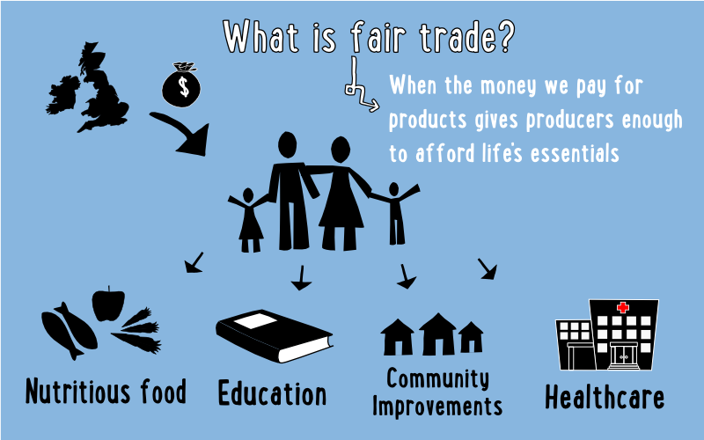

Task 1: Write the Unit Outline below into your Red Books

In this unit we will go over the follow sections:

Introduction to trade:

  - Understand what trade is and how it works

- Case study 1: Cocoa from seed to market

  - Understand the economic issues and problems that farmers growing cash crops in developing nations face
  - An inside look at the chocolate industry

- Case Study 2: Sweatshops

  - Understand the impact of globalisation, cheap labour, and sweatshops
  - An inside look at the garment industry

- Taking Action: Solutions to Trade Injustice

  - We will look at the actions that people, groups, and government can take to ensure trade justice and help reduce the impacts of trade injustice

Task 2: Do the ‘Find Someone Exercise’

Leave your seat and go around the room to find someone who:

1. Is wearing something made in another country…

Name of country:

Item:

2. Owns more than 5 pairs of pants…

Name of person:

Item:

3. Is wearing something made of cotton…

Name of person:

4. Owns more than 2 pairs of footwear…

Name of person:

5. Has eaten chocolate or a banana today…

Name of country:

Brand of chocolate:

6. Knows what a sweatshop is…

Name of person:

7. Drinks Coca Cola at least once a week…

Name of person:

8. Has shopped at a Trade Aid store…

Name of person:

9. How many items do you have at school? List the countries that these items were made in…

Country Item

Country Item

Country Item

Country Item

Country Item

Country Item

Country Item

Task 3: Key Terms and Definitions

Today we are going to focus on the definitions of key terms about Fair Trade.

Look up the following definitions. We will do this in class and discuss the definitions:

1. Fair Washing (go to the site: https://thefairtraderstore.com.au/blogs/be-inspired/greenwashing-and-fairwashing
And write a summary of the definition)

2. Modern-Day Slavery (use the definition at antislavery.org)

Now finish writing out the rest of the key vocabulary words. Be sure to leave a couple of lines between each definition:

- Interdependent
- Globalisation
- Free Trade
- Primary Sector
- Secondary Sector
- Sweatshop
- Co-operative
- Subsistence farming
- Cash crop
- Import
- Export
- Equity
- Fairness
- Marketing
- Developing
- Developed
- Exploitation

Homework: Make sure that your books are neatly set up and that they are up to date.

Week 1 Lesson 3:

The Silk Road

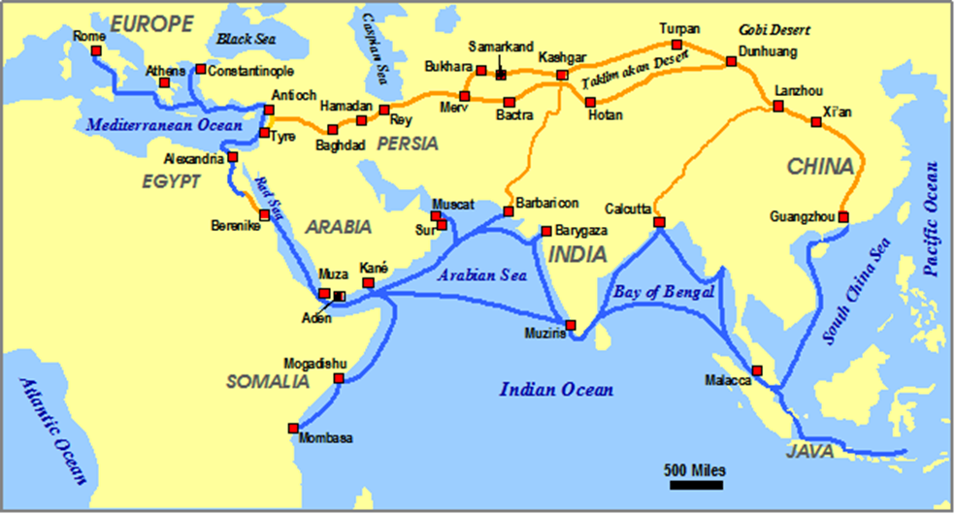

Today we are going to learn about The Silk Road.

Task 1: Go to ‘The Silk Road Reading’ on pages 10 and 11 of this lesson. After you have read the article, answer the following questions:

- The Silk Road began in India (True or False)
- The Silk Road is a group of trade routes across Asia (True or False)
- Beijing is NOT part of the trade route (True or False)
- Europe traded silk for gunpowder (True or False)
- Captain Cook is known to have traveled the Silk Road (True or False)
- Marco Polo traveled with his father and uncle along the Silk Road route (True or False)
- The Chinese traded medicinal herbs and printing machines for perfumes and glassware (True or False)
- The trade route was very safe for caravans of traders (True or False)
- The Silk Road was 7000 kilometres long (True or False)
- The popularity of the trade route declined as overseas ship trading increased (True or False)

Once completed, we will go over the questions in class. Students are to write each of the 10 questions into their Red Books followed by the answer (T or F) in pencil.

Task 2: Watch the clip on ‘The Silk Road’ from Ted Talk at: https://www.youtube.com/watch?v=vn3e37VWc0k and take the quiz

- Which of the following factors hindered early connections between early river valley civilizations?
- Lack of technical innovation
- Physical geography and the fear of the unknown
- Over-reliance on agricultural production
- Political restrictions on trade

2. What role did nomadic people play in the establishment of the Silk Road trade?
a. Nomadic people stopped trade from occurring along the Silk Roads.
b. Nomadic tribes played no significant role in the development of trade.
c. Nomadic people became dependent on the Silk Roads for their survival.
d. Nomadic tribes established some of the earliest trade along what would become the Silk Roads.

3. The conquests of which Greek leader led to the expansion of the Silk Road?
- Darius I
- Zhang Qian
- Alexander the Great
- Pericles

4. What religion makes it way from India along Silk Roads to China?
- Islam
- Buddhism
- Sikhism
- Hinduism

5. The diffusion of maritime technology, like the magnetic compass, led to which effect?
- The dawn of the ‘Age of Exploration’ and the seeking of alternative trade routes to Asia
- The establishment of more extensive overland trade routes
- The immediate end of all trade in Asia
- The strengthening of Silk Road trade routes

6. What role did the physical geography of Eurasia play in the establishment of Silk Road trade routes?

7. Silk Road trade led to global exchange and cultural blending to create new cultural elements. Can you think of a specific example of how the modern world economy has led to similar effects?

Reading for Task 1 on The Silk Road:

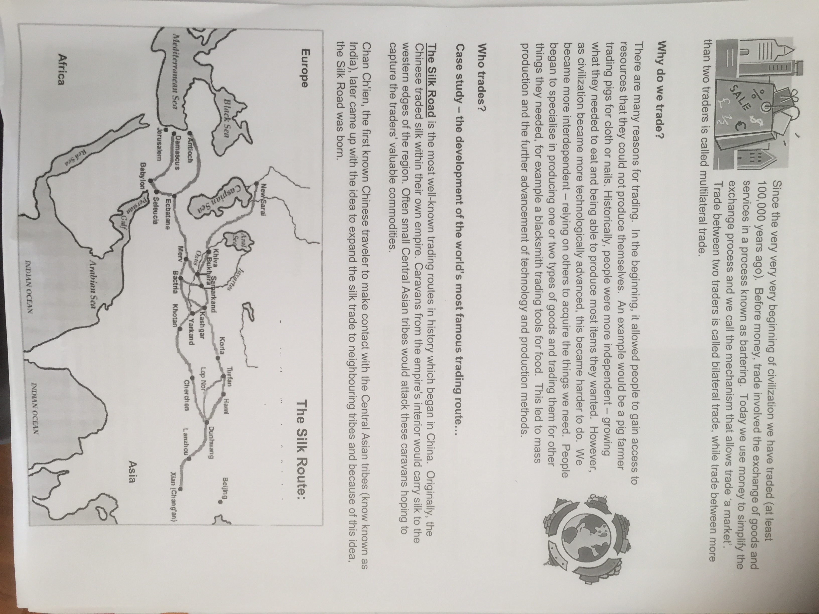
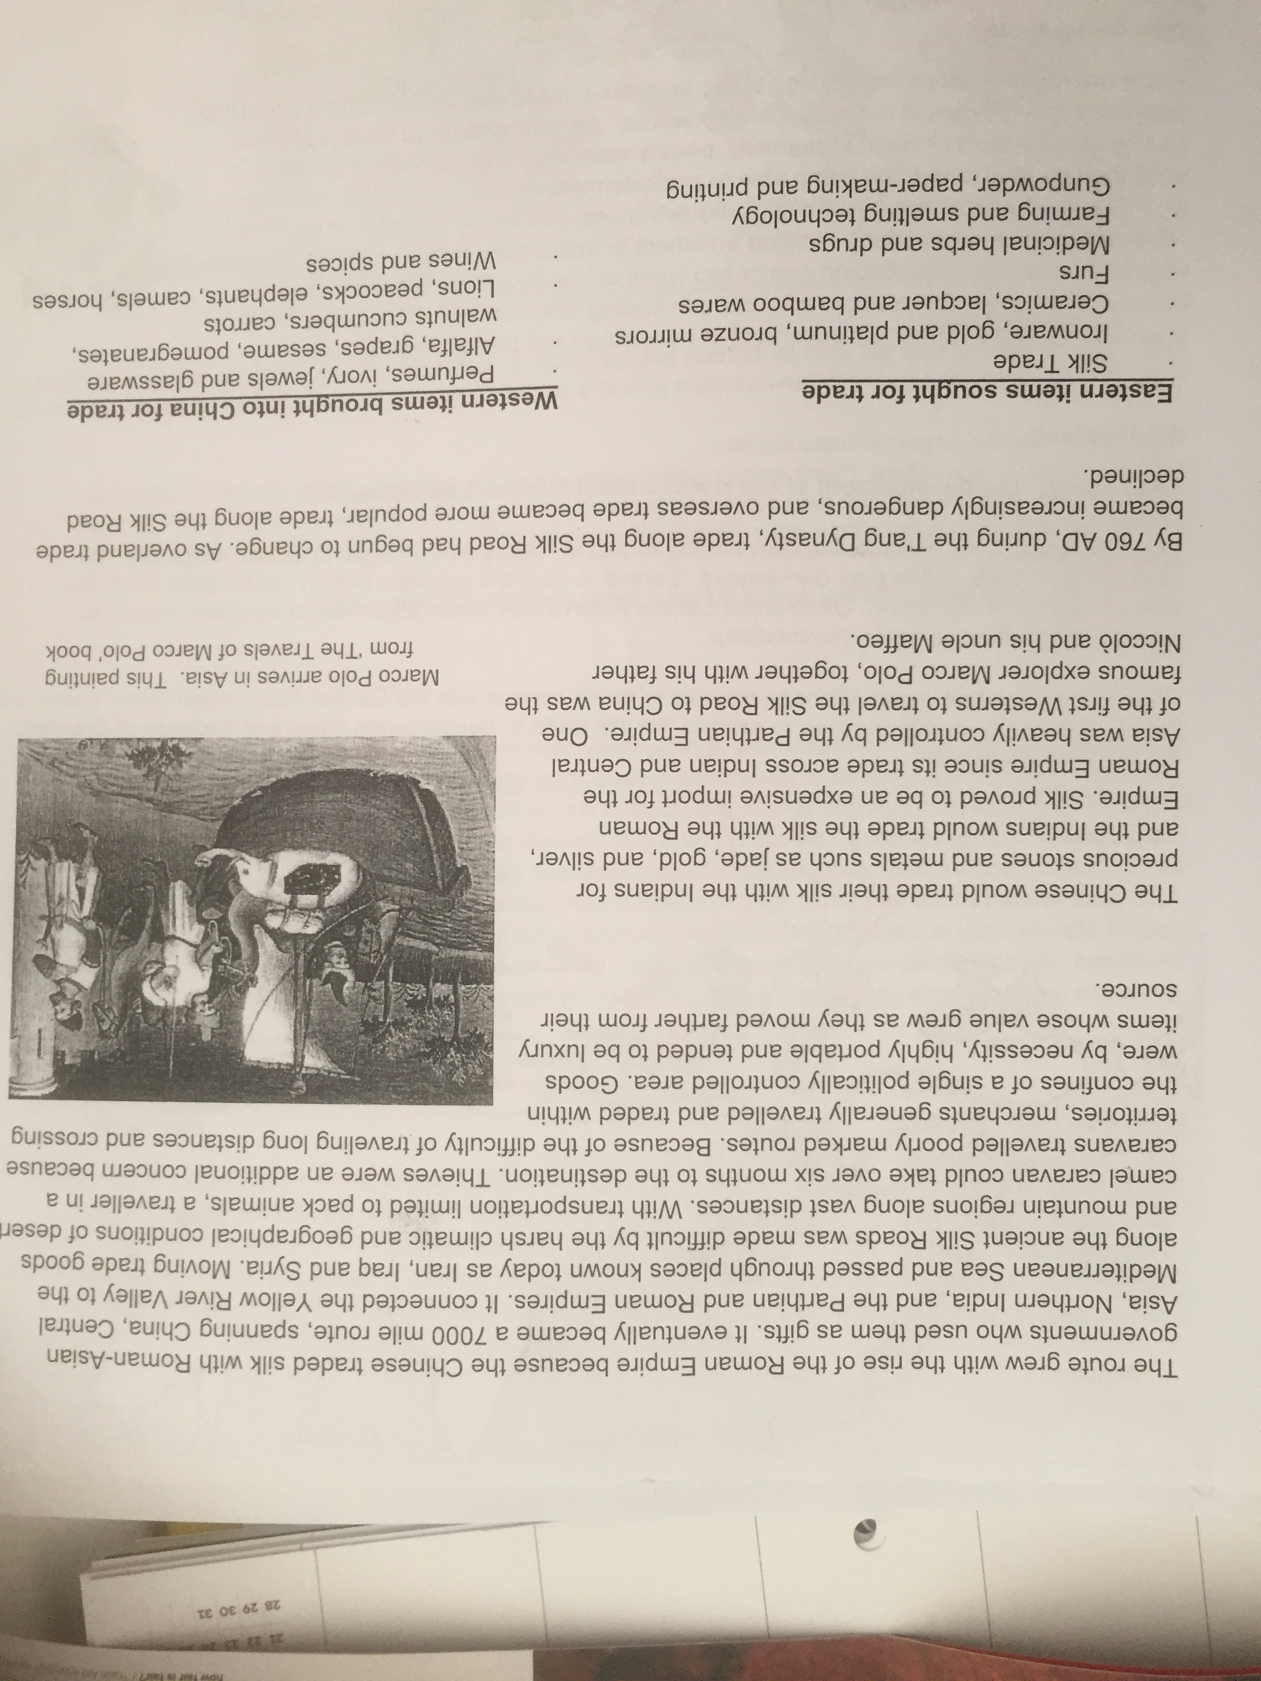

Homework: Make sure that your books are neatly set up and that they are up to date.

