Week 1 – The Week of July 25 to July 31, 2022

Lessons 1 to 3 –
An Introduction to Global Warming

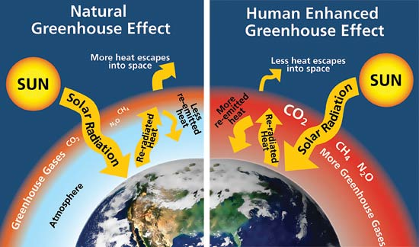

Success Criteria
Students will gain a basic understanding of the concept of global warming which is now accepted as a fact by the mainstream scientific community because the weight of evidence is overwhelming. The only credible debate that remains is the extent to which this change will occur and the speed at which it will happen. At the end of this week students will be able to explain house the Greenhouse Effect works.

Activities:
1. Reading
2. Writing
3. Class Discussion

Task 1: Set up Red Books. Write the unit title at the top of a blank page of your Red Book. One-third of the way down the page, draw a line across the page. Below the line write the 5 Unit Goals that appear below:

Learning Goals:

1. Know key glossary terms related to Global Warming and Sustainability

2. Tell the difference between global warming and climate change

3. Be knowledgeable on the projected impact of global warming on New Zealand and the world

4. Be able to describe the history of human development and its impact on the environment

5. Know how people can help reverse global warming and the importance of future advancements in transportation to slow warming, specifically electric vehicles

Task 2: Class Discussion of the following key points:

- How many students believe that global warming has not been proven or is a hoax?

- Of these, how many can honestly say that their views reflect the beliefs of their parents or relatives?

- What data do students have to support the claim that climate change is not real? What do you base your evidence on? What about climate change believers?

- Many different surveys of climate scientists reveal that 97% have reached the conclusion that global warming is real, and over 90% think it is caused by humans and the release of CO² into the atmosphere.

Task 3: View the two short video clips below by Professor Neil DeGrasse-Tyson and reporter Brian Stelter:

Clip #1: DeGrasse-Tyson https://www.youtube.com/watch?v=y1MZ8U8C9c8&t=100s

Clip #2: Brian Stelter - https://www.youtube.com/watch?v=cbjPQisjyfM

Task 4: Class Discussion on the clips
Task 6: Short written Response: After watching these 2 clips, summarize the mainstream scientific position on the reality of global warming? In other words, how would most scientists answer the question of whether global warming is real and what evidence would they give?

Homework: Make sure that your books are up to date.

Task 5: We will read the following as a class together: What is Sustainability?

Write down the underlined portion of the definition of sustainability in your Red Books. It is a long definition but is one of the most important definitions you will ever write down because the future of our planet is at stake if we do not get this right.

Sustainability is a huge topic. At its core it is about how we can sustain ourselves as a species without becoming extinct and maintaining a high quality of life for everyone. The problem is, as we move forward – think of the invention of the automobile or the airplane – while these advancements improve our lives, they also create new problems such as air and noise pollution. We could ban automobile and plane travel, but that would hurt the economy and restrict the way people move around. Sustainability is about balancing our need to progress, with the need to respect the environment.

In 2012, the United Nations Conference on Sustainable Development identified 17 serious issues that need to be addressed urgently. These include:

- The end of poverty and hunger
- Better standards of education
- Better healthcare - particularly as it pertains to sanitation
- Gender equality (e.g., equal pay, rights, etc.)
- Sustainable economic growth while promoting jobs and stronger economies
- Addressing the effects of climate change, pollution and other environmental issues that can harm health, livelihoods and lives.

Lesson 2: Glossary Words – write the following definitions into your Red Book. The first 2 definitions have been given to you – please write them down in full. Be sure to leave at least 2 spaces between questions.

Definition.

1. Fossil Fuels: A group of energy sources formed over millions of years by the decomposing remains of plants and animals under heat and pressure. They are responsible for a big part of the problem with global warming. Examples include coal, petroleum, and natural gas. They are generating gasses that are responsible for the rise in the earth’s temperatures.

2. Carbon dioxide (CO²): A gas that is produced by all plants and animals. Most CO² in the atmosphere is caused by the burning of fossil fuels.
3. Non-renewable energy:

4. Renewable energy:

5. Greenhouse Effect

6. Recycling

7. Intergovernmental Panel on Climate Change

8. Fact

9. Opinion

Global Warming Action – Writing Exercise:

Once you have finished your definitions, go online and look up information about the recent high temperatures in Europe. Does this concern you? Think of different ways that you could try to help the planet either individually or through group action. You can do this in dot-point form or through a full paragraph. If you are having trouble thinking of ideas, go online and type in ‘Global Warming activism – what can I do?’

Homework: Make sure that all homework is up to date.

Lesson 3: Draw a picture of the Greenhouse Effect on a blank page of your Red Books (or over 2 blank pages) and identify the key elements involved. If you find it useful, you may use the following sketch. NOT to be done on a word file – write it in your books. It does not matter if you are not good at drawing. In some cases, you may be able to lightly sketch over your computer screen, then fill it in and make it darker.

