Year 7 Week 9 – Lesson 1:

Astronomy

Is Pluto a Planet?

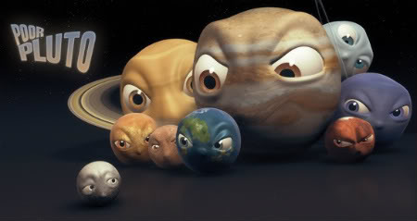
Mr Bartholomew Global Studies

Year 7 Week 9 – Lesson 1:

Astronomy Discovery Week

Pluto lost its spot in our solar system but still holds a place in many hearts
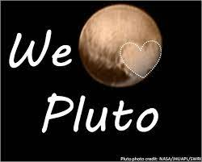

Success Criteria: At the end of the week, students will be able to explain why Pluto should not be classified as a planet, the danger space junk poses to our future, and how doing household chores is good for your brain.

Instructions: On a blank page in your Red Book, write ‘Current Event Analysis’ at the top of a page, followed by the title of this article. Write out and answer the questions at the end of the readings.

Go to Google and type in:

“Pluto lost its spot in our solar system but still holds a place in many hearts” by Susie O’Brien at Kids News, August 8, 2021, or you can go to the link: https://www.kidsnews.com.au/humanities/doing-more-jobs-around-the-house-may-help-kids-succeed-at-school/news-story/b35911577c1355ab5b2a87eaada99e60
Here is the article:

It was 15 years ago this month that former member of the solar system Pluto was kicked out of the club and downgraded to dwarf planet status. And a lot of the world is still pretty upset about it.

But Dr Mike Brown, the man credited with lowering Pluto’s status, stands firm. Indeed, on social media he even calls himself “PlutoKiller”. Enough said.
But why was Pluto kicked out of the solar system anyway? Were nine planets just one planet too many? Or was there more to it?
THE EARLY DAYS OF PLUTO
The discovery of Pluto was announced with much excitement back on February 18, 1930. It was found by astronomer Clyde Tombaugh at America’s Lowell Observatory in Flagstaff, Arizona, with contributions from William H. Pickering.
It was a time of intense planet hunting. Explorers had mapped the continents of Earth and now turned instead to mapping the stars.
And the possibility of a ninth planet in our own solar system – known as Planet X – was the most sought-after prize.
The Lowell Observatory had been on the lookout for the elusive planet since at least 1909, with founder Percival Lowell dying empty-handed in 1916.
But Lowell had actually bagged the prize – he just didn’t realise it. Unbeknown to him, on March 19, 1915, his observatory captured two faint images of Pluto. Indeed, at least 16 photos of Pluto have been identified that predate* its official discovery. Pluto was there all along. But no one realised the significance of what they were looking at.
Then in 1930, 23-year-old astronomer Clyde Tombaugh was tasked with taking photos of the night sky a few days apart, so that a comparison could identify what was moving.
“I looked in (the telescope) and I spied it almost immediately, and a tremendous thrill came over me and I almost shook,” he later said.
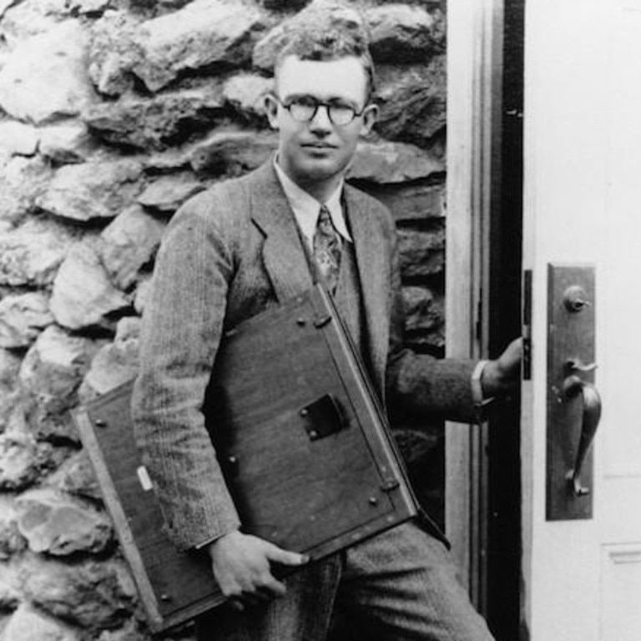 Clyde Tombaugh was just 23-years-old when he was credited with formally discovering Pluto in 1930. Picture: file copy.
NAMING THE NEW DISCOVERY
As discoverers of the new planet, the Lowell Observatory had the privilege of naming it.
They opened it up to suggestions and more than 1000 names flooded in from across the globe.
But 11-year-old British girl Venetia Burney’s suggestion was considered the best.
Venetia, from Oxford in England, had a keen interest in mythology* and suggested Pluto, Roman god of the underworld*. She thought it suited a dark and cold world on the edge of the solar system.
She received £5 as a reward (given by her grandfather), as well as the honour of having named the ninth planet in our little corner of the universe.
The name had one other advantage. The first two letters were the initials of Percival Lowell, who had spent so much of his life devoted to finding the planet.
Venetia was still alive in 2006 when Pluto was kicked off the solar system’s team.
Known by her married name by then, Venetia Phair, the retired schoolteacher, aged 87, wasn’t too upset about the planet’s demotion*.
“It’s interesting isn’t it, that as they come to demote Pluto, so the interest in it seems to have grown,” she said in 2006.
“At my age, I’ve been largely indifferent to (the debate), though I suppose I would prefer it to remain a planet.”
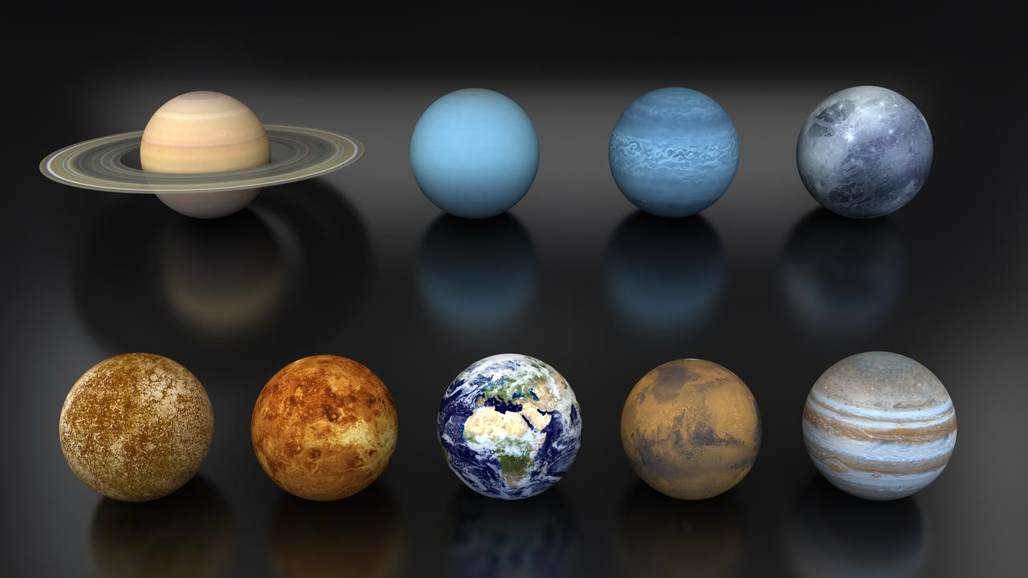 Generations of students grew up learning that there were nine planets of our solar system. From top left to bottom right: Saturn, Uranus, Neptune, Pluto, Mercury, Venus, Earth, Mars and Jupiter.
THEN ALONG CAME THE “PLUTO KILLER”
Fast forward 40 years to a schoolboy growing up in the US in the 1970s, who fell in love with “this funny little oddball at the edge of the solar system.”
“It seemed like the coolest place to think about, literally, in the solar system,” Dr Mike Brown told the BBC.
That same cool loner of the solar system inspired the boy – who became an astronomer – to look for other objects like it, eventually earning himself the nickname “Pluto Killer”.
“It was very clear I think (to) everyone that it was likely that there were objects larger than Pluto to be found out there,” Dr Brown said.
“So in the early 2000s I started searching the skies with these brand new digital cameras and we started finding bigger and bigger and bigger objects.”
Among the many objects he saw in the sky was the planet which was named Eris, discovered on January 5, 2005.
“If it hadn’t been for Eris, Pluto could possibly have been swept under the rug forever. There was no reason to change the solar system. It was fine, even if it didn’t make any scientific sense. The problem is, after we discovered Eris and realised Eris is more massive than Pluto, you gotta do something.”
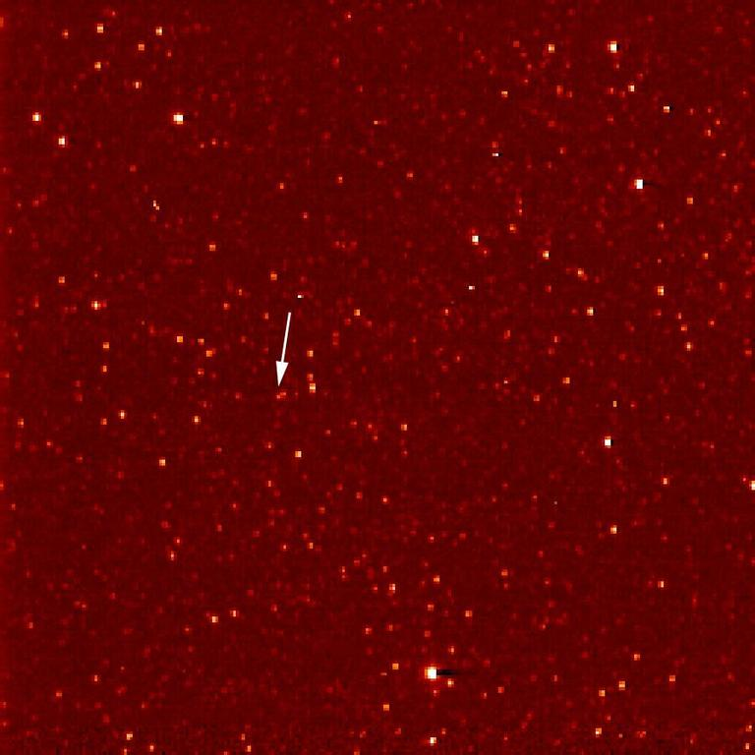A white arrow marks Pluto in this NASA New Horizons Long Range Reconnaissance Imager picture taken September 21, 2006. Pluto is little more than a faint point of light among a dense field of stars.
The International Astronomical Union voted to downgrade Pluto to dwarf planet status in August 2006. But it was a close run decision.
“At one point, it seemed pretty likely the answer was going to be Pluto stayed a planet, Eris was a planet because Eris is more massive than Pluto, and many of the other things that I had also discovered beside Eris would eventually become planets too,” Dr Brown said.
“I would then be the only living planetary discoverer. What I felt about that was fraudulent.
“The correct solution is to draw the line that should have been drawn to begin with and say there are these eight planets and all these small icy things out beyond Neptune are in a different class of objects; they were all part of the Kuiper Belt.”
REMEMBERING PLANET PLUTO
Pluto was a member of the planet club for just 76 years. It takes 248 Earth years for the planet to orbit the sun – for one Pluto year. So does Pluto’s demotion even matter?
And if Pluto doesn’t care – because it has no feelings – why should we?
Kids are now taught about the eight planets of the solar system. There are catchy songs teaching all the names. These days, the tunes end with Neptune – but kids don’t care about that, according to Dr Brown.
“It’s not the schoolkids who were mad,” he said. “It’s the adults who remember themselves as schoolkids (who were) mad. The schoolkids were delighted.
“I mean, what’s more fun than coming home from school and telling your parents what they learnt in school was wrong? Kids love that,” he told the BBC.
So how does he feel about “killing” the much-loved member of the solar system?
“It’s not even that Pluto was demoted. It’s that Pluto was finally classified correctly.”

GLOSSARY

- predate: exist or occur at an earlier date
- mythology: a collection of myths belonging to a religious or cultural tradition
- underworld: mythical home of the dead
- demotion: move to a lower position or rank
- fraudulent: unfair, unfounded; unjustifiably claiming or being credited with accomplishments

QUIZ: Write the question and Answer

- Who is credited with discovering Pluto and in what year?
- What does the name “Pluto” refer to?
- How many planets remain in our solar system and can you name the all?
- The 2005 discovery of which planet changed everything for Pluto’s planetary status?
- Which official body voted to downgrade Pluto’s status and when?
Writing Exercise:
You friend has written to you and noted that Pluto was a planet. Write them back and make the case that it would be unfair to list Pluto as a planet.

Dear Mary,
It was great to hear from you. I was surprised to read your letter in which you claimed Pluto was a planet. I disagree. ...

Global Studies: Year 7 Week 9 – Lesson 2:

Astronomy Discovery

Space Junk


Instructions:
On a blank page in your Red Book, write ‘Current Event Analysis’ at the top of a page, followed by the title of this article. Write out and answer the questions at the end of the readings.

Task 1: Go to Google and type in:

“Space Junk” by Karena Phan at TIME Kids, August 8, 2021, or you can go to the link: https://www.timeforkids.com/g56/space-junk-2/?rl=en-870

Task 2: Watch the video clip on Space Junk from Kids News:
https://www.youtube.com/watch?v=NO2DP55UjeM

Task 3: Read the article:

Space Junk

According to the Union of Concerned Scientists, there are nearly 2,800 working satellites in space. We depend on these devices for technology we use every day, such as video calls, online maps, satellite TV, and weather tracking. Scientists use them to study space and learn more about our planet. But there are many other satellites in orbit that are no longer working. They’re among the objects cluttering up space. Some of these eventually fall back toward Earth, either landing or burning up in the atmosphere. But much of this space junk circles Earth for decades.


SUPER SIZE Space junk comes in different sizes. This big chunk from a rocket fell to Earth in May.

Space junk is a problem. Debris floating around Earth puts technology and future space missions at risk. Experts are working on solutions. “We still have time to act responsibly,” Vitali Braun, an engineer at European Space Agency (ESA), told TIME for Kids.

Trash Trouble
Orbital debris, a type of space junk, is any human-made object that has stopped working but continues to float around the Earth. This includes abandoned satellites and pieces of spacecraft, such as rocket stages. “It’s a legacy problem,” Braun says. “You have a satellite or rocket stages put into space in the 1960s, and they’re still there.”
Space junk also includes fragments of objects. These occur when satellites collide with things. They also result from an object crashing into an old rocket stage that still contains fuel, causing an explosion. Braun says there have been more than 250 space explosions since the 1960s.
Below: DAMAGED The solar panel below on the Hubble Space Telescope was damaged by orbital debris.

Heather Cowardin works at NASA. She says the United States is tracking more than 23,000 pieces of space debris (see “Too Much Junk”). These tiny fragments can damage working satellites, which can affect research in space.

Cosmic Cleanup

Companies all over the world are working to clean up the area surrounding our planet. Astroscale, a company based in Japan, is one of them. It plans to launch the ELSA-d mission soon. This mission will test the concept of using magnets to collect space debris. Chris Blackerby is Astroscale’s chief operating officer.

Below: TRASH COLLECTORS Illustrations from Astroscale show the tools they hope to use to remove space junk
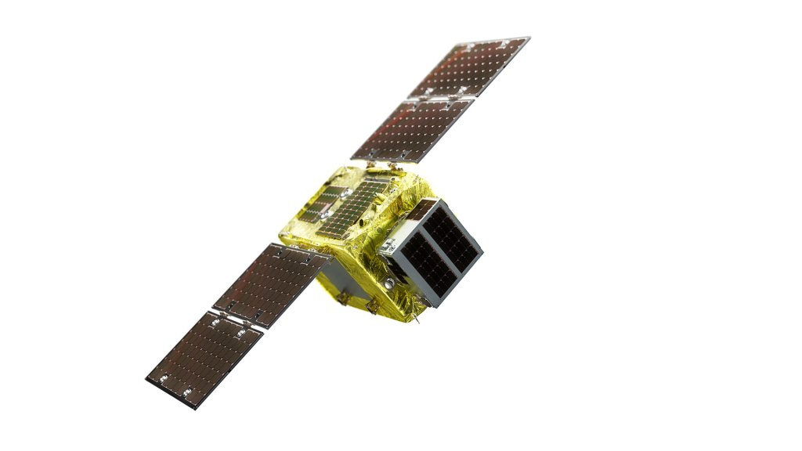

ASTROSCALE

He says the idea is to get companies to put magnetic plates on satellites before launching them. Then an Astroscale spacecraft could attach to the magnetic plate and remove nonworking satellites from space. Cleaning up space junk isn’t easy, Blackerby adds. “We’re trying to pick up a piece of trash that’s moving at 17,500 miles an hour,” he says.
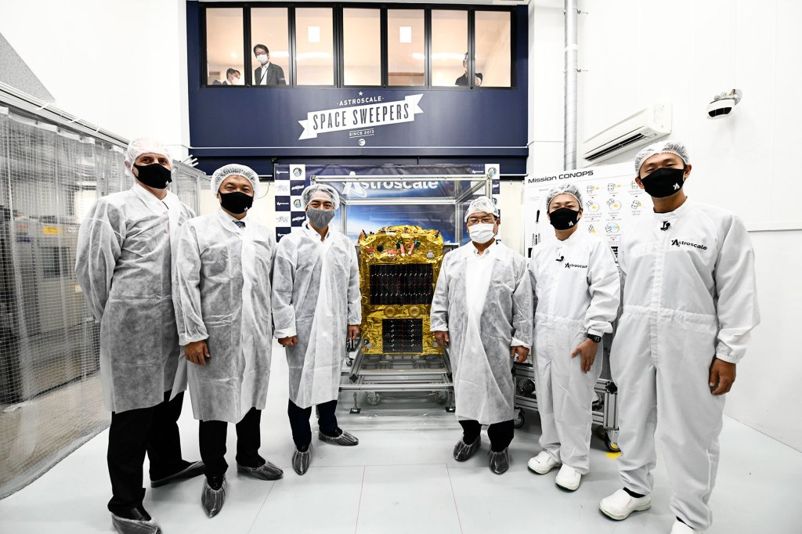
SPACE SWEEPER Astroscale and Japanese government officials pose in front of an ELSA-d satellite. It will use magnets to collect space debris.

ASTROSCALE
Another mission is led by a company based in Switzerland. It’s called ClearSpace, and its work will be supported by ESA. ClearSpace plans to launch a debris-removal spacecraft in 2025. The craft will grab a piece of an old rocket, slow it down, and eject it back to Earth. Eventually, the debris will “burn out like a shooting star,” says cofounder Luc Piguet.
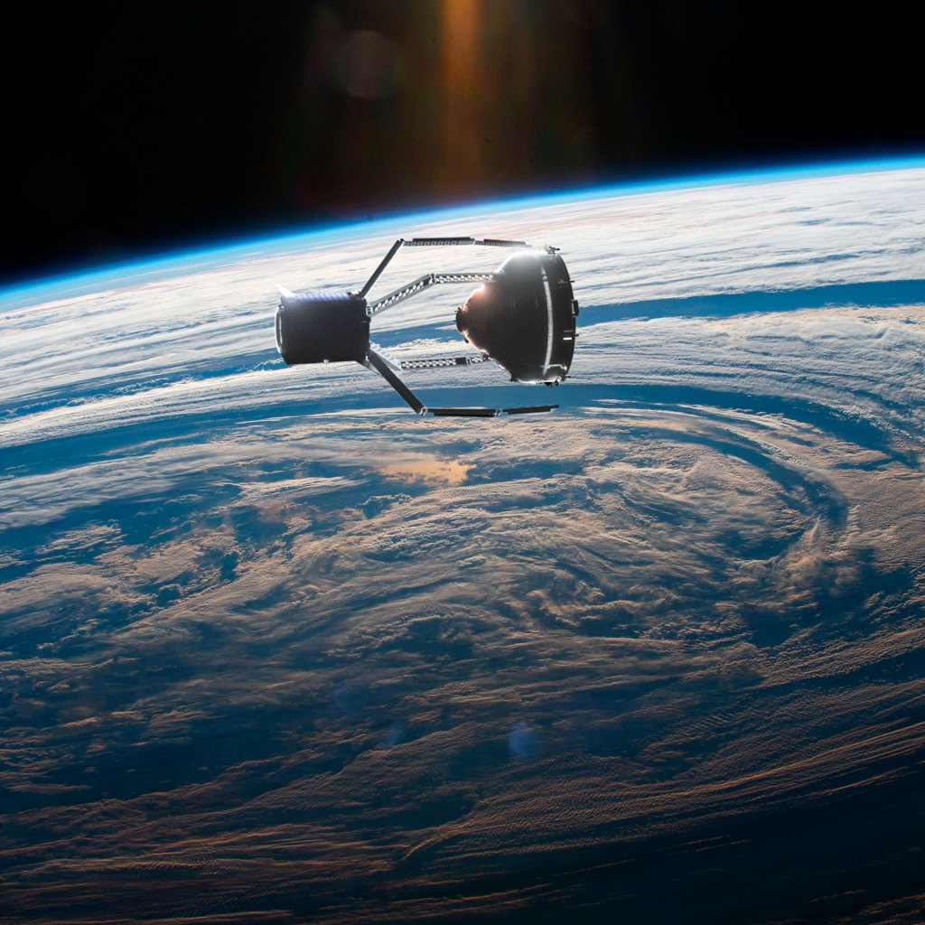
TRASH COLLECTORS Illustrations from ClearSpace show the tool they hope to use to remove space junk.

CLEARSPACE
Governments are trying to help too. Some are updating their country’s space guidelines to limit the amount of debris created. The sustainability of space “is not a single-agency or a single-country problem that we can solve,” Cowardin says. “We have to work on this together.”

Too Much Junk
Thousands of marble-size fragments and millions the size of pencil lead are orbiting Earth. That’s according to NASA’s Heather Cowardin. Some result from satellites colliding with other objects. Cowardin says fragments can travel extremely fast. And they damage working satellites. That’s why cleanup efforts are so important. This chart from ESA shows the increase in space debris over time.
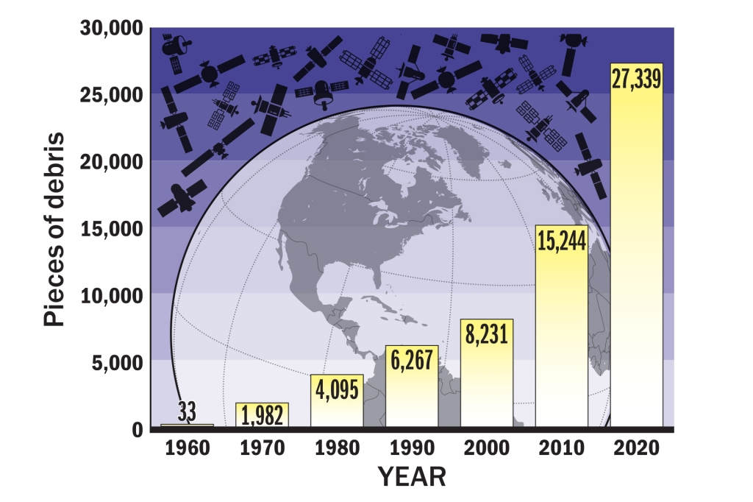

Assignment: Write a letter to a friend

1) describing how big the problem of space junk is, and
2) what government are doing to try and solve it.

