Week 7 Lesson 1

Sputnik’s Launch Begins the Space Race to the Moon

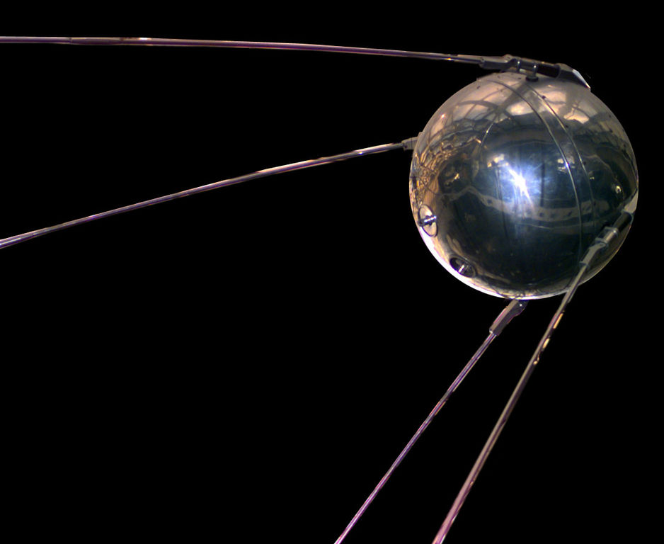

Success Criteria: Students will become familiar with the basic story of the space race between Russia and the United States and be able to describe the fear it created.

What was the space race?

Task 1: In your Red Book write ‘Week 7 Lesson 1.’

Underneath this, write the following summary in your Red Book under the heading – ‘The Space Race.’

The Space Race was a race between the United States and the Soviet Union to see which country would be the first to reach the moon – and control space. The Soviets started it by being the first country to launch a satellite into space. It was called Sputnik. The United States was the first to reach the moon in July 1969.
*The Soviet Union is now smaller in size and is called Russia.

Task 2: Write down the following definitions:

1. Satellite – an object that is sent into space to orbit the earth.

2. Orbit – to travel around a planet, Moon, or sun.

3. Spacecraft – a vehicle that can go into outer space

Task 3: Write down the following 3 questions in your Red Book under the title page, ‘The Space Race.’

1. How did Americans react to the launch of Sputnik 1 and Sputnik 2?

2. How did school students prepare for a possible nuclear attack?

3. Do you think that many people still live with the fear that someday there might be a nuclear attack somewhere in the world?

Next click into the video:
‘Sputnik’s Launch Begins the Space Race.’
https://www.pbslearningmedia.org/resource/amex31ctm-soc-sputnikspacerace/sputniks-launch-begins-the-space-race/

Do not take notes – just watch it from start to finish, then answer the questions.

Homework: Make sure your books are up to date.

Week 7, Lessons 2 & 3

Laika: The First Dog in Space

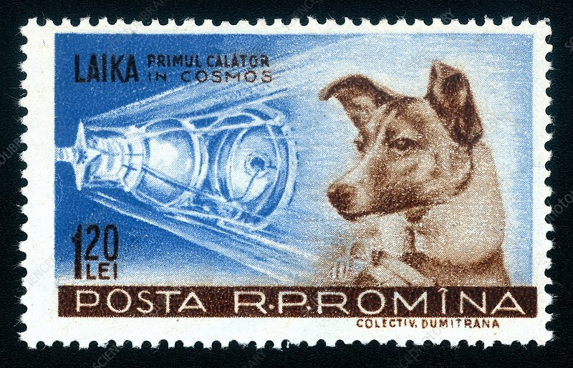

Task: Watch the video “Laika: The Little Astronaut Dog.”
https://www.youtube.com/watch?v=9rf6ai59OA4
(it is a great video that is aimed at Year 7’s)

Next, go online and look up information on Laika. A biography is a story the describes the key points in a person’s life. Write a biography of Laika’s life. It should have 3 sections that are at least one paragraph long.

Section 1. Describe Laika’s Life before going into Space.

Section 2. What happened during the Space Mission?

Section 3. What was the reaction when people learned how Laika
had Died?

Your biography should also include
a) a catchy title
b) at least one image and caption (words that describe what the image is)
c) while it is not necessary, if you can try to include mini-headings for each section

