Week 8

Mātauranga Māori:

New Zealand’s First Matariki Public Holiday

In Māori culture, Matariki is both the name of the Pleiades star cluster and of the celebration of its first rising in late June or early July. This marks the beginning of the new year in the Māori lunar calendar. It will be celebrated on Friday June 24th – hence there will no school on that day.

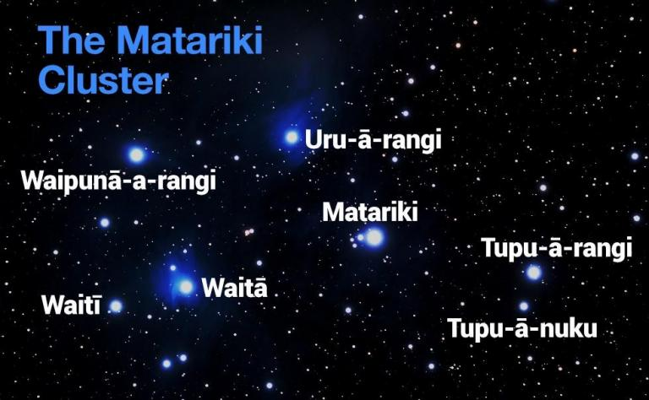

Success criteria:
At the end of this week, students will have a thorough familiarity with the many events that are being held across the greater Auckland region that will be conducted in celebration of the Matariki holiday.

Task: I want you to create a brochure in your Red Books that describes, in alphabetical order, the many Matariki-related events that will be held across Auckland and their significance.

The PURPOSE of the brochure it to get people excited to attend these events. It will include the following:

1. Begin with a catchy title designed to attract attention and get people to read your brochure.

2. Include at least 2 images with captions that relate to the events.
AND explain what the Matiriki is.

3. List several different events

4. Describe when and where they are being held

3. What is the significance and meaning of each event in Māori culture.

Your brochure can be made over 2-3 pages in your Red Book or on a word file.

