Year 7 Global Studies
Reading and Questions
Week 8
Lessons 1-3
The 1938 Martian Invasion Scare:
A Lesson in Critical Thinking

Would you have been Fooled?

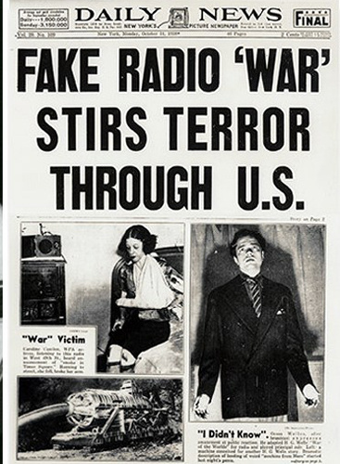
This lesson is about a how a radio play airing in 1938, frightened many Americans into believing that the world was being invaded by Martians! It is a study in critical thinking. There were several different actions that listeners could have done to quickly figure out that the broadcast was fake. How did it happen? Could it happen again? Could such a scare ever occur in New Zealand? This lesson will help to answer these and other questions.

Success criteria: Students will be able to critically evaluate information that is presented by media outlets and will be able to identify key factors that determine whether or not a particular source is credible and the event in question actually happened or not.

Activities: 1. Reading. 2. Writing. 3. Listening.

Task 1: Watch the video clip – from Kid History to get a feel for how the scare happened.
Write the questions and answers in your Red Books. Here is the clip:
https://www.youtube.com/watch?v=dVq2SQIwz5s

1. What were at least two ways that some listeners could have found out if the broadcast was
a play?

Answer: By tuning into other channels or looking at the radio schedule in the paper.

2. How many times during the play were listeners warned it was fictional?

3. How did the Edgar Bergen and Charlie McCarthy Show play a key part in triggering the
broadcast?

4. Of those listening to the drama, how many tuned in late?

5. List at least two ways that people's minds played tricks on them?

6. How many people are thought to have heard the broadcast? Of these, how many
believed it was real?

7. Why did newspapers likely hype the extent of the scare?

8. How did the events going on in Europe at the time, lead many to think the broadcast was
real?

9. Do you believe that a similar scare could take place today, or are people less likely to be
fooled? Explain.

Task 2: The Reading and Questions

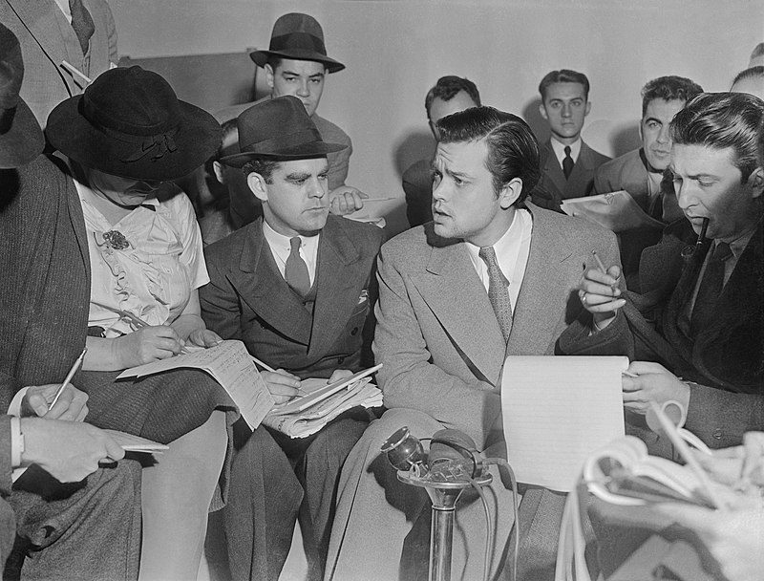
The morning after the radio scare, Orson Welles talks to the media.
On Sunday evening October 30, 1938, Orson Welles was with a small group of actors and musicians in a New York City studio of CBS Radio’s ‘Mercury Theatre of the Air.’ They were getting ready to present a recreation of the famous 1898 book, The War of the Worlds by British science fiction writer H.G. Wells. The book told of a Martian invasion of earth.

After 20 seconds of live music, Welles was introduced: "Ladies and gentlemen: the director of the Mercury Theatre and star of these broadcasts, Orson Welles." After about a minute, Welles finished reading his opening lines and the drama then gave the appearance of being a radio program of the 1930s. A weather forecast was read, then an announcer said: "We now take you to the Hotel Park Plaza in downtown New York, where you will be entertained by Ramon Raquello and his orchestra." Then, the first hint of trouble. "Ladies and gentlemen, we interrupt our program...to bring you a special bulletin. At twenty minutes before eight, central time, Professor Farrell of the Mount Jennings Observatory, reported observing several explosions of gas on the planet Mars."

The music continued to be interrupted with special bulletins describing what were at first, 'explosions' on Mars followed by a 'meteor' crashing near Grovers Mill, a tiny town in the state of New Jersey. Later on the announcer came on: "Ladies and gentlemen, here is the latest bulletin from the Intercontinental Radio News ... a special announcement from Trenton, New Jersey. It is reported that a 8:50 p.m., a huge flaming object, believed to be a meteorite, fell on a farm in Grover's Mill, New Jersey...”

'Live' bulletins from the scene followed. The 'meteor' was later identified as a "metal cylinder" that, before the announcer's eyes, sprouted legs and towered into the air. The cylinder contained beings from Mars who opened fire with "death rays”.

Reporter: "A humped shape is rising out of the pit. I can make out a small beam of light against a mirror. What's that? There's a jet of flame springing from that mirror, and it leaps right at the advancing men. It strikes them head on! Good Lord, they're turning into flame!" Shortly after, dead silence and a grave announcement:

"Ladies and gentlemen, I have just been handed a message... At least forty people, including six State Troopers, lie dead in a field east of the village of Grovers Mill, their bodies burned and distorted beyond all recognition." From this point on, the drama gradually grew more unrealistic, yet many people were no longer listening or not listening that closely as they were so frightened. Later the announcer describes the Martian machines marching towards New York City: "All communication with Jersey shore closed ... army wiped out..." Soon a voice was heard saying: "I've just been handed a bulletin. Cylinders from Mars are falling all over the country. One outside Buffalo, one in Chicago, St. Louis..."

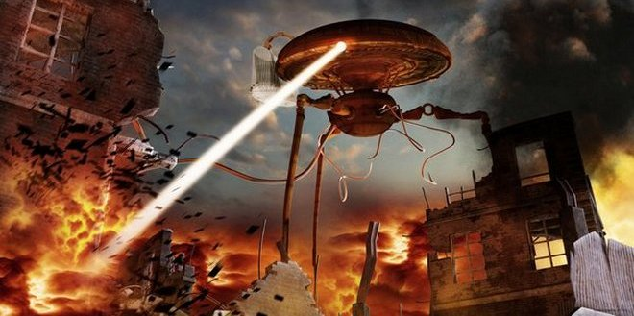

An artist’s interpretation of the ‘attack’ as described in the radio play.

The Timing
The drama appeared in newspaper schedules on the day of the broadcast and was clearly identified as a play. The brief opening announcement clearly states that it was a radio play, but it was common for listeners to miss the first couple of minutes as they shifted dials from other programs. Also, in 1938, there were many live radio shows, and they always didn't end exactly on time.

Three other times during the play listeners were reminded that it was a play, but these came much deeper into the program, starting at the 42-minute mark. A key point came at about eleven minutes and ten seconds into the drama. The most popular program on the air at that time was the Edgar Bergen and Charlie McCarthy Show. The show had great ratings as each week Edgar Bergman would come on and tell jokes. They would open with about 12 minutes of comedy, followed by a singer.

Listeners commonly tuned back and forth between radio programs, especially near the beginning or during slow periods. The practice was so common that it even had a name – 'airplaning' – the modern-day equivalent of 'surfing' with a TV channel changer. In 1937, Welles and actor John Houseman founded the Mercury Theatre. His radio show by the same name began in September 1938, but it didn’t have a lot of listeners. Each week Welles had a small window of opportunity to hook listeners. Historian Barbara Leaming writes: "Each week their one big chance to attract listeners came when Edgar Bergen introduced a guest performer. At that moment, if the performer was not especially good, people across America would quickly turn the dial to hear what else was on the radio before switching back..." Welles planned his script to include live dance music interrupted by special bulletins, in order to grab listeners, especially those switching channels. Leaming suggests that Welles had used the technique to scare some listeners but that it worked beyond his wildest dreams. Of those who began to surf the dial for more interesting programs, about 12 percent of Bergen's audience stopped at one of the over 150 stations that were broadcasting the Mercury Theatre. In fact, two separate surveys estimated that roughly 50% of listeners to the Welles drama, tuned in late, missing the opening disclaimer (a statement that said the broadcast was a play and not true), many believing it was a live news report.

Welles wanted to boost his small audience and thought that some listeners would panic but did not realize so many would think it was real. This view is supported by earlier versions of the script which was toned down from the broadcast. Prior to its airing, CBS radio said the script sounded too real and made 28 changes. The working script had such phrases as "New Jersey National Guard," "Princeton University Observatory," "Langley Field," and "Magill University," which were changed to "state militia," "Princeton Observatory," "Langham Field," and "Macmillian University."

The Impact
The center of fear was in the tiny town of Grovers Mill which became gridlocked with cars as thrill-seekers and rescuers were trying to reach the 'crash' site; others were trying to drive away. At Grovers Mill, hundreds of people arrived. Many searched for the imaginary Wilmuth farm, and instead went the Wilson farm, assuming the reporter was mistaken. In one block of houses in Newark, New Jersey, over twenty families fled their homes, covering their faces with wet cloths and draping towels over their heads to protect themselves from the 'poison gas.' Phone lines were jammed as police were swamped by frantic residents desperate for information on the 'gas raids from Mars.' At one newspaper office, 875 phone calls were received. At one New York City Police Headquarters, they could not keep up with calls. Upon hearing the early reports of a large meteor impact nearby, two Princeton University geologists (people who study rocks) even rushed to the impact site, only to find others like themselves, searching in for the object.

A New Jersey police officer wrote the following description of the panic in his police report:

"Between 8:30pm and 10pm received numerous phone calls as result of WABC broadcast this evening re: Mars attacking this country. Calls included papers, police departments including N.Y.C. and private persons. No record kept of some due to working teletype and all thru extensions ringing at same time. At least 50 calls were answered. Persons calling inquiring as to meteors, number of persons killed, gas attack, militia being called out, and fires. All were advised nothing unusual had occurred and that rumors were due to a radio play.”

Peoples’ minds also played tricks on them. One person became convinced that they could smell the poison gas; others reported that they could feel the heat rays as described on the radio; another became upset and felt a choking sensation from the imaginary gas. In Hamilton, New Jersey, a frantic woman told police she had stuffed wet papers and rags into all of the openings of her doors and windows, but the fumes were already seeping in.

Why it was Exaggerated?
Many experts believe that the panic as described by Princeton University psychologist Hadley Cantril in his book The Invasion from Mars, was exaggerated. But regardless of the extent of the panic, there is little doubt that many Americans were frightened and some did try to flee. Cantril calculated that at least 6 million people heard the drama, 1.7 million of which believed they were hearing a news bulletin, of which 1.2 million became excited. While there are some claims that hundreds of thousands panicked, there is not much evidence to suggest that many listeners took some action after hearing the broadcast, such as packing belongings, grabbing guns or fleeing in motor vehicles. In fact, much of Cantril's study was based on interviews with just 135 people. William Bainbridge is critical of Cantril for citing just a few colourful stories from a small number of people who panicked. According to Bainbridge, on any given night, out of a pool of over a million people, at least a thousand would have been driving fast or engaging in bad behaviour.

The News Media in 1938
In 1938, newspapers and magazines saw radio as a threat to the money they got from advertising. This may have given reporters a reason to make the panic look worse than it was. Newspaper editors opinion columns were mostly negative of Welles.

At the time of the broadcast, most Americans listened to radio for news. The global situation was tense with Adolf Hitler continuing his invasion of Europe. With each passing day, Europe was slipping closer to a Second World War which would soon involve the United States. Listeners were used to news bulletins interrupting regular programming with live reports from war reporters. At the time, rapid progress in airplane technology was quickly 'shrinking' the world. The US would soon no longer able to isolate itself, and it was well known that there was no coherent civil defense system against an aerial attack. With each passing day Americans listened to broadcasts of the widening war in Europe. It was within this context that the Welles drama would have appeared to have been real.

Week 8 Lesson 3

The Strange Case of Frederick Valentich:

Was an Australian Pilot Kidnapped by a UFO?

A Lesson in Critical Thinking

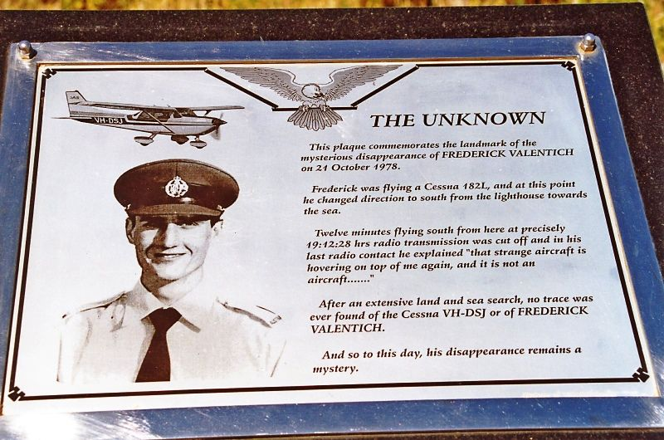
The plaque above discusses the disappearance of Frederick Valentich. On the evening of October 21, 1978, the 20-year-old Australian pilot disappeared over Bass Strait, while flying from Melbourne, Australia to King Island. His airplane had been refuelled to capacity, enough for five hour of flying. At 1819 hours (6:19 pm) local time after he had obtained a weather briefing and set off. After take-off Valentich established radio contact with Melbourne Flight Service. At 1900 hours local time (7 pm) Valentich radioed that he had Cape Otway in sight. According to the weather station, the weather in the Cape Otway area was clear, there was excellent visibility, and light winds.
The pilot contacted the Melbourne Flight Station and reported that a UFO was following him. One of the last things Frederick said was: "Melbourne, that strange craft is hovering on top of me again...It`s hovering and it`s not an aircraft!
Task 1: Watch the video Video – ‘The Valentich Story.’ (13:46 sec). It can be found at: https://vimeo.com/101901539
Task 2: Write a summary of the evidence that Valentich was NOT kidnapped by a UFO. You can do it the form of a paragraph or key dot-points
Extension Exercise (optional – if you have the time).
Write a summary of a Current Event that has appeared in the New Zealand Herald within the past week. Be sure to include who, what, where, when, and why.

