Mātauranga Māori

Ancient Food Cooking Techniques

Year 8 - Week 7

The Māori Hangi

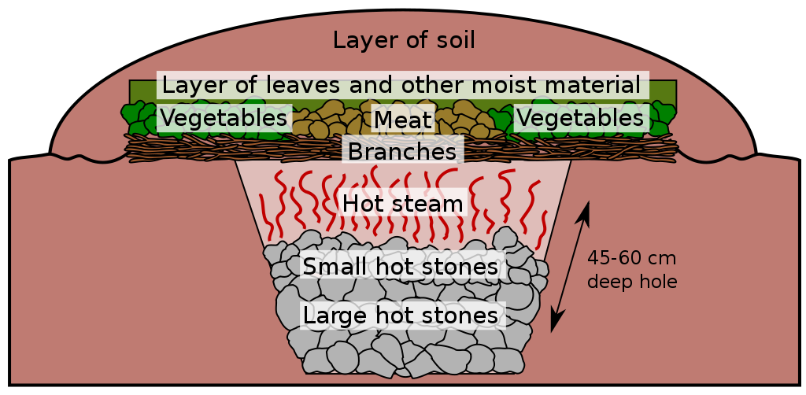
Success Criteria: Students will gain an understanding of the Māori Hangi – a method of cooking food using heated rocks buried in an oven pit. Students will be able to describe the various steps involved in constructing a hangi – from shoveling the hole to eating the food.

Task 1: Watch the video on the creation of a Hangi at Tinwald High School in New Zealand.

https://www.youtube.com/watch?v=K6-AT7DZpvQ

(Do not watch the entire video - stop at the 7:50 sec. mark).

1. What people are not allowed to be near the Hangi fire? Why?

2. What type of rocks are used to heat the Hangi? Why?

3. How long are the rocks heated for before they place them into the pit?

4. Once placed into the pit with the food, how long does it take to cook?
Task 2: Read the article on the cultural significance of a Hangi for Maori people, “Traditional hangi more than a Maori meal’ by Robert Virtue of ABC News Australia. Create key dot-points on the main messages in the article.

https://www.abc.net.au/local/stories/2015/03/30/4207394.htm

Here is the full article below:

1 April, 2015 1:26PM AEDT

Traditional hangi more than a Maori meal
By Robert Virtue

The Newcastle Maori Club says cooking meat and vegetables in a hole in the ground is more than just a cultural ritual; it's an integral bonding moment for communities.
Australia may have beaten New Zealand in the cricket World Cup final, but the connection between the two countries extends far beyond the sporting field.
From fighting together in wars under the Anzac name, to sharing close political and economic ties, the nations have long been considered allies and friendly rivals.
In the NSW Hunter region, an active community of New Zealand ex-pats gather at the Newcastle Maori Club.
They meet regularly to discuss and practise aspects of their culture, including the art of cooking a traditional hangi.

What makes a good hangi?

A hangi is a method of cooking used by the Maoris to steam vegetables and meat, by placing it in the ground on top of hot rocks, and covering it.
"You can cook a hangi for as little as 30 people, to as many as 3,000 people," said the President of the Newcastle Maori Club, Richard Eriwata.
Richard said the process of creating a successful hangi is reliant on a number of factors.
Firstly, a hole of up to 300mm in depth is dug.
A fire is then started in the hole, and river rocks are placed on top of its coals.
"The idea is to turn those rocks white hot, and so we need a lot of timber to be able to get that heat generated," said Richard.
"It usually takes about four hours to do that."
Once the rocks are hot, the vegetables and meat should be prepared.
"Then, it's just a simple matter of putting the food into baskets, and then we put a clean cloth over the top to keep it nice and clean," said Richard.
"The reason why timing is critical is that we've got to put the hangi into the hole while the rocks are really hot."
Water is then poured over the rocks to create steam, which is trapped after the food baskets have been covered in sacks and dirt has been placed on top.
The food in the hangi usually needs up to three-and-a-half hours to cook before it is ready.
Richard said a leader tests some of the food and makes the final decision on whether it is ready.
"Inside the hangi is the secret," he said.
"[The food is] then placed on a big table where you've got six to 10 guys waiting for it with a knife each to carve it up."

The taste

Richard Eriwata said there's no taste like a hangi taste.
It is entirely unique - earthy and hearty, with a pungent scent.
"It's nothing like KFC or McDonald's or anything like that," he said.
"This is something that is absolutely unique to our Maori culture.
"It's all in the process of what you use to heat the rocks; that's where the taste lies."

Importance to Maori culture

To create a hangi is a team effort.
It draws the community together as they prepare, cook and eat the meal.
"It's a group thing, it's a family thing, and it's a tribal thing. We connect," said Richard.
"It's part of who we are as a people, and the best way to get to know each other and to build on our cultural values and heritage."
Richard said coming together as a community is integral in Maori culture.
"That keeps who we are as a people together; it builds strength in our young men - because they know who they are and where they come from."

Educating the Hunter community

The Newcastle Maori Club isn't exclusively for New Zealanders. It's a group intent on sharing their culture with the broader population.
"A lot of Maori have integrated. We have this friendly rivalry between Australia and New Zealand, [but] we love Australia and we love Australians. Together it's quite easy to connect," said Richard.
"We fought on the battlefields and died in the trenches together.
"We've got a great history together, and we've got a lot to offer our non-Maori friends. We've got a place for them to come to feel a part of something."

## End of Story ##

Week 7: Lesson 2 & 3 –

The Māori Hangi Poster



In the near future, Mission Heights Junior College is going to participate in a hangi. Students will be able to watch how it is made and eat the food. Either in a word file or over 2 blank pages in your book, create a poster that is designed to get students excited about this event. Include –

1) A catchy title that captures student interest

2) At least 2 images with captions (words describing what is in the image)

3) Describe what a hangi is

4) Describe what foods are cooked in it, and

5) List and explain the key steps involved in making a hangi from start to
finish.

