Mātauranga Māori

Week 6: Lessons 1 & 2 –
Listening to Māori Ancestors –
How a Maori Man Changed his Life
by Changing his Relationship with Food

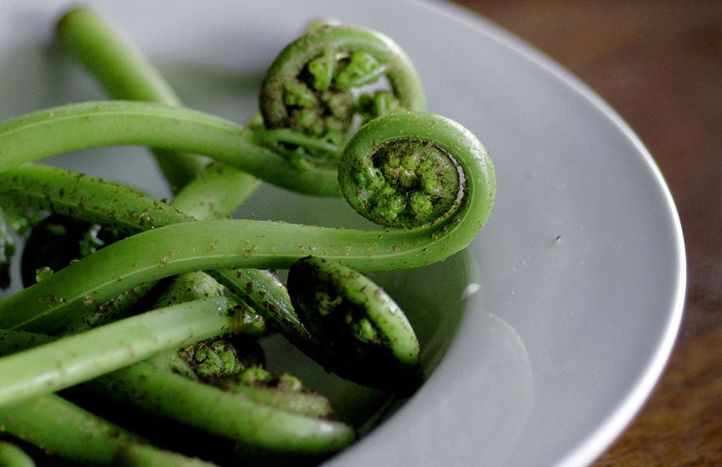

Success Criteria

Students will gain a better understanding of traditional Māori foods, how Māori view food, and the best times to eat and to fast according to Maori tradition.

Lesson 1, Task 1: Watch the video – ‘TUPUNA KAI: A Māori diet based on what ancestors ate.’
https://www.youtube.com/watch?v=ziCKhZRqHXk

This video shows how a Maori man who was overweight and searching for meaning in his life, lost weight and changed his life by turning to traditional Māori kai (food).

1. What plants did he find in the forest to eat?

2. What fruits did he eat?

3. What does he believe you should do during a full moon?

4. What does he do when there is very little moon (‘the moon is dark’)?

Class Discussion: The man in the video talks about fasting. Go online and look up which major religions engage in fasting. Name the religions. When do they fast? Why? Look up the health benefits of fasting. Many doctors believe that there are several benefits. Name some.
Week 6: Lesson 2 – A Look at
Traditional Māori Kai (Food) Tourism

Success Criteria

Students will gain an understanding of how traditional Māori would forage for food and how elders are attempting to keep the ancient traditions alive by foraging for traditional foods so the knowledge does not become lost.

Task 1: Watch the video on Māori Food Tourism

https://www.youtube.com/watch?v=B8sKQeLmax0

(12:07 sec.)

1. Look up the definition of the word ‘foraging.’ What is it and what are some of the foods that they forage for? The words of the plants they gather are shown on the video and what they are used for, what are its qualities (e.g., taste, colour), and how is it beneficial for your health?

2. Kawakawa

3. Why do they harvest the Kawakawa on the north side of the tree?

4. Pirita vine:

5. Piko Piko:

6. Ear Mushroom:

7. Puti Puti:

8. White bait:

9. Kamo Kamo

10. What do they do to sweeten the salmon?

11. Koa Koa Pavolva

Homework: What you do not complete in class is homework.

