Year 7 – Week 6 Lessons 1 & 2
Mātauranga Māori and Astronomy

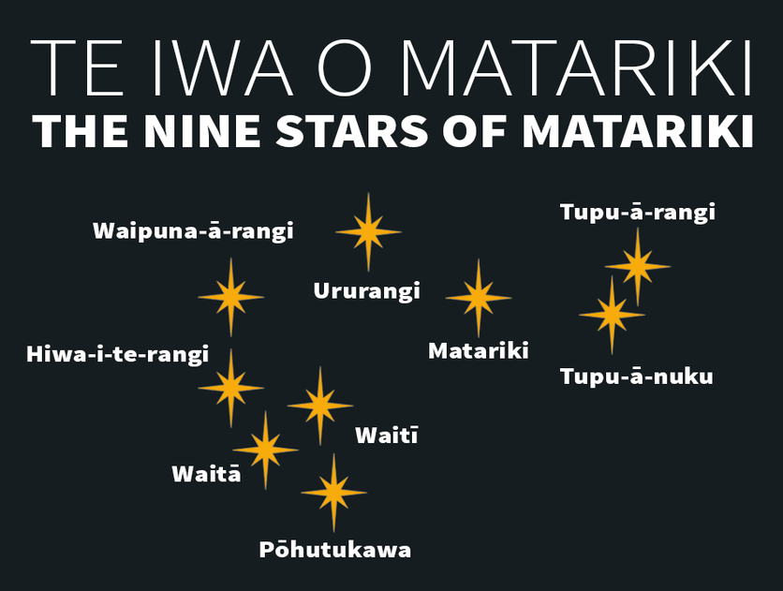

Success Criteria:
At the end of this week, students will have a basic understanding of Mātauranga Māori (Māori knowledge) in relation to astronomy, and how Māori used the stars to navigate the ocean, plant crops by season of the year, harvest kaimoana, and to tell the time.

Māori Astronomy
Task 1: In you Red Book, at the top of a blank page write Week 6, Lesson 1, the date, and the heading ‘Māori astronomy.’

Task 1b: In your Red Books write down the following definitions of the words below. The first word has already been done – please write it into your book (the word followed by the definition).

1. dense: compacted and close together.
2. Tāne
3. ethnographer
4. compass
5. align
6. waiata
7. rākaunui
8. kaumatua
9. revitalize
10. Matariki
11. narrative
12. kōrero

Task 2: Next go to the website: ‘‘Revitalising Māori astronomy’ at:
https://www.sciencelearn.org.nz/resources/1274-revitalising-maori-astronomy

Watch the documentary, ‘Rākaunui, full Moon, Garden Today but don’t Fish,’
and answer the following questions in your Red Books. So, you will write out the question, then give the answer. You can reword the question to make it shorter.

1. How were the stars important for Māori life and how is it related to Māori Whakapapa? (the answer can be found at the 4:45-second mark)

2. Where do Māori believe they originally came from?

3. Much of Māori astronomical knowledge – tātai arorangi started to be lost after the early Europeans arrived in New Zealand. Why? (7:00 sec. mark).

4. Some people look down on Māori stories as being silly. Why is this wrong? (8:00 sec. mark)

5. How is the ‘SMART group’ trying to save the history of Tātai arorangi (9:00 sec.).

6. What are some of the uses of astronomy in Māori life (13:25 sec mark).

7. The Māori used the stars to tells the season and time? How could they tell when it was Winter (13:40 sec.)?

8. What star did they look for to tell it was Summer?

9. The Matariki was important because each year when it appeared it ________ the Māori calendar.

10. Māori have a big connection with planting and harvesting crops. When there was a full moon, crops were thought to grow better (16:15 sec.). How did they believe this happened?

11. How were the stars important in navigating? (17:25)

12. Navigators used a ________ compass to navigate

Homework: Make sure Lessons 1 & 2 are completed and your Red Books are up-to-date.

