Week 5 Global Studies

Pressure to Conform



Two Famous Studies and What they Mean for Teenagers
and Obedience to Authority

Success Criteria
Students will become familiar with two well-known studies in the history of the psychology of conformity – the Hofling Experiment and the Bickman study and the factors involved in why people are vulnerable to peer pressure or the pressure to conform brought on by the power of the situation.

This week’s Lessons:

Lesson 1. Current Events Analysis on the threat to New Zealand from Feral Cats

Lesson 2. Obedience and Conformity – the Bickman Study

Lesson 3. The Hofling Experiment

Week 5, Lesson 1

Current Event Analysis:
New Zealand’s Great Cat Debate

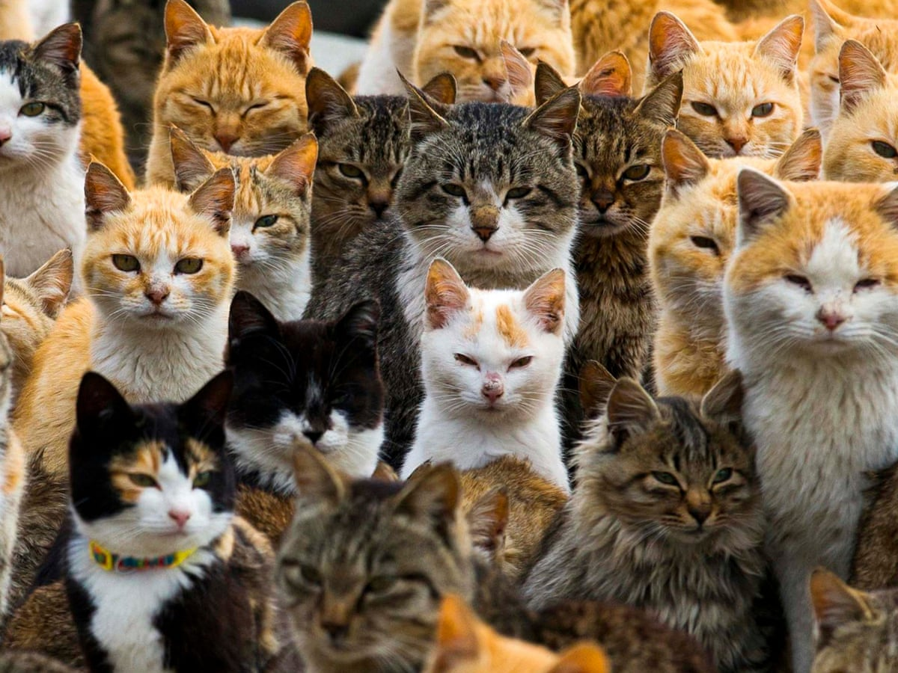
Our first lesson of the week will be a current event analysis on the debate in New Zealand over the issue of cats as they do a lot of damage to native birds each year. Some people think that all cats should be banned from leaving their owner’s yard. Others think cats should be banned altogether.

Task 1: In your Red Books, write down and look up the definitions for the following words. Be sure to leave 2 or 3 spaces between words so you have plenty of room for the definition.

1. domestic cat

2. feral cat

3. extinction

4. ambitious

5. regulation

6. dotterels

7. furore

8. philanthropist

Task 2: Read the article below by Samantha Hayes, The Guardian, April 22, 2022, ‘New Zealand’s cats are decimating native wildlife – should they be treated as pests?’ at: https://www.theguardian.com/world/2022/apr/07/new-zealands-cats-are-decimating-native-wildlife-should-they-be-treated-as-pests.

Answer the following questions. In writing out he questions in your books, you may reword it in order to make it shorter.

1. Name several actions that the Australian Government has already taken to try and control feral cats?

2. How have feral cats impacted on the adult kea?

3. Why are New Zealand’s native birds, insects, lizards and bats defenceless against predators such as cats?

4. In 2013, Gareth Morgan introduced a plan to get rid of all cats. What was the reaction?

5. What is the plan that Jessi Morgan, CEO of Predator Free NZ, would like to see in New Zealand?

Task 3: In a paragraph, explain your position on whether Kiwis should have to keep all cats fenced in near your homes?

Week 5 Lesson 2:

Obedience to Authority



Psychologist Leonard Bickman investigated the effect of situational factors on the likelihood of obedience – specifically with regards to clothing worn by a person. He conducted a field experiment in Brooklyn, New York, using people walking on a street. He found that wearing a uniform gives authority a greater power to influence people's behaviour than not wearing a uniform. However, to affect levels of obedience, the uniform has to reflect a high degree of social power.

Task 1: Watch the video clip ‘Obedience: Obeying a man in uniform.’ It is narrated by Phillip Zimbardo, the former head of the American Psychological Association. https://www.youtube.com/watch?v=16QMQXIjYVU (4:22 Sec.)

Class Discussion: How surprised were you at how readily people were willing to obey another person based solely in what they were wearing? Do you think that you would have obeyed?
Task 2: Now watch the second clip: How obedient are you?
https://www.youtube.com/watch?v=4jcleVvgchs (3:50 sec.)

Task 3: Read the article, ‘How Obedient are You’ by Radhika Sanghani from the BBC, 16 November 2017.

Write key dot-points about article and what they experiment shows.

Week 5 Lesson 3

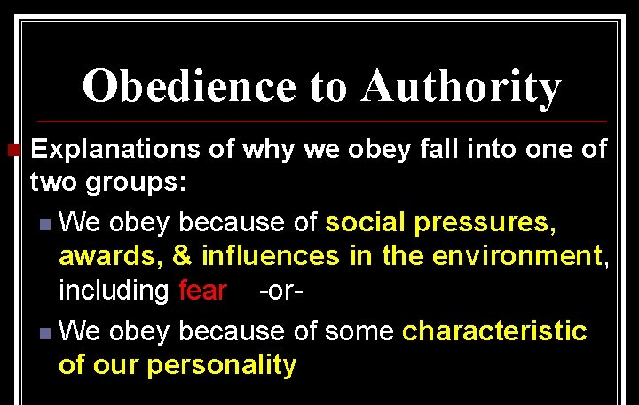

In 1966, psychiatrist Charles Hofling created a more realistic study of obedience than Milgram’s electric shock study by carrying out field studies on nurses who were unaware that they were involved in an experiment. In the natural hospital setting, nurses were ordered by unknown doctors to administer what could have been a dangerous dose of a drug to their patients. What would you have done?

Task 1: Watch the clip on the Hofling study:
https://www.youtube.com/watch?v=CDGZ9Ky4O8I (5:25 sec.)

Task 2: Read ‘The Hofling Nurse Study’ (February 2022) at: https://practicalpie.com/the-hofling-nurse-study/

In your Red Books, write down and answer the following questions that appear under the follow sections of the reading:
https://www.bbc.co.uk/bbcthree/article/098290e8-e675-444e-85b1-934ca9ae6c72
You do not need to write down the headings, just the questions and responses.

What Is the Hofling Nurse Study?
1. What experiment was Hofling trying to replicate?

How Did the Hofling Nurse Study Work?
2. What was Astroten?
3. How many people were involved in the study? What was their job?
4. What was written on the drug container?
5. What were the many reasons that the nurses should have declined the request to give out the drug?

The Results of the Hofling Hospital Study
6. How many nurses complied with the request?
7. In what way did these results parallel the findings of Stanley Milgram?

