Week 4 Lesson 1

Teenagers and the Power of the Group



Success Criteria
Group dynamics (peer influence) is one of the most powerful forces in human psychology. Students will gain an understanding of key findings from two key studies that look at the influence of peers on individual behaviour. Students will be be able to summarize the research conducted by Solomon Asch and Stanley Milgram. If you go to university and take a class in law, psychology or sociology – you will come across these studies.

Task 1: In your Red Books write down Week 4 Lesson 1 – The Power of the Group to Influence Teenagers.’ Next write down the 7 questions below in your books, then watch the clips and write out your responses. You may reword the question to make it shorter.

Task 2: Watch the clips: Go to https://www.youtube.com/watch?v=BOBhKR4MK3w (3:38 sec.) and watch the video clip, ‘Brain Games - Asch Line Study.’ In your Red Book, write down each question followed by the answer. You may reword the question to make it shorter.

Now watch the second clip:

https://www.youtube.com/watch?v=iRh5qy09nNw (1:57 sec.)

1. When a study subject was alone and asked to judge the length of the lines, how often did they get the answer wrong? (3:40 sec. mark)

2. How often did they get the answer wrong at least once? (3:50 sec. mark)

3. How often did they get the answer wrong every time the group did? (3:55 sec. mark)

4. In the study they made use of a confederate. What does this term refer to? (4:15 sec. mark)

5. When interviewed, what did most people who went along with the group, say why they had done it? (5-minute mark)

6. What is normative social influence? (5:30 sec. mark)

7. What is informational social influence? (6:50 sec.)

Class discussion: How do you think you would have responded? What does this study tell us about conformity?

Homework
Complete today’s tasks and make sure your Red Book is up to date.

Week 4 Lesson 2:

The Milgram Experiment:
How Far Would You Go to Please Someone?



Task 1: In your Red Books write down ‘Week 4 Lesson 2 – The Milgram Experiment.’ Next write down the 6 questions at the end of this lesson into your books, then watch the clips and write out your responses. You may reword the question to make it shorter.

Video Clip: Watch the video clip on the Stanley Milgram Experiment at:
https://www.youtube.com/watch?v=fCVlI-_4GZQ (9:53 Sec.)

This clip will give you a broad understanding of the Milgram experiment.

Class Discussion: How do you think you would have fared in the experiment? What does it tell us about conformity and the capacity for people to engage in what they believe to be dangerous acts?

Task 2: Reading. Read ‘What Was the Milgram Experiment?’ at: https://www.verywellmind.com/the-milgram-obedience-experiment-2795243

Based on the reading, answer the following questions –

1. Why did Milgram conduct his experiment?

2. How were the people who took part in the experiment recruited?

3. Summarize the results of the experiment.

4. What factors were found to influence obedience?

5. What ethical concerns do some people have with conducting the experiment?

6. Under the section, ‘Impact of the Milgram Experiment,’ write a summary of the key findings.

Homework
Complete today’s tasks and make sure your Red Book is up to date.

Week 4 Lesson 3
Current Event Analysis –

Captain Cook was not the First European
to Set Foot in New Zealand
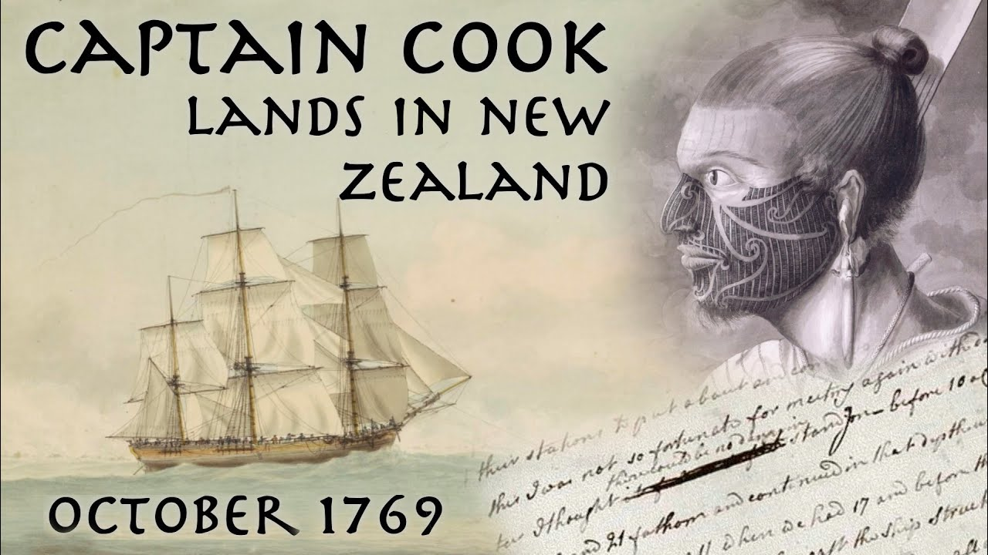
While Maori were the first humans to settle the land now known as New Zealand, it has been widely taught in textbooks that James Cook was the first European to set foot here. This now appears to be untrue with the discovery of a human skull of European origin that is older than Cook’s arrival. This finding was first reported 14 years. Let’s go back and look at the report.

Task 1: Read the article below (Read the article – ‘Skull has experts asking how European landed in NZ before Cook,’ By Paul Chapman in Wellington, Sydney Morning Herald, August 7, 2008). Next, write out and answer the questions in your Red Books.

Skull has experts asking how European landed in NZ before Cook
THE discovery of a European skull dating back more than 260 years has cast doubt on the presumption that Captain James Cook was the first Westerner to set foot on the shores of New Zealand. Scientists are baffled by carbon dating showing that the skull, a woman's, which was found near the capital Wellington, dates from 1742. Cook's Pacific expedition arrived in 1769.
The discovery was made by a boy walking his dog on the bank of a river in the Wairarapa region of the North Island, an area settled by Europeans only after the establishment of a colony by the New Zealand Company in 1840.
Dr Robin Watt, a forensic anthropologist called in by police investigating the find, said yesterday: "It's a real mystery. We've got the problem of how did this woman get here? Who was she?"
The mystery of the skull, found four years ago, was raked over last week at an inquest in Masterton, the provincial capital.
John Kershaw, the local coroner, was told that police at first thought they had a murder inquiry on their hands.
"One of the reasons some work was done on the skull was because it had a number of puncture wounds," Mr Kershaw said. "We don't know how this lady met her death, although the historian we used indicated drowning was a reasonable guess." The inquest heard that the skull was definitely not Maori, the only race known to have inhabited New Zealand in the 18th century and almost certainly of European origin.
The European discovery of the shoreline of New Zealand was made by the Dutch explorer Abel Tasman in 1642. Tasman had no women aboard and there is no record of him landing. The Maori are believed to have settled in the country in about 1200. The first white women known to have arrived were two convicts who escaped from a penal colony in NSW in 1806.
Gareth Winter, the official Masterton archivist who was called as an expert witness, said that the possibility of a hoax could confidently be ruled out. Mr Winter said that Captain Cook recorded in a log in 1772-75 a tale told to him by a Maori chief of a ship having been wrecked many years earlier.
Early missionaries wrote of hearing the same story from Maori, who related that the survivors had been killed and eaten when they came ashore. Historians believed the most likely site of such a shipwreck was Cape Palliser, the North Island's southernmost point.

Task 2: In your Red Book write today’s date and write out the answers to the following questions, followed by your answer.

1. Where was the skull found and by whom?
2. What do scientists know about the skull? What is the age and was the gender?
3. When the skull was first found, where did police think it came from?
4. Dutch explorer Abel Tasman sailed to New Zealand in 1642. Why do experts think it is not possible that someone from his ship may have come ashore in New Zealand?
5. Experts think that the skull may have been a member of a shipwreck. Why do they think this?
6. Go online and Google the article – ‘Riddle of the Skull’ at: https://www.dailymail.co.uk/sciencetech/article-1041871/Riddle-skull-What-white-woman-doing-New-Zealand-100-years-Europeans-settled-there.html
This article was published the the UK Daily Mail newspaper at the same time as the first article. Compare this article with the one you just read. How is the conclusion of the second article different from that of the first article? What was left out?
*If you would like to read more about the European skull, see: ‘Written in Blood’ by Vaughan Yarwood in New Zealand Geographic at: https://www.nzgeo.com/stories/written-in-blood/

