Week 3 Lessons 1 & 2

Teenagers and Cannabis

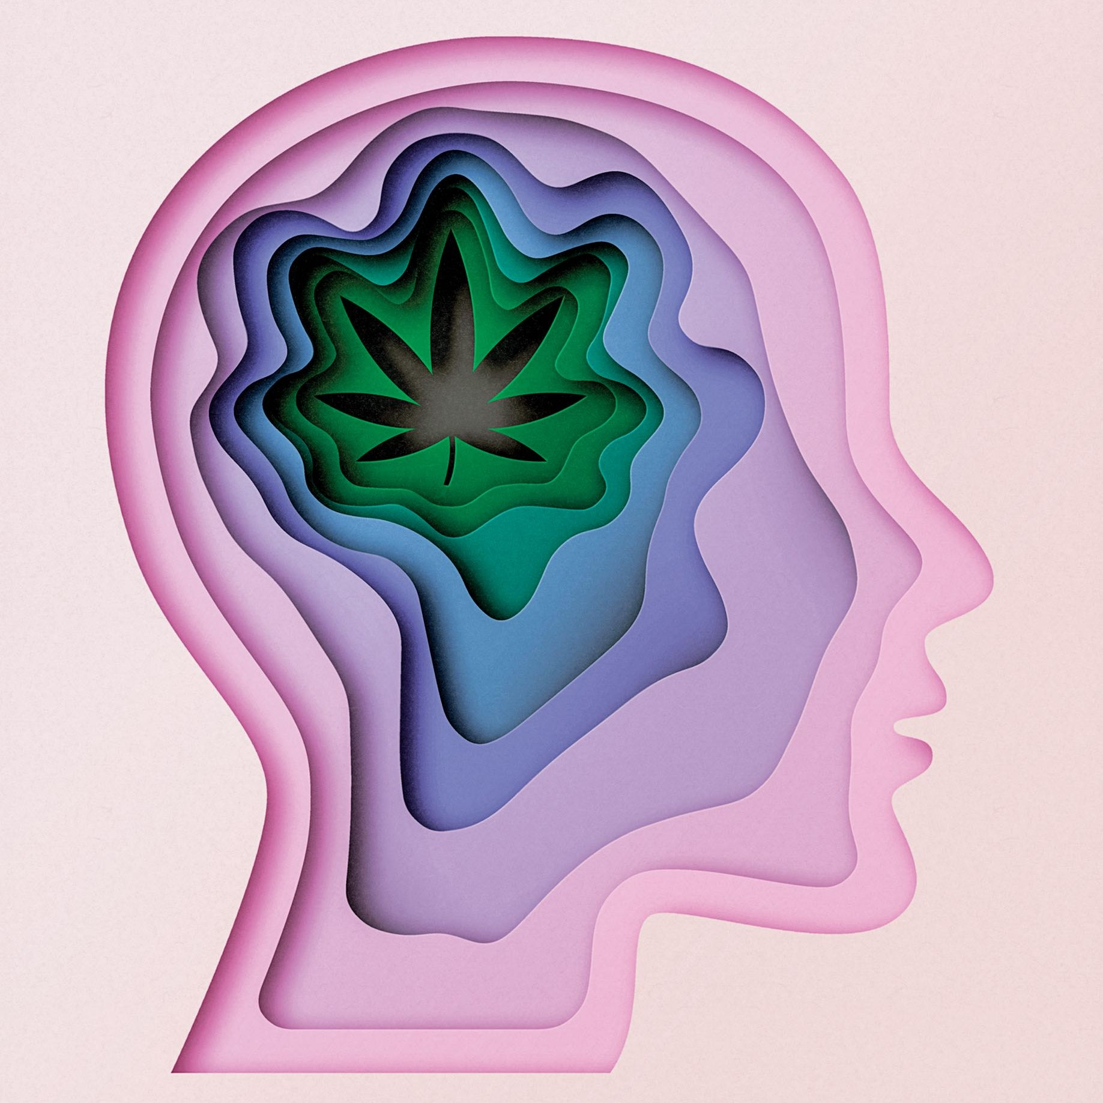

Success Criteria
Students will become familiar with the prevalence of marijuana smoking among New Zealand teenagers and the impact on physical well-being and mental health. They will also be able to identify factors that place teens at such high risk of not only casual use, but excessive use.

According to researchers at the University of Otago, Cannabis (another word for marijuana) is the illicit drug (that is, forbidden by law) that is most commonly used by New Zealand adolescents. It is estimated that by the age of 21, about 80% of young Kiwis will have used cannabis at least once, with 10% developing a pattern of heavy use and dependency.

Task 1:
Go to the website: https://brainwave.org.nz/article/short-term-highs-long-term-risks/

In your Red Book, write today’s date, the lesson, followed by the lesson title. Then write:

1. Who is behind this website?

There is a lot of information on the internet about the pros and cons of smoking marijuana. Some people claim it is quite harmful, while others downplay that harm. Before we do anything more, go to the ‘About Us’ page on the website and see the people who are behind its creation. Is the information contained on this site likely to be accurate and representative of the mainstream scientific community? Write your response under question one.

Under the ‘Introduction’ section, answer the following questions:
1. What two groups are the most vulnerable to cannabis?

2. Under the sections, ‘Using cannabis while pregnant' and ‘At birth. I te whanautanga,’
explain why cannabis use is so harmful to an unborn baby?

3. Go to Section 2: ‘Using cannabis as a young person. Tarukino me ngā taiohi.’
a. How are adolescent brains are different from adult brains?
b. How does using cannabis during the teenage years put them at greater risk of long-term effects?
c. Look up the definition of the word ‘Dependency.’
d. How does using cannabis during your teen years put you at greater risk for marijuana dependency?

Class Discussion:
We know that cannabis has the potential to cause harm and puts people at higher risk, yet it is widely used in New Zealand. Are there other things, such as economic stability, educational success, social support, strong whanau and strong communities, that may provide the ‘comfort’ and ‘highs’ of drug use without putting babies, young people and adults at risk?

Week 3, Lesson 3
Current Event Analysis – Global Studies

The Issue of Microplastics in New Zealand –
A new study has found it in our air as well
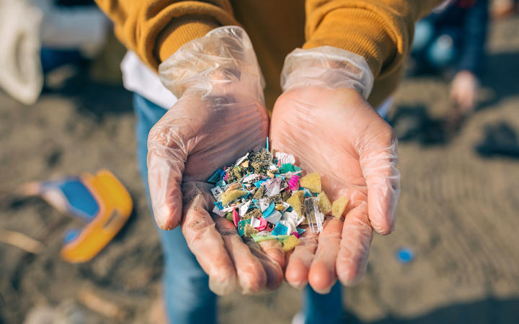 Microplastics are now commonly found across New Zealand.

Microplastics are found in the most remote places on land and in the ocean as well as in our food. Now several studies have confirmed they are also present in the air we breathe.

Task 1: Watch the Auckland University video about the issue of microplastics in New Zealand:

https://niwa.co.nz/videos/microplastics-a-deeper-problem-than-we-thought (1:25 sec.)
Based on watching the Auckland University video ABOVE, answer the following questions in your Red Books. Please write out the question (you can reword the question to shorten it):
1. Define what is meant by ‘microplastics.’
2. What are the tubes that the researchers have collected from underneath the ocean near New Zealand?
3. Researchers are finding many different pieces of different coloured plastics in the waters off New Zealand. What does this suggest?
4. What was the most concerning finding?

Task 2: Read the article below and answer the following questions:
5. How did microplastics get in our food and water?
6. List some health problems that have been linked to microplastics.

7. Make a list of the 6 different things you can do to protect yourself from microplastics. For each one, write a one or two-sentence summary of it in your own words. I will do the first question as an example:
a. Drink water from your tap. The amount of microplastics in bottled water is about double that of water you get from your tap, so it is healthier to drink tap water.
b.
c.
d.
e.
f.

READING:

You’re literally eating microplastics.

How you can cut down exposure to them.

By Consumer Reports

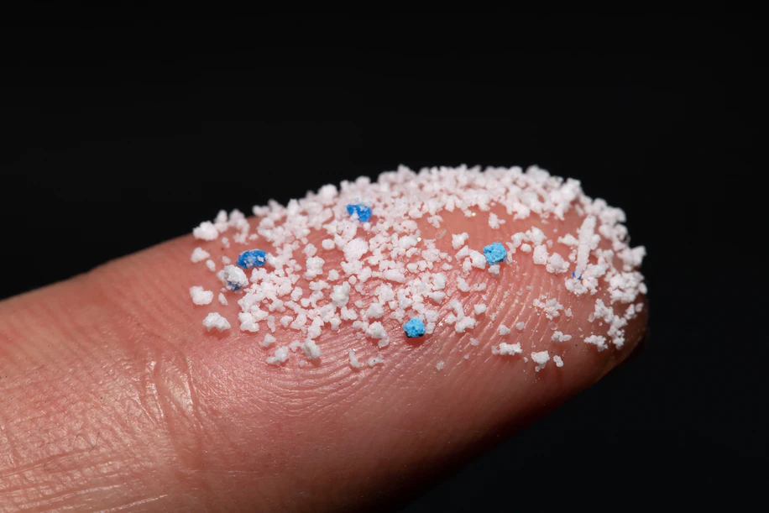
For anyone living in the United States in 2019, plastic is nearly impossible to avoid: It lines soup cans, leaches out of storage containers, hides in household dust, and is found inside of toys, electronics, shampoo, cosmetics and countless other products. It’s used to make thousands of single-use items, from grocery bags to forks to candy wrappers.

But what many people don’t know is that we’re doing more than just using plastic. We’re ingesting it, too. When you eat a bite of food or even have a sip of water, you’re almost certainly taking in tiny plastic particles along with it. These fragments are known as microplastics.
Because research into microplastics is so new, there’s not yet enough data to say exactly how they’re affecting human health. Pete Myers at Carnegie Mellon University says it is likely that ingesting microplastics could further expose us to harmful chemicals that have been linked to a variety of health problems, including being overweight, having unhealthy babies, and even cancer.

Why is it in food and water?
Humans have produced more than 8 billion tons of plastic, mostly since the 1950s. Less than 10 percent of it has been recycled. Over time, much of it has broken down into tiny particles that make their way into lakes, rivers and oceans, eventually contaminating our food and water. And much of our food comes wrapped in plastic, which leads to tiny particles breaking off into our meals.

There is so much plastic all around that we even breathe in tens of thousands of tiny plastic fragments or fibers every year.

How much do people eat?
One research review published in June calculated that just by eating, drinking and breathing, Americans ingest at least 74,000 microplastic particles every year. In another study it was estimated that people eat about 5 grams of plastic a week — roughly the equivalent of a credit card.

How does it affect health?
There is evidence, at least in animals, that microplastics can get into the bloodstream. And there’s some evidence that mothers may be able to pass microplastics through the placenta to a developing fetus.

6 tips to cut down on your risks

You can’t totally avoid microplastics or the chemicals found in plastic. But these small steps can help you avoid at least unnecessary extra exposure:

Drink water from your tap. Drinking water is one of the biggest contributors to microplastic ingestion, but bottled water has about double the microplastic level of tap water, according to Sherri Mason, sustainability coordinator at Penn State Behrend and a chemist who has studied plastic in tap water, beer, sea salt, and bottled water.

Don’t heat food in plastic. Heated plastics have been known to leach chemicals into food. The American Academy of Pediatrics also recommends not putting plastic into your dishwasher.

Avoid plastic food containers with known issues. The AAP report noted that recycling codes “3,” “6,” and “7” respectively indicate the presence of phthalates, styrene and bisphenols. It adds that if these products are labeled as “biobased” or “greenware,” they do not contain bisphenols.

Eat more fresh food. Though the levels of microplastics in fresh produce have been largely untested, these products are less likely to expose you to unwanted chemicals, according to the AAP, especially when compared with anything wrapped in plastic.

Minimize household dust. Household dust can expose people to chemicals, including phthalates, per- and polyfluoroalkyl substances, and flame retardants, Flaws says. Vacuuming regularly can help reduce household dust exposure, according to the Silent Spring Institute.

Think big picture. Individuals can take actions to limit their plastic exposure, Myers says, but large-scale solutions will require reducing the amount of plastic used overall. The experts we spoke with say that consumers should opt for products packaged in glass instead of plastic, use reusable nonplastic containers whenever possible and support policies limiting the use of single-use plastic.

