Week 3, Lesson 1

Rongoā Māori Knowledge & Western Science

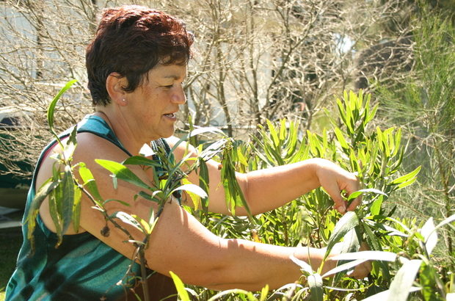

Success criteria:
At the end of this week, students will have a thorough understanding of Mātauranga Māori in relation to traditional Māori healing.

Task 1: In you Red Book, write ‘Lesson 1: An Introduction to Traditional Māori Healing.’ Next go to the following site: https://www.sciencelearn.org.nz/resources/185-rongoa-maori - read the article on Rongoā Māori and answer the following questions:

1. Write the definition of Rongoā Māori.

Class discussion: How many people are aware of different uses that Maori or Pacifica people have for various plants that grow in New Zealand. Can any students name any of these plants and their uses?

2. How was Maori health when James Cook arrived in New Zealand?

3. Describe the Māori holistic approach to healing. What is it?

4. Look up the definition of ‘Rongoā’ online and write it down.

5. According to the reading, Māori used a holistic approach to healing. Define the word ‘holistic.’

Task 2: The holistic approach to healing that has been used by Māori included 4 things. What were they? Write what they were and what it means in Māori. Number 1 has already been done – write it in your book.

1. mauri (spark or life force)

2.

3.

4.

Week 3, Lesson 2

Rongoā Māori Knowledge & Healing

Under the section, ‘Rongoā Fighting Infection,’ write down the 6 plants and how they are used to keep Māori healthy. Also draw a picture of each plant in your book.
1. Koromiko
The tips of the leaves can be chewed to help with such conditions as diarrhoea. During World War II, the dried leaves from this plant were shipped to Kiwi soldiers and it was reported to have been very effective.
The tips of the leaves were also chopped up and placed on skin sores of babies. Today scientists have identified the active ingredient as phenolic glycocide.
Picture Below:
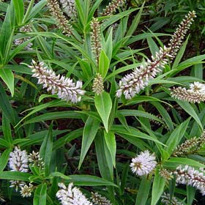
2. Kōwhai

3. Harakeke (flax)

4. Pōhutukawa

5. Pūriri

6. Kawakawa

Week 3 Lesson 3:

Current Event Analysis – Global Studies

It Appears that Captain Cook was not the First European to Set Foot in New Zealand
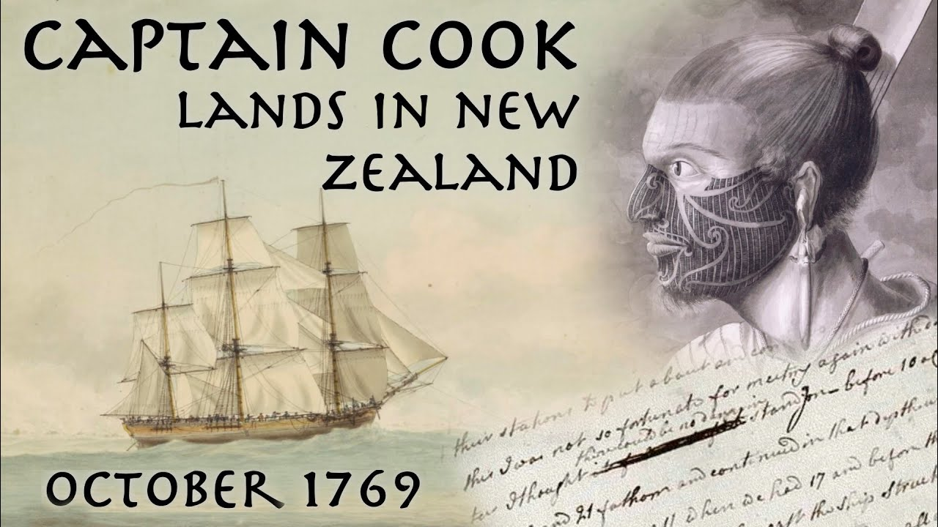
While Maori were the first humans to settle the land now known as New Zealand, it has been widely taught in textbooks that James Cook was the first European to set foot here. This now appears to be untrue with the discovery of a human skull of European origin that is older than Cook’s arrival. This finding was first reported 14 years. Let’s go back and look at the report.

Task 1: Read the article below (Read the article – ‘Skull has experts asking how European landed in NZ before Cook,’ By Paul Chapman in Wellington, Sydney Morning Herald, August 7, 2008).

Skull has experts asking how European landed in NZ before Cook
THE discovery of a European skull dating back more than 260 years has cast doubt on the presumption that Captain James Cook was the first Westerner to set foot on the shores of New Zealand. Scientists are baffled by carbon dating showing that the skull, a woman's, which was found near the capital Wellington, dates from 1742. Cook's Pacific expedition arrived in 1769.
The discovery was made by a boy walking his dog on the bank of a river in the Wairarapa region of the North Island, an area settled by Europeans only after the establishment of a colony by the New Zealand Company in 1840.
Dr Robin Watt, a forensic anthropologist called in by police investigating the find, said yesterday: "It's a real mystery. We've got the problem of how did this woman get here? Who was she?"
The mystery of the skull, found four years ago, was raked over last week at an inquest in Masterton, the provincial capital.
John Kershaw, the local coroner, was told that police at first thought they had a murder inquiry on their hands.
"One of the reasons some work was done on the skull was because it had a number of puncture wounds," Mr Kershaw said. "We don't know how this lady met her death, although the historian we used indicated drowning was a reasonable guess." The inquest heard that the skull was definitely not Maori, the only race known to have inhabited New Zealand in the 18th century and almost certainly of European origin.
The European discovery of the shoreline of New Zealand was made by the Dutch explorer Abel Tasman in 1642. Tasman had no women aboard and there is no record of him landing. The Maori are believed to have settled in the country in about 1200. The first white women known to have arrived were two convicts who escaped from a penal colony in NSW in 1806.
Gareth Winter, the official Masterton archivist who was called as an expert witness, said that the possibility of a hoax could confidently be ruled out. Mr Winter said that Captain Cook recorded in a log in 1772-75 a tale told to him by a Maori chief of a ship having been wrecked many years earlier.
Early missionaries wrote of hearing the same story from Maori, who related that the survivors had been killed and eaten when they came ashore. Historians believed the most likely site of such a shipwreck was Cape Palliser, the North Island's southernmost point.

Task 2: In your Red Book write today’s date and write out the answers to the following questions, followed by your answer.

1. Where was the skull found and by whom?
2. What do scientists know about the skull? What is the age and was the gender?
3. When the skull was first found, where did police think it came from?
4. Dutch explorer Abel Tasman sailed to New Zealand in 1642. Why do experts think it is not possible that someone from his ship may have come ashore in New Zealand?
5. Experts think that the skull may have been a member of a shipwreck. Why do they think this?
6. Go online and Google the article – ‘Riddle of the Skull’ at: https://www.dailymail.co.uk/sciencetech/article-1041871/Riddle-skull-What-white-woman-doing-New-Zealand-100-years-Europeans-settled-there.html
This article was published the the UK Daily Mail newspaper at the same time as the first article. Compare this article with the one you just read. How is the conclusion of the second article different from that of the first article? What was left out?
*If you would like to read more about the European skull, see: ‘Written in Blood’ by Vaughan Yarwood in New Zealand Geographic at: https://www.nzgeo.com/stories/written-in-blood/

