Global Studies Year 7 – Week 3

The Early Astronomers and How they
Understood the World Around them



Week 3, Lesson 1

Success Criteria
Students will gain an understanding of how early astronomers in different cultures attempted to understand the nature of the universe.

Task 1: Open your Red Book and write down today’s date and ‘Lesson 1: The life of a Famous Early Astronomer.’

Today we are going to revisit Lesson 2 from last week. Students are going to pick out ONE of the astronomers who we have already looked at – EITHER Nicolaus Copernicus or Galileo Galilei.

Imagine you are a reporter who works for the Star newspaper (get it – ‘Star’ newspaper) and you could go back in time and interview your chosen astronomer. Using information you can find online, write a story about their discoveries and how they got into trouble with the teachings of the Church. In your article, include:

1. a catchy title
2. when and where they lived (dates of birth and death)
3. how their discoveries change the way humans looked at the universe?
4. how they got into trouble with the Church and the consequences?

Week 3 Lesson 2 – Postage Stamp & Letter


Look at the image of the stamp above. It shows Copernicus holding a model that has the Sun at the centre of the solar system, which was one of his big discoveries.

Task: Create your own postage stamp for one of the other early astronomers who we have studied from last week. Pick one of them and imagine that in the country they were born in, the head of that country’s postage stamp department wants you to help them to design a postage stamp that highlights their accomplishments. Create the stamp in your book. It should include an image and key words.

Task 2: After you have created the stamp, write a letter to the stamp department explaining what the image in the stamp stands for and why you think they should pick your stamp.

If we have time, we may ask some students to show the class their designs and why they think they are worthy of being on a stamp.

Current Event Analysis – Global Studies

New Study on Global Warming Raises
Alarm Bells for New Zealand

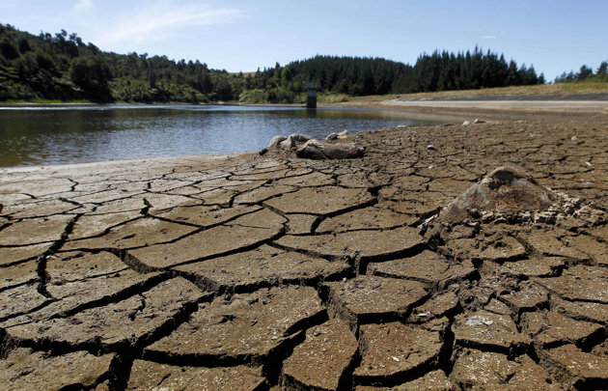
A recent study says that more needs to be done to combat the effects of global warming on Kiwis.

Task 1: Read the article below (Read the article – ‘Alarming new statistics reveal New Zealand's sea level could rise 30cm in next 10 to 20 years,’ By Samantha Hayes, NewsHub, May 1, 2022.

Task 2: You may find it helpful to watch the video that appeared with this story.

https://www.newshub.co.nz/home/new-zealand/2022/05/alarming-new-statistics-reveal-new-zealand-s-sea-level-could-rise-30cm-in-next-10-to-20-years.html (7:34 sec.)

Alarming new statistics reveal New Zealand's sea level
could rise 30cm in next 10 to 20 years
New climate change research has pinpointed the places in New Zealand where sea level rise will greatly outpace the global prediction of 30cm by 2060. For parts of Auckland and Wellington, 30cm of sea level rise isn't 40-50 years away, but just 10-20. By 2060 it’s approaching a metre in some places. That’s because combined with rising sea levels, parts of New Zealand are slowly sinking. It is predicted that by 2060, some people will have to abandon their homes and businesses and retreat from the coast.
The study's lead scientists are Richard Levy and Tim Naish. "I was shocked. I mean I knew it was bad, I knew we were getting sea level rise, we know that, I've been a climate scientist for 20 years, but I was shocked at how quickly it can happen," Naish told Newshub. "As we were going through it the surprises just kept coming," Levy added.
While Kiwis have all been getting on with their busy daily lives, the changes have been occurring and in climate change terms, it's happening at light-speed. "Like most people, I thought we had more time. We don't, we literally have a decade or two before in places like this we're gonna be at decision points about whether you look at some sort of managed retreat," Naish told Newshub.

So who's in the firing line?
Auckland's Britomart will flood. The north-western motorway, Tamaki Drive, Napier's brand new airport, Nelson's airport while Christchurch and Dunedin have big problems too.
Levy and Naish have spent the last five years working on this groundbreaking new sea-level rise study.
They've drilled sediment and ice cores to look millions of years back into the past, painstakingly reconstructing a precise climate record to inform their future projections. It's the cutting edge of climate research.
The whole world has been using one sea-level rise prediction - 30cm by 2060 if we limit warming to 2C - and New Zealand has used it too.
But there's one big factor that until today hasn't been included in the calculations, vertical land movement.
We know New Zealand has a dynamic coastline - it can move up and down in a dramatic way, just like we saw with the Kaikoura earthquake. But there are also constant tiny movements, just millimetres a year.
It might not sound like much but when you add any sinking to global sea-level rise it makes a massive difference. That's why some places in New Zealand will experience two or three times the global average of the sea level rises and we didn't know that until today. "When you weave that in with the ice sheets melting, the glaciers melting and the global oceans rising - in some places it happens twice as fast," Naish said. "We get twice as much sea-level rise than we expected so it's a big deal."
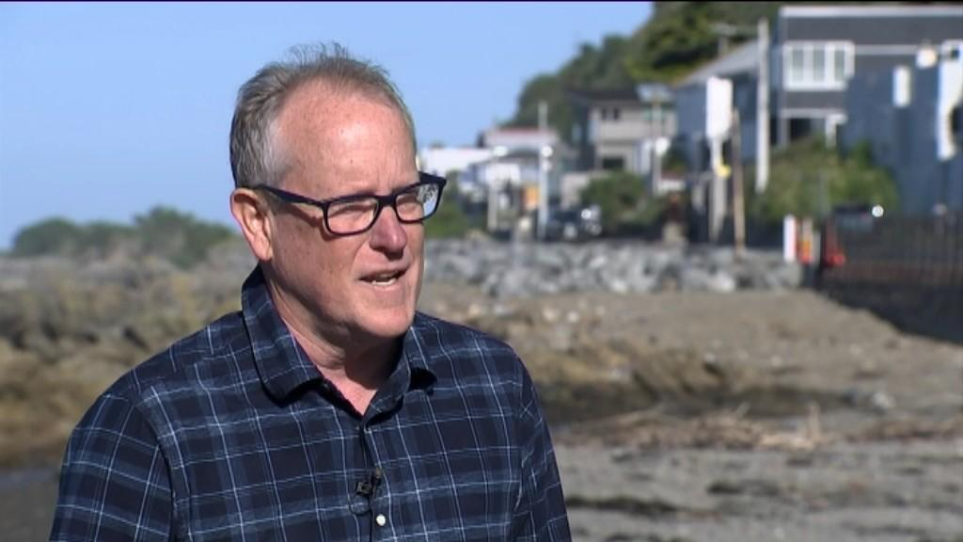Study's lead scientists Tim Naish Photo credit: Newshub
In areas where land is subsiding - such as Auckland and Wellington - town planners no longer have 40 or 50 years to deal with this. In just 10 or 20 years many homes, roads and rail lines will need to be raised, protected with sea walls or abandoned.
"Auckland was a big shock to us," Levy said. "It's one of those things where people think 'oh it's not gonna affect me, I don't have to worry about it' but the information we've produced is really making it clear that you do need to be concerned, you do need to pay attention," Levy said.
There have been a lot of moments over the last 30 years where scientists and climate activists have thought this is the moment that people will sit up and pay attention and do something about this and those moments have passed us by.

So what does sea level rise look like?
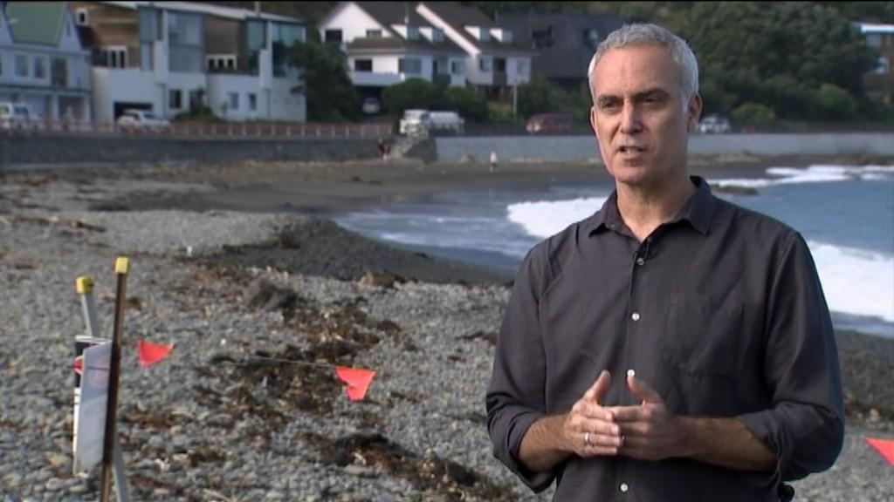
Study's lead scientists Richard Levy. Photo credit: Newshub
"We respect the science, we believe in the science, now get on and start developing those adaptation plans, start drilling down bay by bay, community by community to get the best strategies in place and then actually start spending money sorting it out to the degree that is reasonable."
"I do think that decision-makers will start to act on that because they're gonna have to," Shaw added.
This is a red alert, a siren blaring at the loudest it can go.

Task 3: In your Red Book write today’s date and write out the answers to the following questions, followed by your answer.

1. Write a newspaper headline about the danger of climate change to Kiwis – one that will get peoples’ attention.

2. Create a series of key dot-points in your own words. You should be able to generate several main points – in your own words.

