Global Studies Unit Overview (Year 8 Term 2)

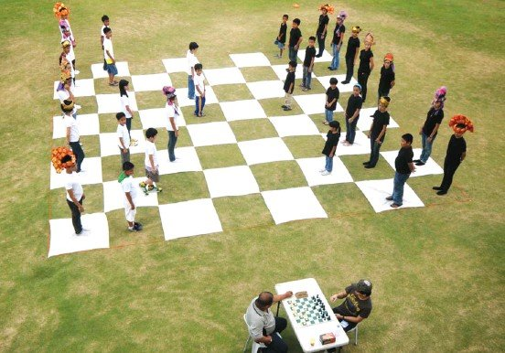

Games People Play
The social, cultural and economic significance of games and game-playing and their impacts on our physical and psychological health will be explored. Game-playing is very important to child development and to growing up normal and healthy. What are games, why have humans been playing them for so long, and what benefits do they offer? We will include some Maori games and their function in society. As the teaching of this unit will coincide with the new Matariki public holiday on June 24th, we will also cover the significance of this event to Maori society.

Week 1, Lesson 1

What is a Game and Why do Humans
All Over the World Play Games?

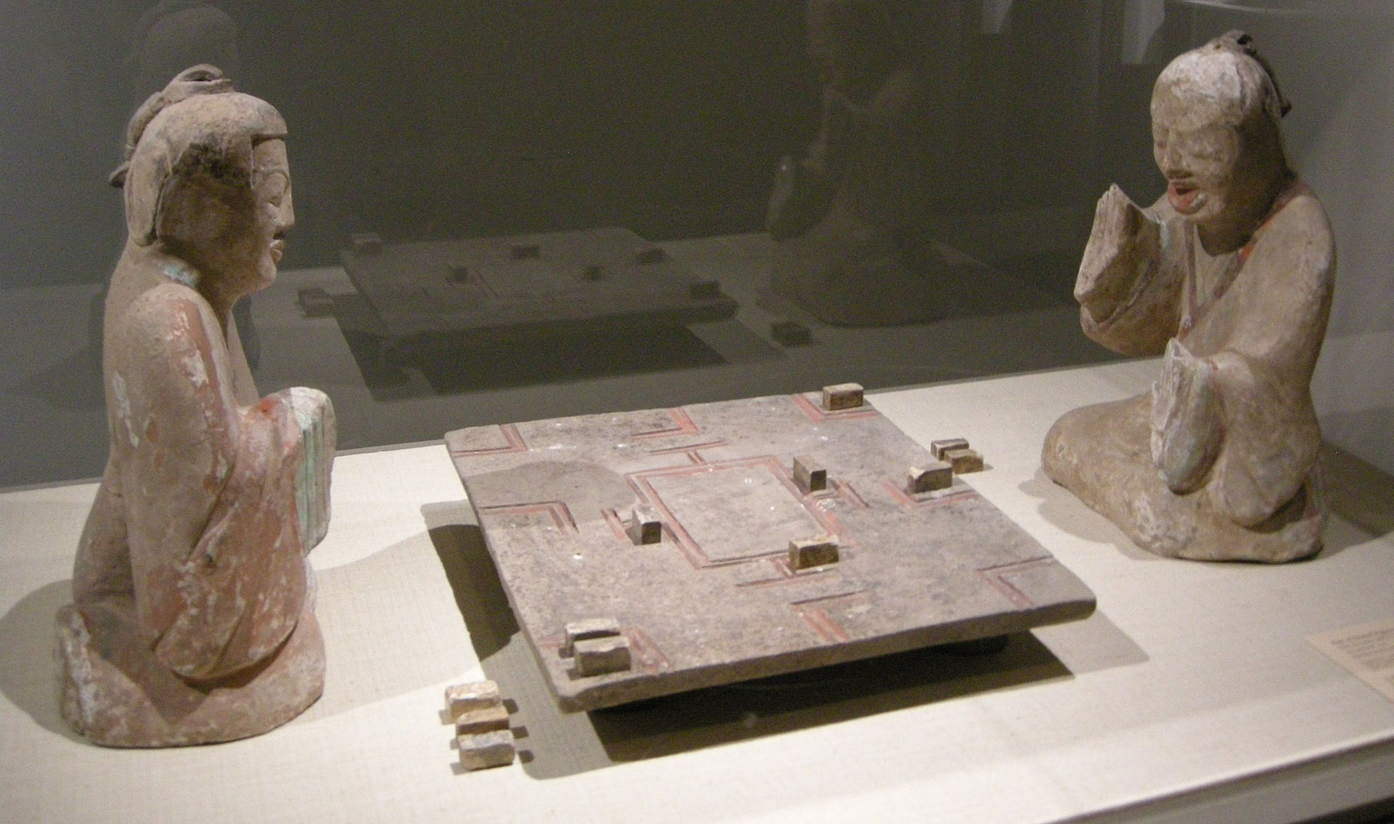

Task 1: In you Red Book, go about one-third of the way down the page and draw a line across the page. In the top section write the Title of this unit. Underneath the line, write ‘Lesson 1: ‘What is a game and why do humans all over the world play games?’

Task 2: As a class we are all going outside on lawn and we are going to play a game of catch with a ball (10 minutes). We are then going back inside and breaking up onto groups of 4-6 at different tables and each group is going to come up with the different benefits students gain from play the game. Each person in the group is to write your own ideas into dot-points.

DO NOT LOOK UP ANY INFORMATION ABOUT THE BENEFITS OF PLAYING GAMES online.

The teacher will go around to each table and ask students to write their dot-points on the board and we will discuss them.

Make sure you have written down any dot-points from other groups that your group had not thought of.

Homework: Make sure your Red Books are set up and are up-to-date.

Week 1 Lesson 2:

Why Humans Need to Play Games

We are going to watch a video clip shows a Professor who has studied the history of play. The clip is fantastic. He speaks in an easy to understand way, and it is filled with interesting information. Watch: ‘The Decline of Play’ by Peter Gray: https://www.youtube.com/watch?v=Bg-GEzM7iTk (9:07 Sec.). After watching the clip, answer the follow questions below – please write out the full question in your Red Books, followed by the response.

1. Every species of animal on earth engage in play. What are some of the benefits to play? (see the video at the 30 second mark)

a.

b.

c.

2. In experiments, scientists have given young animals plenty of food and everything else they need to survive except they are left alone, what happens to them? (1:10 sec)

3. What animals plays by far the most of all the animals? (2:20 sec.)

4. When ten anthropologists (scientists who study different cultures) who had studied isolated tribes in remote parts of the world, were asked if the children played a lot, what did they all observe? (3:30 sec.)

5. Why were children in these tribes allowed to play?

6. At the 4-minute mark, Professor Gray mentions something that is alarming. What is it?

7. How were schools from 60 years ago, different to schools today? (5:30 sec).

8. At the 6-minute mark, Dr. Gray says that when children are engaged in little league football and baseball games, it isn’t really play – why?

9. List 4 reasons for the decline of play (6:42 sec.).
a.
b.
c.
d.

10. Around the 8:30 sec. mark, Dr. Gray talks about how children in Western countries like the United States, Australia and New Zealand, have been playing less and this has resulted in the rise of 2 mental health issues – one is depression and the other is _________.

Extension Exercise (Optional): If you have time, give your opinion on the importance of play. Do you agree with Dr. Gray? Has play been a major part of your life?

Week 1 Lesson 3: Current Event

Current Event Analysis #1
Term 2 Week 1 Lesson 3 (Global Studies)
A Wave of Ram Raids Sweeps New Zealand
At the Ormiston Town Centre (below), over a dozen youths took part.
More Ram Raids are happening across New Zealand. A car (above) races through the Ormiston Town Centre.

1. Watch the video on the recent ram raid in Ormiston. ‘3 Stolen Vehicles used in Ram-raid on Auckland Shopping Centre’ at: https://www.youtube.com/watch?v=Qq5Iz9SPpE0 (2:38 seconds).

Task 1: In you Red Book, write today’s date, ‘Current Event,’ and underneath put the title of the lesson.

Task 2: After watching the video clip, answer the following questions in your Red Books.

1. How many stolen vehicles were involved in the robbery?
2. Which two stores were targeted?
3. What were the items that the offenders stole?
4. The Mall opened about one year ago. In that time, how many smash and grab break-ins have occurred?
5. According to police, what are the ages of most of those involved?
6. What is mall security doing to try and stop future break-ins using vehicles?

Task 3: Read the article, ‘Police warn it's only a matter of time until someone dies as New Zealand sees ram raid epidemic,’ by Tom McRae from NewsHub, April 27, 2020 at: https://www.newshub.co.nz/home/new-zealand/2022/04/police-warn-it-s-only-a-matter-of-time-until-some-dies-as-new-zealand-sees-ram-raid-epidemic.html.

The answers to the last 4 questions below can be found in the article.
8. On average, how many ram raids happen in New Zealand each month?
9. New Zealand is planning to boost the number of police – by how many?
10. What does Auckland Councillor Efeso Collins think are the reasons for the raids?
Do you agree?
11. If you were the Police Commissioner, how would you handle the problem?

Task 4: Write a two-sentence summary of what happened and include who, what, where, when, and why.

Global Studies Unit Overview (Year 10 Term 2)

Why Teens do Foolish Things?
The Science Behind Why adolescents are Prone to Engaging in Risky Behaviours

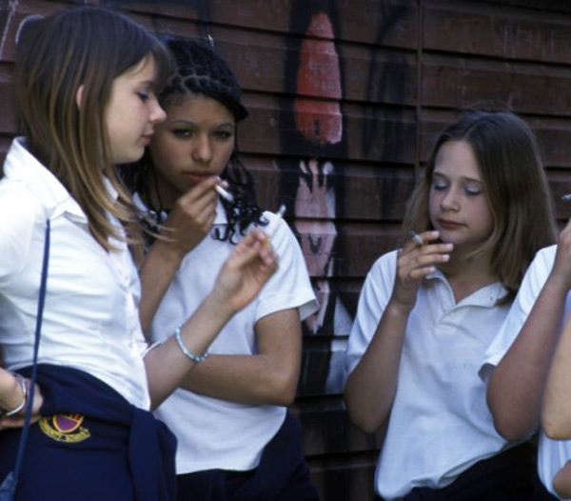

Studies show that teenagers are much more likely than adults, to engage in highly risky behaviors that could endanger their lives and the lives of those around them. Whether it is racing in cars, experimenting with drugs, engaging in crime, binge drinking, smoking, vaping, or diving off a cliff into a pool of water, teens are notorious for doing risky things. Yes, we all take risks, but it is important to balance the potential risks versus the possible rewards. We will explore why this is, and the brain science behind it. As part of the assessment, students will be asked to create an advertisement that highlights a particular risky behaviour and what can be done to modify the risks.

Week 1 Lesson 1:

Why Teens are at Risk for Risky Behaviours

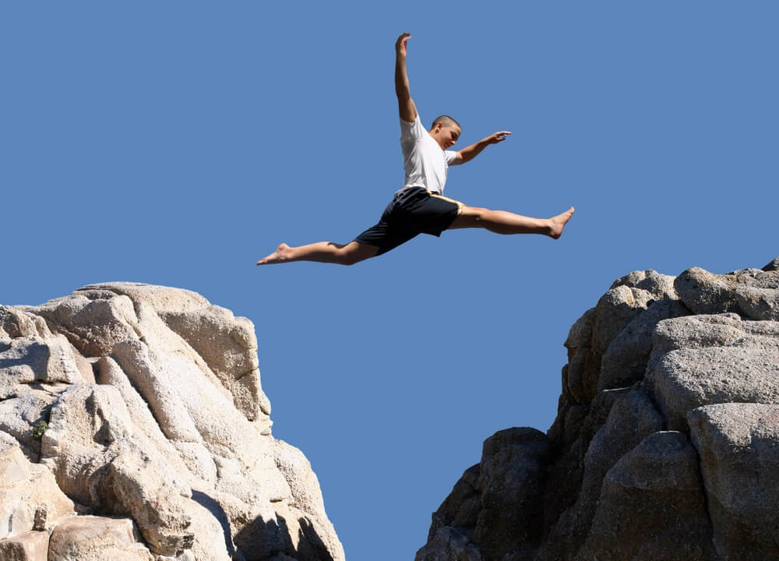

Success Criteria
Students will gain a thorough understanding why teenagers are so prone to engaging in dangerous behaviours.

Activities
1. Reading & Writing
2. View and respond to a video clips from a study on risk-taking

Homework
Complete all lessons by Friday at 3 pm.

It’s true – teens are at the highest risk for injury and death from a variety of acts that they engage in with their own free will. But why? What is different in teenagers that places them at such a high risk?

Task 1: In you Red Book, go about one-third of the way down the page and draw a line across the page. In the top section write the Title of this unit. Underneath the line, write ‘Lesson 1: ‘How Risk-taking Changes a Teenager’s Brain.’

Task 2: Watch the video by Kashfia Rahman on ‘How Risk-taking Changes a Teenager’s Brain.’ WATCH IT FROM START TO FINISH. DO NOT think about writing down answers – just watch it for pleasure at:
https://www.youtube.com/watch?v=VLDwh4ivNf4

This is an amazing video; it is about a high school student who conducted a study on teen risk-taking. As a result of her study, she ended up winning one of the world’s biggest science awards for teenagers and being accepted into one of the best schools in the world – Harvard University.

While many scientists blame teen risk-taking on the undeveloped teen brain, Ms. Rahman found that while that may be true, something else was driving the risky behaviours. When she uses the word ‘habituation,’ all this means is becoming used to something.

Task 3: In Paragraph #1, write a summary of the study she conducted at her school (this starts at around the 5:30 second mark).

Task 4: Next, list the key dot-points of what she found.

Lesson 2: The Risky Teen Brain

Task 1: Read the article from Psychology Today Magazine, ‘Why Are Teen Brains Designed for Risk-taking?’ by Psychologist Joe Magliano at: https://www.psychologytoday.com/nz/blog/the-wide-wide-world-psychology/201506/why-are-teen-brains-designed-risk-taking. I have re-written the article and targeted to a Year 10 reading level.

Task 2: Write the following questions and answers in your Red Books.

1. Define the word ‘adolescence.’
2. Define the word ‘puberty.’
3. Write a letter to your friend who has been driving his car in an unsafe manner and who is binge drinking. A) Explain to him why the teenage brain is more prone to doing risky things, and 2) what he can do to try to be more sensible.

Reading for Lesson 2

The Wide Wide World of Psychology

Why Are Teen Brains Designed for Risk-taking?
Nina Mounts is a professor of psychology at Northern Illinois University

Here are several ways parents can reduce the danger

Adolescents and young adults take more risks than any other age group This risk-taking includes dangerous driving (for example, texting), drug use, binge drinking, and risky sexual behavior. Despite educational efforts to provide teens with information about risky behavior, many teens continue to engage in risky behavior.
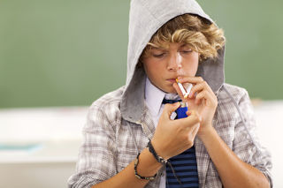
A teenager engaging in risky behaviour - smoking

People often believe that teens engage in risky behavior because they are not very good at evaluating risk. But research in this area demonstrated that teens are just as good as adults at evaluating risks. across a broad range of risky behavior. Teens know that the behaviors are risky, but they still engage in them. Why?
Research on how teens interact with their friends as well as their brain development at this age, may provide an answer.
In recent years, there has been an increase in the availability of magnetic resonance imaging (MRI) – devices which scan the brain. Using MRI scans of teen brains, researchers have found several changes take place in the brain during puberty that are important in explaining risky behavior.
#1. First, during the teenage years young people become very prone to peer pressure, which peaks at about the age of 14. At the same time, MRI scans of the brain show that teen brains are more sensitive to the rewards of peer relationships than adults. As a result they are more likely to do risky or silly things around their friends in order to fit in and feel liked and wanted.
#2. While teens become more interested in their peers (friend who are about their same age) and can become very unhappy and upset when they are excluded by their peers. Research shows that it is less developed in teens than adults so adolescents may not be as effective at controlling distress during peer social exclusion. This likely contributes to engaging in risky behaviors to prevent being excluded by their peers. They may engage in silly or risky actions to become accepted into a group.
#3. Third, another area of the brain (the lateral prefrontal cortex), regulates how we control ourselves and our emotions. In one study, early teens, late teens, and adults behaved similarly on a computerized driving task when they were by themselves. However, when they were paired with two same-aged friends, clear differences emerged. Early teens were more likely to engage in risky driving when friends were present. Late teens were somewhat more risky in their driving when they were with friends. The presence of friends had no impact on adults’ driving.
If talking about the dangers of risky behaviors isn’t as effective in preventing them as parents would like, what can parents do?

Week 1 Lesson 3:

Create a poster

Based on the information we have learned so far in this unit, create a poster over one or two pages in your Red Book on how the teenage brain places them at higher risk for engaging in risky behaviours.

Include information on
1) a catchy, relevant title
2) Discuss how the teen brain is different to the adult brain and why they are higher risk for risky acts
3) what can you do as a teenager to reduce your chances of doing dangerous things?
4) Include an image (hand drawn only – stick figures are fine)

This assignment is NOT to be done on your computer but in your Red Book.

