Famous Scientists & How they Changed the World

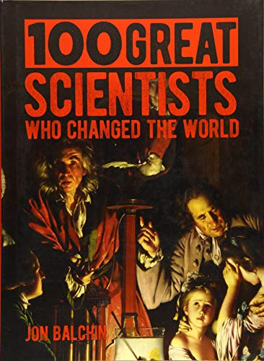

Global Studies Unit Overview (Year 7 Term 2)

In this unit we will learn about the lives of famous scientists, how they refused to give up in the face of adversity, and how their discoveries have changed how we look at our world. It will also look at the lives of famous female scientists and how they have often not received the recognition that they deserved for their discoveries.

Week 1, Lesson 1 – What is a Scientist?



Success Criteria
Students will gain an understanding of what is Science and will be able to identify several key scientists and their discoveries.

Task 1: Open your Red Book to two blank pages, go about one-third of the way down the page and draw a horizontal line across the page. In the top portion of the page, write ‘Lesson 1: Famous Scientists & How they Changed the World.’ Include today’s date.

Welcome back – we will take a few minutes to go around the room and see how everyone is doing, what they did over the break, and what they hope to learn from this unit.

Task 2: Watch the video clip on what makes someone a scientist.
https://www.youtube.com/watch?v=AUs6af5Iu8g 5:23 sec.

Class Discussion: How many students aspire to become scientists? What field of science would you like to go into and why? Do you think some fields of science are seen as being more suited to males?

Task 3: Go to the website ‘What is a Scientist’ at: https://www.indeed.com/career-advice/career-development/what-is-a-scientist and answer the questions below:

a. In your Red Book, write down the definition of ‘Scientist’ in your own words.
b. List the 5 key skills required to be a good scientist, and a one-sentence summary of each (in your own words)?

Homework: Make sure that your Red Books are up to date and all of the tasks have been completed.
Week 1, Lesson 2:

‘How Female Scientists have Helped to Change our Understanding of the World’ (but did not receive the credit they deserved).
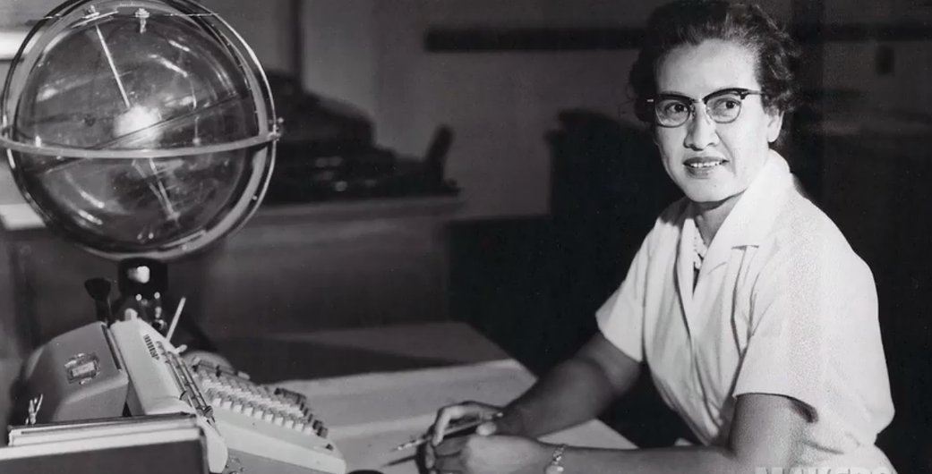
NASA research mathematician Katherine Johnson (she featured in the film ‘Hidden Figures’)

Success Criteria
Students will be able to identify several key female scientists, their accomplishments and the obstacles they faced in gaining the recognition they deserved for their discoveries.

Task 1: Write down the title of this lesson and the date in your Red Book.

Task 2: Next, watch the video clip on ‘Women in Science who Changed the World’ at: https://www.youtube.com/watch?v=W53Ks824GTA (4:55 sec.). The clip introduces several women who have until recently, been forgotten about, yet they made discoveries that others (men) took credit for or were ignored.

Task 3: After watching the video, go online to Britannica Kids at: https://kids.britannica.com/kids/article/Caroline-Herschel/628507 and read about the life of Caroline Herschel. There is also a short clip on her life and accomplishments that you may find helpful at: https://www.youtube.com/watch?v=9Lp7g-3mgi4&t=69s

Create a basic Poster that highlights key information and some of the major accomplishments of Caroline Herschel. Do this on a single blank page in your Red Book. This is not to be done on your computer – please do it by hand in your books. If necessary, you can draw Pak’n Save stick figures! (You could include things like date of birth, where she lived, major discoveries, when she died, how she was treated by the scientific community at the time.

Extension (opitional): Any student who completes their poster before the end of the class can watch the story of the woman who invented Wi-Fi, yet most people have never heard of her. The clip is here: https://www.youtube.com/watch?v=I41DZZx0dmY

Question – If Hedy Lamarr had been a man, do you think she would have gotten the recognition that she deserved sooner? Why or why not?

Week 1 Lesson 3: Current Event

Current Event Analysis #1
Term 2 Week 1 Lesson 3 (Global Studies)
A Wave of Ram Raids Sweeps New Zealand
At the Ormiston Town Centre (below), over a dozen youths took part.
More Ram Raids are happening across New Zealand. A car (above) races through the Ormiston Town Centre.

1. Watch the video on the recent ram raid in Ormiston. ‘3 Stolen Vehicles used in Ram-raid on Auckland Shopping Centre’ at: https://www.youtube.com/watch?v=Qq5Iz9SPpE0 (2:38 seconds).

Task 1: In you Red Book, write today’s date, ‘Current Event,’ and underneath put the title of the lesson.

Task 2: After watching the video clip, answer the following questions in your Red Books.
1. How many stolen vehicles were involved in the robbery?
2. Which two stores were targeted?
3. What were the items that the offenders stole?
4. The Mall opened about one year ago. Since that time, how many smash and grab break-ins have occurred?
5. According to police, what are the ages of most of those involved?
6. What is mall security doing to try and stop future break-ins using vehicles?

Task 3: To answer the final 4 questions below, read the article, ‘Police warn it's only a matter of time until someone dies as New Zealand sees ram raid epidemic,’ by Tom McRae from NewsHub, April 27, 2020 at: https://www.newshub.co.nz/home/new-zealand/2022/04/police-warn-it-s-only-a-matter-of-time-until-some-dies-as-new-zealand-sees-ram-raid-epidemic.html.

The answers to the last 4 questions below can be found in the article.
8. On average, how many ram raids happen in New Zealand each month?
9. New Zealand is planning to boost the number of police – by how many?
10. What does Auckland Councillor Efeso Collins think are the reasons for the raids?
Do you agree?
11. If you were the Police Commissioner, how would you handle the problem?

Task 4: Write a two-sentence summary of what happened and include who, what, where, when, and why.

