A mini murder mystery
(data handling based)
Who
One of these 4 people has committed a murder. Analyse the data below.
The suspects have all calculated the mean, median, mode and range of the set of data shown in the diagram. The murderer has got 3 answers wrong. The innocent people have all got at least 2 of the answers correct.
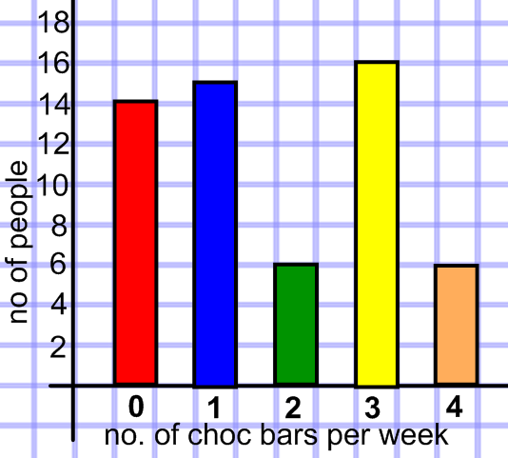
  Person A said the following  Mode = 3  Median = 1  Mean = 75.42  Range = 5 |  |  |   Person B said the following  Mode = 3  Median =2  Mean =11.4  Range = 4
  Person C said the following  Mode = 16  Median =2  Mean = 1.74  Range =5 |  |  |   Person D said the following  Mode = 2 and 4  Median = 1  Mean =1.98  Range = 4
When
Work out the date and time when the murder took place by analysing the following data.
You must find a day, and month then a time.
All will be numerical like 23/11 would be 23rd Nov and 16:35 would be 25 to 5 pm
The day is the mean of this set of data |  |  |  | 23, 32, 15, 39,31
The month is the median of the data |  |  |  | 1.2, 1.9, 2.8, 2.9, 2.1,  2.1, 0.9, 2.7, 1.8, 1.0
The hour part of the time is the missing number x that would make the mean of these 4 numbers 20. |  |  |  | 28, 29, 9, x
The minutes part of the time is the range of |  |  |  | 23, 32, 15, 39,31
Where
The murder took place in a Yorkshire town
By analysing the data decide in which of the 4 towns it happened.
This stem and leaf diagram shows the ages of the 13 people who were close to the place the murder was committed. |  | 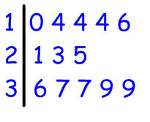
It was committed in York if the mode is 14, the median is 23 and the range is 8

It was committed in Harrogate if the mode is 4, the median is 23 and the range is 29
It was committed in Leeds if the mode is 14 and the median is 23 and the range is 9
It was committed in Doncaster if the mode is 14, the median is 23 and the range is 29
It was dentist, silly boy, chef, artist
Date was_________________
Time was ____________________
Town was _____________________

