Mini murder mystery
(circle stuff)
Who (This is A/A* work)
One of the following 4 people is a murderer. They have each given the answer to a circle problem correct to 3 sig figs. 3 answers are correct and 1 is wrong. The person giving the incorrect answer is the culprit. All have used the π button on their calculator if needed and only rounded off at the final answer.
This circle’s area is 2m². |  |  |   The mad scientist says the circumference is 5.01 m | 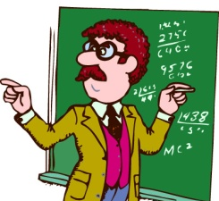  The maths teacher says the diameter is 160 cm
 |  |  |   The gardener says that a square with the same area would have a perimeter of 5.67 m |   The astronaut says the volume of the sphere with this as the maximum cross section is 2.13 m³
Where (Grade B/C standard)
The murder was committed at one of the tourist hotspots in Otley. Which one ?
(Numbers have been rounded off). It happened where the answer is true.
The Buttercross |  | If a circle whose circumference is 90cm has an area of 90 cm² and a radius of 14.3 cm.
Chippindale’s statue |  | If a circle measuring 45m diameter has a radius of 90m and a circumference of 141 m.
The Navvies Monument |  | If a circle whose circumference is 1m has a radius of 15.9 cm and an area of796 cm²
The Maypole |  | If a circle with an area of 20cm² has a diameter of 5.05cm  And a radius of 2.52 cm.
When(Grade A/B work)
(find the day where all the facts are correct)
BE is a diameter
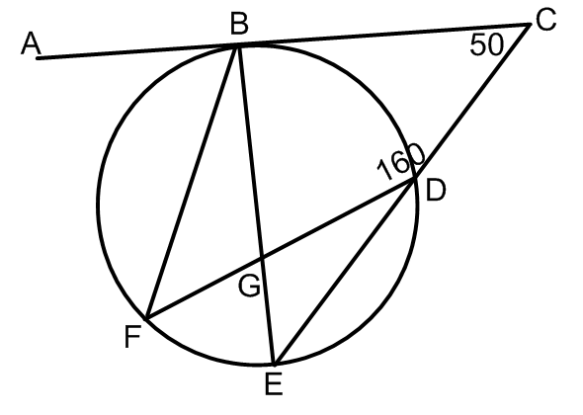

Monday | If ABE =90 and DGE=120 and BFD=60
Tuesday | If EDG =20 and FGE=40 and CBE=90
Wednesday | If ABF=70 and EGD=120 and CBF=110
Thursday | If FBE=20 and BGF=120 and DEB=60
The Accusation
Who
Where
When

