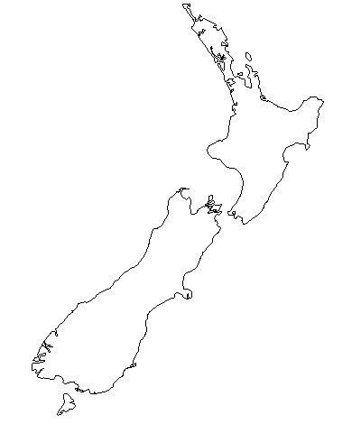
Mapping Task
Label the following mountains using appropriate symbols on your map.
Ruapehu
Tongariro
Ngauruhoe
Taranaki/Egmont
2. Draw and label the Alpine fault
3. Label the Indo-Australian Plate .
4. Label the Pacific Plate
5. Label the cities of:
Auckland
Christchurch
Wellington
Dunedin
6. Draw and label White Island
7. Label Lake Taupo.
8. Label the Tasman Sea, Cook Strait, Pacific Ocean, Foveaux Strait and Stewart Island

