Multicultural New Zealand - Assimilating to Our
Home Sweet Home in the South Pacific
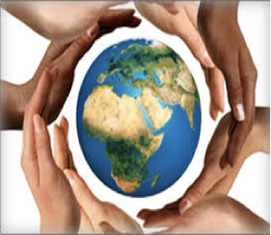

New Zealand is one of the most ethnically diverse nations on earth; we are also one of the most peaceful.

Every culture has different ways of communicating, and in order to be able to work with someone from a different background or culture in a respectful way, you need to understand how people might see, value or express things differently. Our biggest challenge is how we choose to live our lives and what kind of country we let New Zealand become.

To enable you to have a better understanding of how multicultural New Zealand works, and the different cultural protocols we have, this assessment task will require you to research and design a presentation of your choice, on the features of your own cultural identity and New Zealand's many cultural identities, and examine the impact of these identities on each other.
To complete this assignment you will need to use the resources used in class, especially about New Zealand identity, and the activity about ‘Who Am I’.

Create your own poster or booklet that includes visuals.
GLOBAL STUDIES
You must answer these two questions:
- A description of what New Zealand Culture is today. Use the word bank below to help you.
- How New Zealand culture has impacted your cultural identity and how your cultural identity has impacted New Zealand's cultural identity. Discuss both positive and negative impacts.
AND answer one (or more) of the following questions:
- A definition of National Identity.
- The ways in which your own cultural group interacts in New Zealand society. For example, what foods or customs are shared with the wider community? (I think an example might be good here so they clearly understand what it is we want).
- Significant cultural events that your own cultural group celebrates in New Zealand and their meaning.
Global Word Bank:
Culture
Multiculturalism (what it is and why it is important to New Zealand; tolerance and inclusion).
Beliefs Racism Diversity Tolerance Equality Discrimination Racism Assimilation Identity

SCIENCE

Part 1
Include the following:
- A picture of ONE animal with cultural significance from another country. Write examples of its adaptations (structural, behavioural and physiological) and a brief description of its habitat.

Example for cactus:
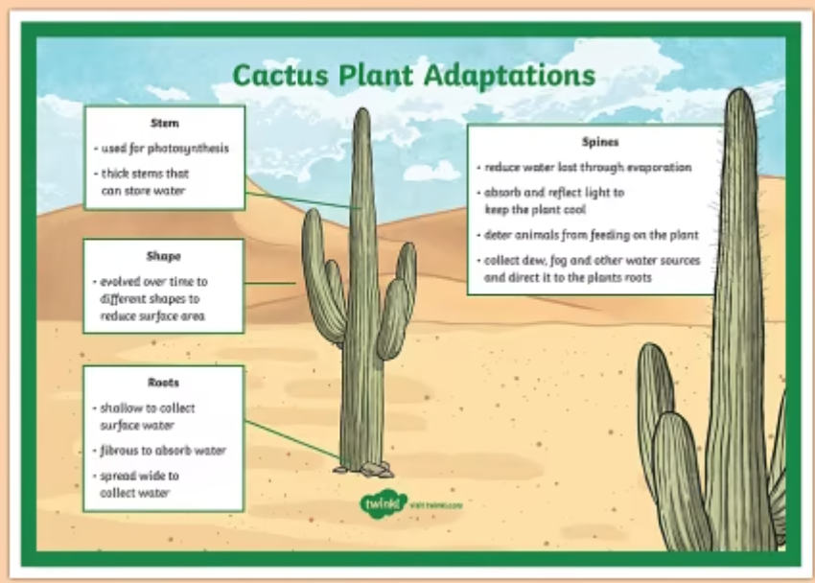

Part 2
Short written explanation (1-2 paragraphs):
- What does the animal normally eat and what type of consumer is it? You can include a picture of a food web if that helps.
- EXPLAIN how the non-native animal would have to adapt to living in NZ.
- DESCRIBE what would the impact be to NZ’s ecosystem and food webs if the non-native animal was introduced to NZ.

Science Word Bank:
Habitat Adaptation Ecosystem Survival Competition Predator Prey Food web
Herbivore Carnivore Omnivore

Science rubric
L3/ Y7 | TOWARDS | AT | ABOVE | BEYOND
Habitat | You have yet to identify particular habitats of different living things | You have identified particular habitats of different living things | You have described how different living things are are suited to their particular habitat | You have described and compared how different living things are are suited to their particular habitat
Adaptation | You have yet to identify adaptations of different living things | You have identified some adaptations of different living things | You have described how different living things are suited to their habitat and respond to either natural or human induced environmental changes | You have explained how different living things are suited to their habitat and respond to both natural and human induced environmental changes
Communicating Science | You have used one example of scientific symbols, conventions or vocabulary | You have used more than one example of scientific symbols, conventions or vocabulary | You have used several scientific symbols, conventions, and/or vocabulary | You have used at least two of: relevant scientific terms, symbols, simple representations, or simple models to communicate effectively
Accuracy in Writing
Overall Grade

Students need to show an understanding of how the features of New Zealand and their own cultural identities have impacted on each other.

Tangata Whenua Cultural Features | You have attempted to identify some features of New Zealand cultural identity | You have identified some features of the Tangata Whenua cultural identity | You have described cultural features of the Tangata Whenua | You have described cultural features of the Tangata Whenua and how they contribute to New Zealand’s wider cultural identity
Own Cultural Identity | You have yet to identify the features of your chosen cultural identity | You have identified some features of your chosen cultural identity | You have described features which contribute to your cultural identity | You have described in detail a range of features which contribute to your cultural identity

