Global Studies
Week 8: Nature vs Nurture

The 1981 Springbok Tour:
A Dark Chapter in New Zealand History

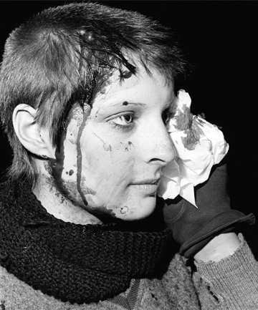

Success Criteria
Students will gain a deeper understanding of and appreciation for the history and significance of the 1981 Springbok Rugby Tour of New Zealand and how it relates to the issue of racism.

Activities:
1. Reading & Writing
2. View and respond to the text and visual images of the Springbok Tour

Homework:
Complete all lessons by Friday at 3 pm.

Look at the following cartoons. What are they saying about the 1981 Springbok Tour? Use the following analysis:

C-A-M
Helpful hints in analyzing cartoons

- C = caption - What is the title and/or caption of the cartoon and what does it suggest?
- A = Activity - What is happening in the cartoon? Look for movement, actions and dialogue. These provide clues to the message.
- M = message - Ask yourself these questions to decipher the meaning: What is the author’s point of view? What is the theme of the cartoon? What is the purpose for making this cartoon?

Write the responses in your red book –

Cartoon #1
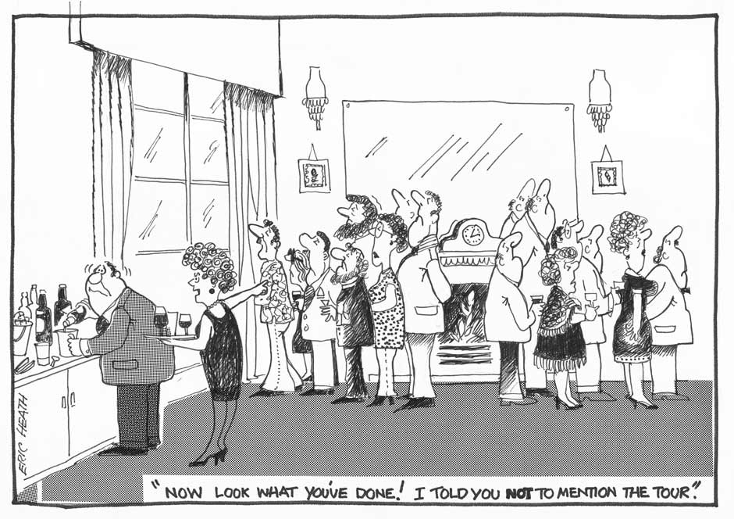

Cartoon #2
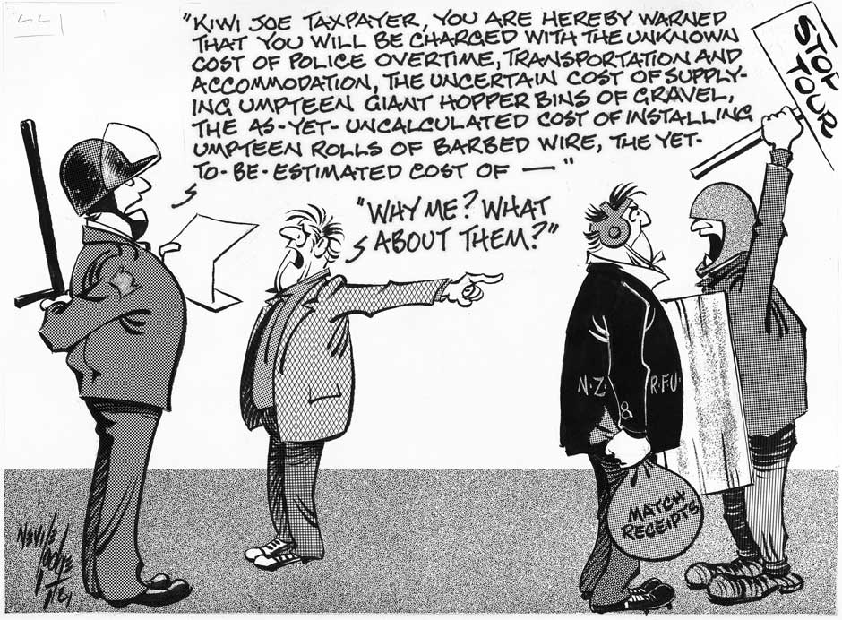

Cartoon #3
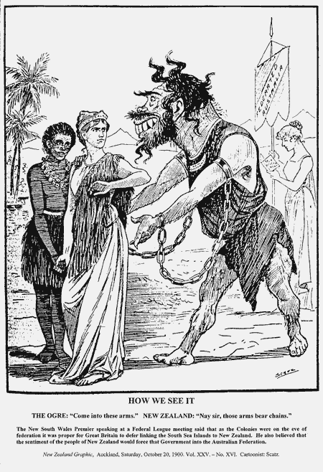

Cartoon #4
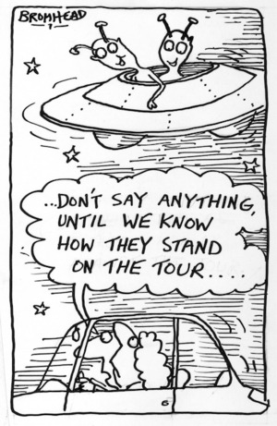

Cartoon #5

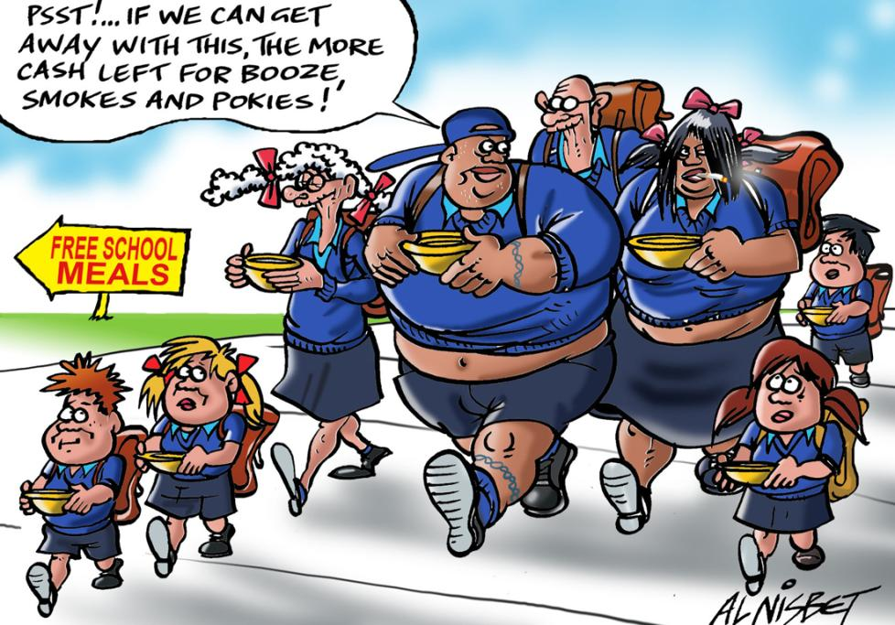

Cartoon #6
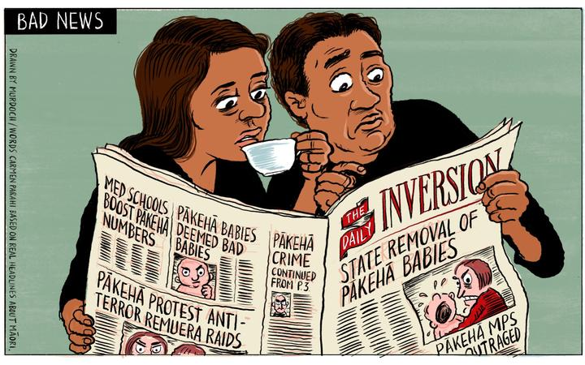

Cartoon #7
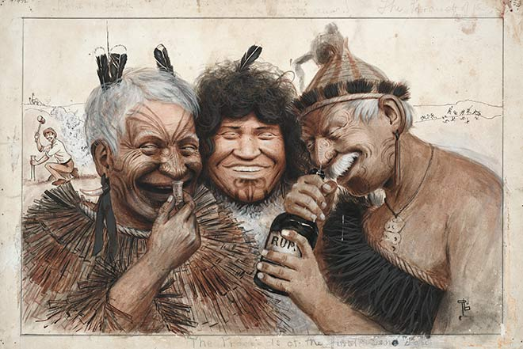

Cartoon #8

Try drawing your own cartoon about the 1981 Springbok Tour that highlights the issue of racism in New Zealand sports.

Week 8 Lesson 3
Current Event

The Anti-Vaccine Mandate Protests in Wellington

Read the article: “New Zealand Protestors in Tinfoil Hats Blame Sickness on Radiation Rays” by Robert Bartholomew in Psychology Today Magazine, March 1, 2022.

https://www.psychologytoday.com/nz/blog/its-catching/202203/new-zealand-protestors-in-tinfoil-hats-blame-sickness-radiation-rays

In at least 5 sentences, write a summary of the article. Cover who, what, where, when, and why.

Additional questions:

1. What is the position of the author?

2. What is the nocebo effect?

3. Why is it believed the nocebo effect was responsible for the Hastings Pool incident? The Westfield Shopping Center Bathroom incident?

4. Why does Kate MacKrill think that some of the symptoms may be more than just Covid?

5. How is the recent study of the Covid-19 vaccination reactions relevant to the article?

