10 Global Studies Mr Bartholomew

Week 7: Lessons 1 to 3

The 1981 Springbok Tour:
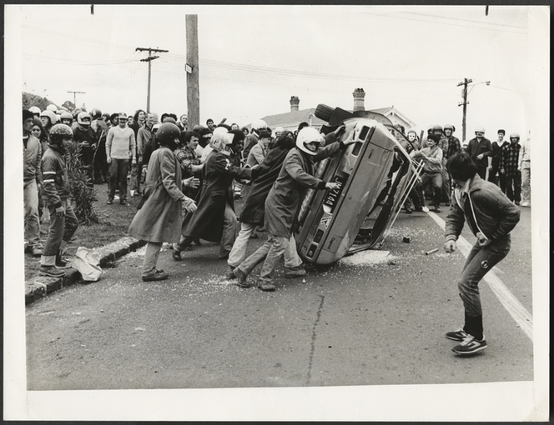
A Dark Chapter in New Zealand History

Those who do not remember the past are condemned to repeat it.
--George Santayana

Success Criteria
Students will gain a deeper understanding of and appreciation for the history and significance of the 1981 Springbok Rugby Tour of New Zealand and how it relates to the issue of racism.

Activities:
1. Reading & Writing
2. View and respond to the text, clips and visual images of the Springbok Tour

Homework:
Complete all lessons by Friday at 3 pm.

Lesson 1 – Task 1:

Watch the short clip on the riots that broke out in reaction to the Tour.
https://www.youtube.com/watch?v=-I3NBE7BS34

---Class Discussion about the clip ---
What students already know about the Tour and what happened?

Task 2: Short Write: Write a reaction to the clip based on the questions below:
a. Had you heard of the protests before?
b. Were you aware of the extent of the violence?
c. Do you know that during the 1976 Olympics in Montreal (Canada), some countries refused to attend because New Zealand was going – and that at the time many people considered New Zealand to be a racist country because they were playing rugby with South Africa?
d. Do you think it was fair to label New Zealand as a racist country?

Lessons 2 and 3:
Reading #1: The 1981 Springbok Tour – New Zealand History, accessed online at: https://nzhistory.govt.nz/culture/1981-springbok-tour (in nine sections).

Read the source from beginning to end, then go back and answer the questions.

Answer the following questions that are based on the reading, using complete sentences. Write out the full question followed by the answer.

- When did the 1981 Springbok Tour of New Zealand take place? (Section 1)

- Briefly recount the long and storied history of the rivalry between the All Blacks and the Springboks. (Section 2)

- How has ‘race’ played a part in South African Rugby selection? (Section 2)

- Define ‘apartheid.’ When was the apartheid policy implemented in South Africa? (Section 3)

- What was the ‘No Maoris – No Tour’ movement? (Section 3)

- As early as 1921, many ‘white’ South Africans expressed disgust at competing on the rugby field against Maori players. Provide an example of these sentiments. How were Maori players viewed by Springbok players from the 1920s to the 1970s? (Section 3)

- What were the key influences that led to the cancellation of the 1973 Springbok Tour of New Zealand? Describe the actions taken by Prime Minister Norman Kirk and why were the contradictory? (Section 4)

- In 1976, how was New Zealand’s international reputation damaged?
(Section 5)

- What was the Gleneagles Agreement and what impact did it have on New Zealand? (Section 5)

- Describe the various organisations in New Zealand that were for and against the 1981 Springbok Tour of New Zealand. In addition to the web text, look these groups up online and describe their key functions. (Section 6)

Terms/People to look up:

Protest,
Apartheid,
Racism,
Honorary Whites
Polarized
Norman Kirk,
Robert Muldoon,
Keith Holyoake,
John Minto
Civil disobedience

