Current Event Analysis #1
Fitness Trackers
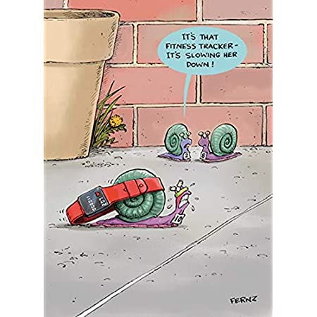
So you’re outdoors and getting fresh air and exercise. Great!
And you’re tracking every step you take.
But just how Safe is your Fitness Tracker?

Watch the video – ‘Dangerous Side Effects Reported From Popular Fitness Trackers’ at: https://www.youtube.com/watch?v=NNpBgX284Sk

According to a CBS News report, there have been several complaints from people who claim that the fitness tracker they were wearing, gave them shocks. After watching the clip, l want you to complete the following Tasks in your Red Books

Task 1: Write a short summary making the case that fitness trackers can be dangerous. What is the evidence?

Task 2: Write an evaluation of how accurate this report is. Make the case that fitness trackers ARE safe based on what was reported in the second half of the article. Also, you may wish to comment on how old this report is, and if you found many similar reports online.

Current Event Analysis #2
Are People being attacked by a Mysterious new Weapon?
Is ‘Havana Syndrome’ Real or in the Mind?
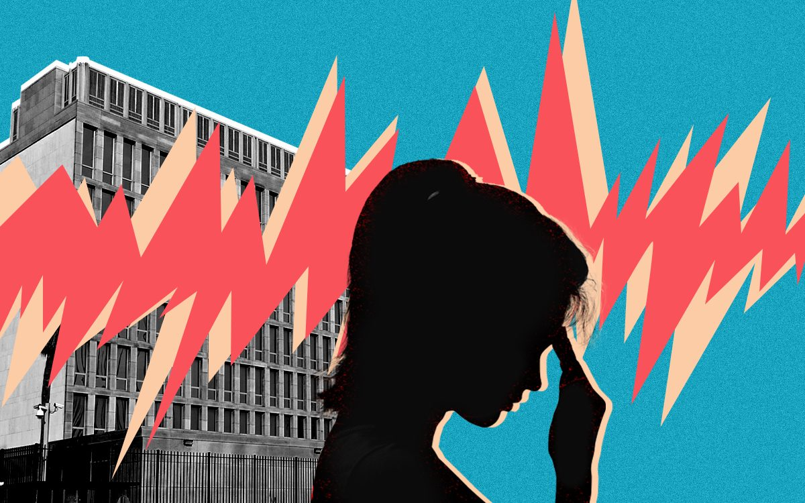
Over the past several years, dozens of American and Canadian officials have reported hearing strange sounds and feeling unwell. Some scientists believe that they are the victims of a secret weapon that causes brain damage. Because it was first reported in Havana, Cuba in 2016, it was given the name ‘Havana Syndrome.’
Task 1: Listen to the news report summarising the story:
https://www.youtube.com/watch?v=TbFRomflb2M&t=7s

Task 2: Read the article: ‘CIA Skeptical of ‘Havana Syndrome’ in Psychology Today Magazine, January 20, 2022’ at: https://www.psychologytoday.com/nz/blog/its-catching/202201/cia-skeptical-havana-syndrome

Create a series of key dot-points that make the case that ‘Havana Syndrome’ is an imaginary illness. We will work on this assignment on class together.

Current Event Analysis #3
The Power of a Name
Read the following article on an Asian reporter who decided to use her real name, and what happened.
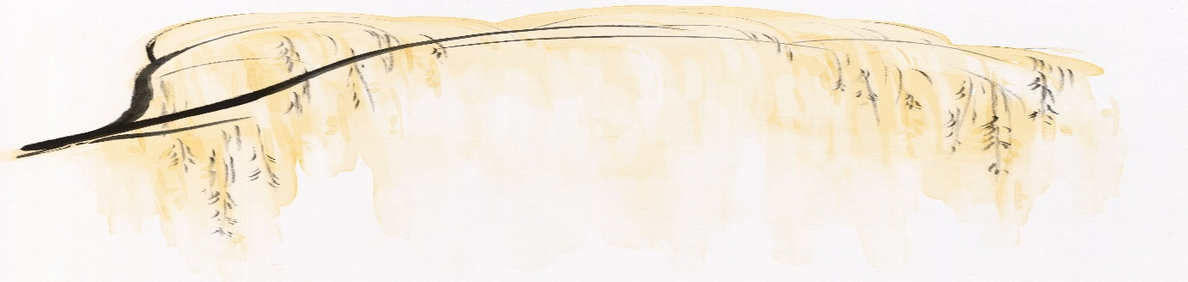
By Marian Chia-Ming Liu, The Washington Post, January 5, 2022.
This past spring, at the height of violence against Asians and Asian Americans during the pandemic, my husband and I chose to eat dinner at a Vietnamese restaurant near where we live in Florida. As we finished our beef noodle soup and paid the check, a White man, who was sitting with his family at the table next to us, started mocking the accents of our waiter and the cook, loud enough for the entire room to hear. Besides the staff, we were the only people of Asian descent in the establishment.
As a Chinese American journalist who had been covering the recent anti-Asian attacks, I was all too familiar with the scenario and how it could easily escalate into violence. I had recently interviewed 61-year-old Noel Quintana, whose face was slashed cheek-to-cheek with a box knife while he was on his way to work on the New York subway. Another victim I spoke to, Iona Cheng, was tackled to the ground as she delivered a Christmas gift near Oakland’s Jack London Square — not far from where I used to hang out with friends growing up in the Bay Area.
After my stories published, I was accosted online, with racist tweets and emails. To protect myself, I started wearing sunglasses in public often, to obscure my race. I became a bit of a recluse, not wanting to leave the apartment. One person I had interviewed recommended that I carry a personal alarm.
As this man continued his ridicule for what felt like 10 minutes, nobody in the packed restaurant reacted. Our tables were separated only by makeshift partitions made of blinds tacked onto a clothing rack for social distancing. My husband, who is also Chinese, stood up and glared at the man. My personal alarm was in my purse, ready to emit a high-pitched sound with a touch of a button. The man shut up, and then I bolted for the parking lot.
As had been the case so many times in my life — when I was repeatedly asked where I was from or told to go back there — I avoided conflict at all costs. Like many immigrants, I had long believed that the nail that sticks up gets hammered down.
When my husband caught up to me before I reached the car, he asked me to stop running. “We need to stand up and stand tall,” he said. “We need to be proud of who we are and look people in the eye.” This was coming from a man who had suffered countless bouts of racism after immigrating from Hong Kong to Florida during high school. At age 14, his barber nicknamed him “Charlie,” off the Vietnam War-era racial slur.
I was born in the United States, but I was very much caught between two cultures. In my traditional immigrant family, I learned Mandarin first. Then, starting in kindergarten, I had to take English-as-a-second-language classes and speech therapy, and had a rough time fitting in. So, I became a journalist with hopes of squashing stereotypes. But while I was proactively calling out racism in my stories, I wasn’t doing the same in my personal life — not even with my own name.
Whether they are learning English as a second language or bringing lunches to school that smell “rotten,” plenty of Asian Americans find that their full name is just one more way they stick out. And so, many assimilate through changing or adjusting their given names. I was no exception: Over the years, I’d essentially erased the middle two words of the name on my birth certificate: Marian Chia-Ming Liu.
The conversation outside that restaurant with my husband — coupled with my experience covering the increase in anti-Asian sentiments and violence — made me realize I needed to stop hiding. And my name, I decided, was a good place to start.
As part of being ashamed of my name, I’ve never corrected how English speakers pronounce my last name, and further concealed my identity by introducing myself as the English-sounding “loo.” (A reader once emailed me to criticize a concert review I wrote as a music critic but first said my last name reminded him of the bathroom.) It’s actually pronounced “LEE-ō” (柳) and means “willow tree.” My mom’s maiden name is Ling (林), meaning “forest,” and together with my dad’s last name they represent a beautiful partnership.

My parents also gave me “Marian” as my first name, separate from my individual Chinese name, out of American custom. “Because everybody has English names,” says my mom. It is derived from both the first letter of my individual name, Ming, and the Christian Mary.
Many Asian immigrants end up adopting or being assigned Anglicized names to fit in. “The experience is very common,” says psychologist Ranjana Srinivasan. She changed her own Indian name several times to “be more pronounceable,” experimenting with Rita, Jay and even Rah Rah. After realizing she was “trying to meet the needs of White culture” in college, she went back to Ranjana, which is of Hindu religious origin and means “delightful.”
My mom, like many in the community, had the sad experience of being renamed by teachers for their convenience. “That’s just how things were done if you planned to study abroad,” she says. Her Chinese name is Wan In, but she was renamed “Wanda” by an American professor in her dentistry program “because it was easier for them to remember you.”
After I ran away from that dreadful restaurant incident, my husband challenged me to reclaim my name as a way to be proud of who I am. He further dared me to drop my American name in lieu of my Chinese one. Now I’m going to start by telling folks I have a Chinese name and how to properly pronounce my last name.
So let me reintroduce myself: My full name is Marian Chia-Ming Liu. Chia is pronounced with a J, like Jiā. Liu like Leo. And yes, it includes all four words. I’m proud of it all, because it represents my complete self, Asian and American.
Below is a picture of the author of this article - Marian Chia-Ming Liu.
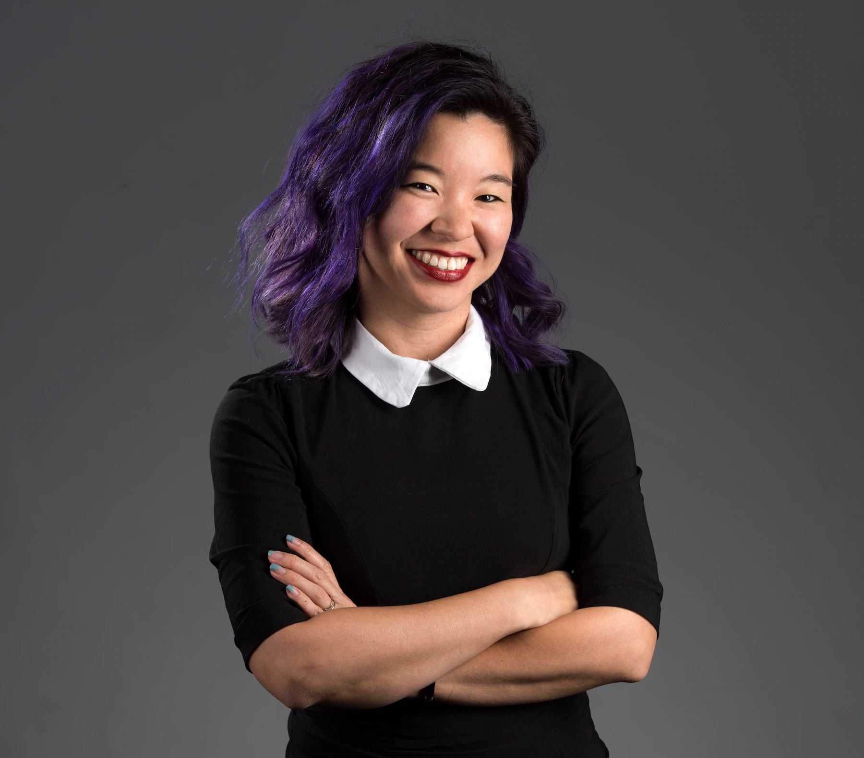

Current Event Analysis #4
Why Conspiracy Theories Thrive
during times of Crises

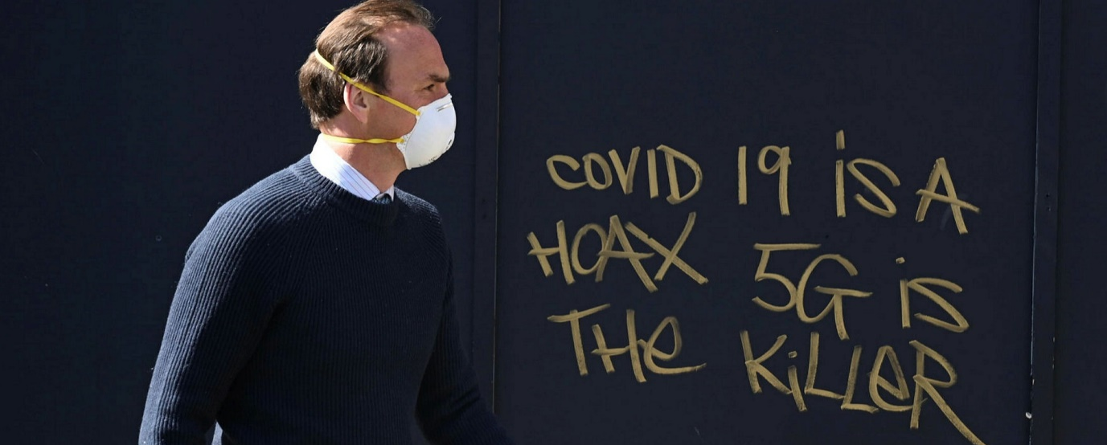
Some people believe that 5G Towers cause cancer and help spread Covid. There is no evidence to support these claim – so why do some people believe them?
Watch the video clip on the fear of 5G towers that has recently swept across New Zealand.
https://www.newshub.co.nz/home/entertainment/2020/05/david-farrier-s-surprise-at-5g-conspiracy-theories-taking-hold-in-new-zealand.html

Questions
1. Write a 1 or 2-sentence summary of David Farrier’s views on 5G and health.
2. Read the article in the Otago Daily Times, ‘Why Conspiracy Theories Thrive in times of Crisis?’ May 21, 2020. Answer the following questions:
1. How many attacks have there been on New Zealand 5G cell towers?
2. How does damaging 5G towers put peoples’ lives in danger?
3. When the article was written, how many Covid0related conspiracy theories were there in New Zealand?
4. How far back can conspiracy theories be traced?
5. Name a conspiracy theory from the 1920s.
6. What was the conspiracy theory about ice cubes and talking on the telephone?
7. What does Robert Bartholomew think are key factors that generate conspiracy theories?
8. Look up the word ‘vetted.’ What does he mean about ‘unvetted news?’
9. How does he think that Donal Trump has influenced what some people believe?
10. What does he say is the problem with getting our news from places like Facebook and Twitter.
11. Go online and look up the definition of a ‘Deep Fake.’ Write it down.

2. Read the article, Why conspiracy theories thrive in times of crisis

Current Event Analysis #5
Did Giant Crocodiles once swim in
the Waikato River?

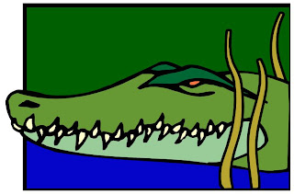

Believe it or now – and do believe it because it’s absolutely true – during the 1880s, some people believed that a giant crocodile once roamed the Waikato River on the North Island. Our story begins in September 1886, when …
Read the article on Great Waikato Crocodile Hunt of 1886 at: https://timespanner.blogspot.com/2008/12/great-waikato-saurian-hunt-of-1886.html
1. Who were the first two witnesses?
2. What happened when Constable Wild looked for the creature?
3. How was the story reported in the Waikato Times newspaper? Did they try to hype it up to get more readers or were they skeptical?
4. How did some of the Auckland newspapers sensationalize the story?
5. At the end of the article, what does the writer conclude was responsible for the monster sighting?
6. You can go to the New Zealand National Archives online and read one of the newspaper reports for yourself at: https://paperspast.natlib.govt.nz/newspapers/WH18871108.2.17

7. Some experts believe that what people were seeing in the Waikato was a large seal? See: https://www.stuff.co.nz/national/95338327/waikato-farmer-surprised-by-sunbather-on-his-property
8. What is your opinion? How is it possible a crocodile could survive in the river for so long? Where did it come from? Isn’t it more likely that people were misidentifying a large seal from a distance?

Current Event Analysis #5
Did Giant Crocodiles once swim in
the Waikato River?

Dear Robert

Thank you very much for getting in contact, it’s a pleasure to hear from you. I know that our students and staff enjoyed and benefitted greatly from your recent talk in the town library, and it is certainly good to be able to communicate with you directly.

The links you have sent me are actually to information contained on the Pukekohe Hill School website rather than the Pukekohe High School website. You probably know or know of Simon Williams who is the principal at the Hill School – his email address is simonw@pukekohehill.school.nz and I’m confident he would enjoy working with you on the points you have raised.

I hope that there will be the opportunity to meet you in person before too long. This year is our centenary year and if there are any records that may be of interest for your researches we would of course be very happy to make those available to you.

In the meantime I wish you well and hope that you find an answer to the questions you have posed.

With best wishes and kind regards,

Richard

simonw@pukekohehill.school.nz

Dear Simon,

After my recent talks at Papakura and Pukekohe Libraries, some residents approached me and challenged my claim about the impetus for the Maori-only school in Pukekohe (1952-1964) being pakeha parents - pointing to information that appears on the Pukekohe Hill School webpage. This information runs counter to everything I have seen in the government files.

The information about Princess Te Puea on the Pukekohe Hill School website appears here:
https://www.pukekohehill.school.nz/school-info/our-history/

and in the accompanying Powerpoint (slide 6):
Heritage of Pukekohe Hill School 2017.pptx - Google Slides
It states: "Princess Te Puea saw what was happening to her people and approached the Government to build a Native school in Pukekohe."

Unfortunately, no source was given.

I can find no reference to this other than the source below:
Pukekohe Heritage Survey – Historic Context Statement on p. 212:
Pukekohe heritage survey appendix 1 (p.151-293) (aucklandcouncil.govt.nz)

This document isn't dated, there is no author given and no reference for the claim. I have checked everywhere including biographies of Princess Te Puea, books on the history of Native Schools, and even contacted several prominent historians who specialise in this area as well as the President of the Franklin Historical Society, and I have not been able to find anything that supports this claim. The Heritage Survey document specifically states:
"Māori Princess Te Puea approached the New Zealand Government requesting that a native school be built in Pukekohe." (p. 212)

If you are aware of any document(s) that specifically mention Princess Te Puea being the impetus for the building of the Native School in Pukekohe, I would be happy to cite it in my presentation on Thursday June 24th at the Town Hall - and thank the Hill School for their assistance. Everything I have seen in the Archives suggests otherwise but am happy to defer to local experts such as yourself.

Any clarifying information on this would be gratefully received. At the end of the day, I would like to think that we are on the same side - which is - of accuracy and truth.

Take care and best wishes,

Robert

Robert Bartholomew
Honorary Senior Lecturer
Department of Psychological Medicine
University of Auckland
Auckland, New Zealand
M: 022 313 3053.

649 Ormiston Road
Flat Bush 2576

Put the students into seven groups. Get the students to read the relevant text in Tauiwi.
  - Sheep Farmers
  - Gold Miners
  - Chinese Gold Miners
  - Kauri Gum Diggers
  - Scandinavians
  - Dalmatians
  - Early women migrants (Pioneering women)

They then need to come up with a short role play that outlines:
- Where they came from
- When they came to New Zealand
- Why they came to New Zealand
- Their life in New Zealand
- Their work in New Zealand
- The challenges they faced here

Give the groups freedom to present in the style they wish – though they must stay in character. They may use props etc.

Follow up with the PP on 19th Century Migrants if needed.

