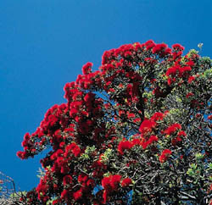
Below are some terms which we will be using when we investigate the concept of “who are we?”.

Find the meanings for the following definitions

Culture –



Heritage –

Identity -


