Year 7 Global Studies

Weeks 6 & 7, Term 4

The Space Race

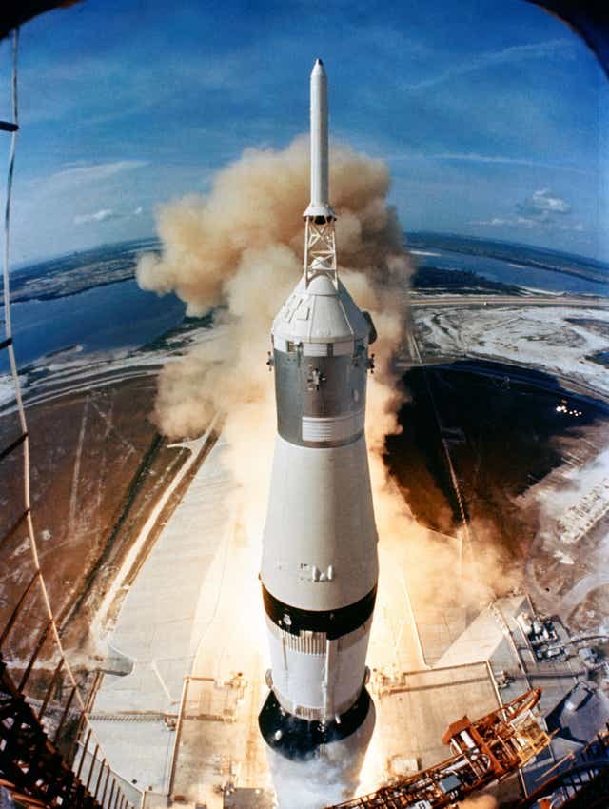

Success Criteria:

Students will continue to deepen and solidify their knowledge of key information about the Space Race between the former Soviet Union and the United States of America.

At this point you have become an expert on one part of the Space Race – the topic you chose to do your assessment on. Over the next 2 weeks students are going to create a short video that uses the information you have already gathered for the topic you chose, and additional information as needed.

The Project

On October 4, 1957, The Soviet Union launched the Sputnik satellite officially starting the Space Race (some people use an earlier date , but this is the date I am using). You have been asked to create a video of this event and to focus on one part of it – the topic you chose for your assessment. Using information that you have already collected and any additional information that you may deem necessary, you are to create a 3 to 5-minute-long video that will involve you narrating your topic. Your video will:

1. Describe the event
2. Explain why it is was important
3. Include visual images that help you tell the story
4. You will present your video to the class during Week 8

The Presentation:

Whether you are attending school or classes online, all students will present their videos to the class during Week 8. Since the lockdown, many students have found themselves isolated at home. As a result, I would like to encourage you to get together online to create your video. You can complete it alone or in groups of up to 4 (that is – you and up to 3 other students). Be CREATIVE. For instance, if you were doing the life and accomplishments of Yuri Gagarin, perhaps someone could dress with a bike helmet and make believe they are Yuri. That would not take up the entire video, but it could be part of it. The best videos inform and entertain at the same time.

Video Checklist
1. You can work alone or with up to 3 other students (4 in total) to create your video.
2. It must be between 2 and 5-minutes-long.
3. Tells a story that informs your audience about the topic. For instance, if your topic is Yuri Gagarin, you could re-enact key events in his life and describe key challenges that he faced and overcame.
4. Be sure to include images with captions that help to tell the story.

Option 2: Narrated Powerpoint. You must get permission from me if you wish to do this option which will consist of a taped Powerpoint presentation that is narrated by the students involved in the project. I prefer students to do the first option, but if you are finding it too challenging, I will give some students the option of doing it as a Powerpoint.

