Year 9 Global Studies

Term 4, Week 2

Success Criteria:

Students will gain a better understanding of how to cope during lockdowns; they will also become familiar with the Consumer Guarantees Act and how it can protect them – specifically with buying a mobile phone.

Week 2 Lesson 1

Coping with Life in Lockdown –
We are now in Week 8 of Lockdown: Hang in there!


Term 4 - Week 1: Lesson 1: Welcome back to a new term!

Because this has been an extraordinary time for students with an extended period of lockdown, I have decided to do the first lesson back on how to cope with what’s going on and remain positive and well.

Read the article on coping with Lockdown stress. You can view it at:
https://lighthouse.mq.edu.au/article/july-2021/stress-busting-tips-for-hsc-students-facing-lockdown-learning

Psychologist Viviana Wuthrich has come up with 10 tips. In your Red Book under the Heading “How to Beat Lockdown Stress,” on the left-hand side of the page write the numbers 1 to 10. Skip 3 lines between each number. After reading each section, write a one or two-sentence summary of that section. I have done the first one as an example.

Tommie and I have also created a video that you can listen to.

1. It is important to keep in contact with your friends and stay connected because they may need you and you may need them.

2.

3.

4.

5.

6.

7.

8.

9.

10.

Week 2: Lesson 2:

Contracts and Consumer Decision-Making
Follow the story of Jay – The Boy in the Blue-stripped Shirt


Jay faces decisions when he decides to buy a cell phone.

When we buy things we enter into a contract with the seller that includes specific terms and conditions. Every consumer (buyer) has rights. So, what rights do you have when you buy a mobile phone? It depends on the circumstances.

Task 1: Click into the following link about the story of Jay – the boy who wanted to buy a new mobile phone. Work your way through the questions until you reach the end. Here is the link: https://www.oppia.org/explore/5ctnVXfAGXxv
Answer all of the questions of the online quiz. Once you have finished with the quiz, write out the following questions and answer them.

1. What is the Consumer Guarantees Act?

2. If you are buying a mobile phone, under what circumstances will the Consumer Guarantees Act protect you?

Task 2: Look up the definitions of the following words:
1. Contract
2. Consumer
3. Safeguard

Week 2, Lesson 3:

What are your Rights when you Buy Something?

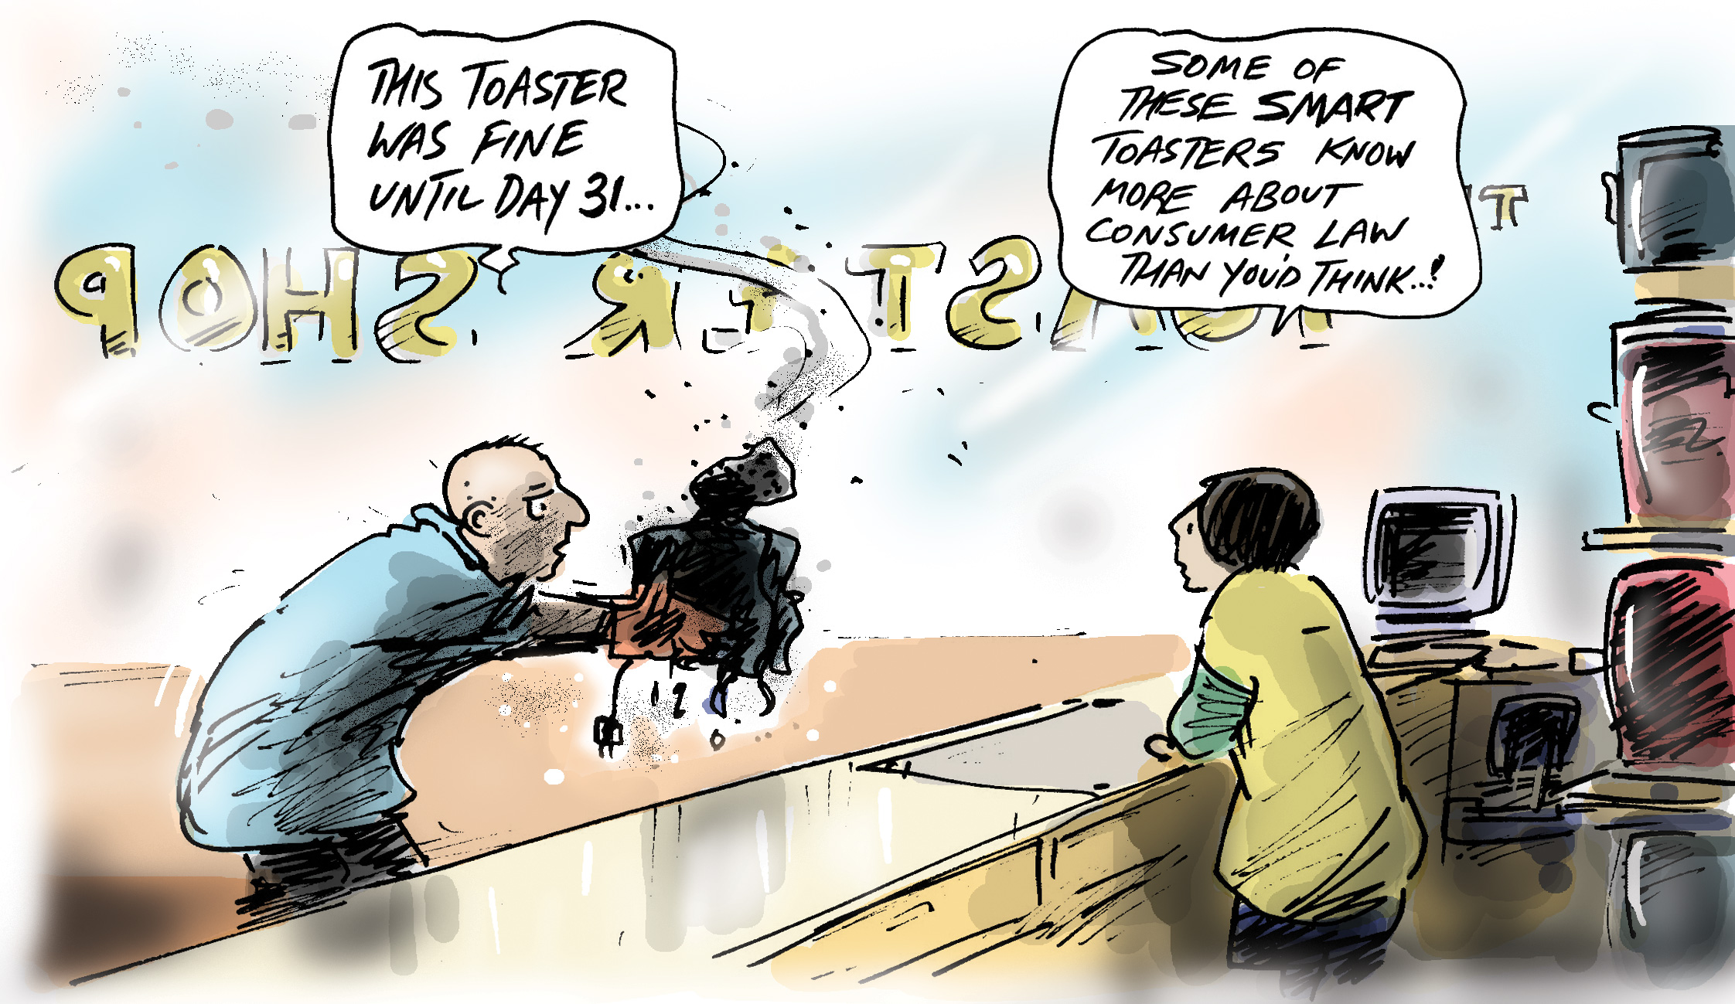

Terms and conditions
When you buy something, you will usually see a piece of paper or something online that says ‘Terms and Conditions.’ What does this mean?
1. Go online and choose an item they may wish to purchase. Go to a website where the item is available for sale.
2. Next, locate the terms and conditions of sale that apply to the item they are considering purchasing.
Identify the following:
- a positive term or condition of the sale
- a term or condition of the sale you didn’t understand
- a term or condition of the sale that was interesting.

List at least possible terms and conditions that could be unfair.

1.

2.

3.

It may be useful to read through the information on the New Zealand Commerce Commission fact sheet, Consumers and Unfair Contract Terms at:
https://comcom.govt.nz/consumers/your-rights-as-a-consumer/unfair-contract-terms

