Mr Bartholomew, Global Studies The Week of September 13 to the 19th

Week 8
When Myths come Alive:
The Salem Witch-Hunts

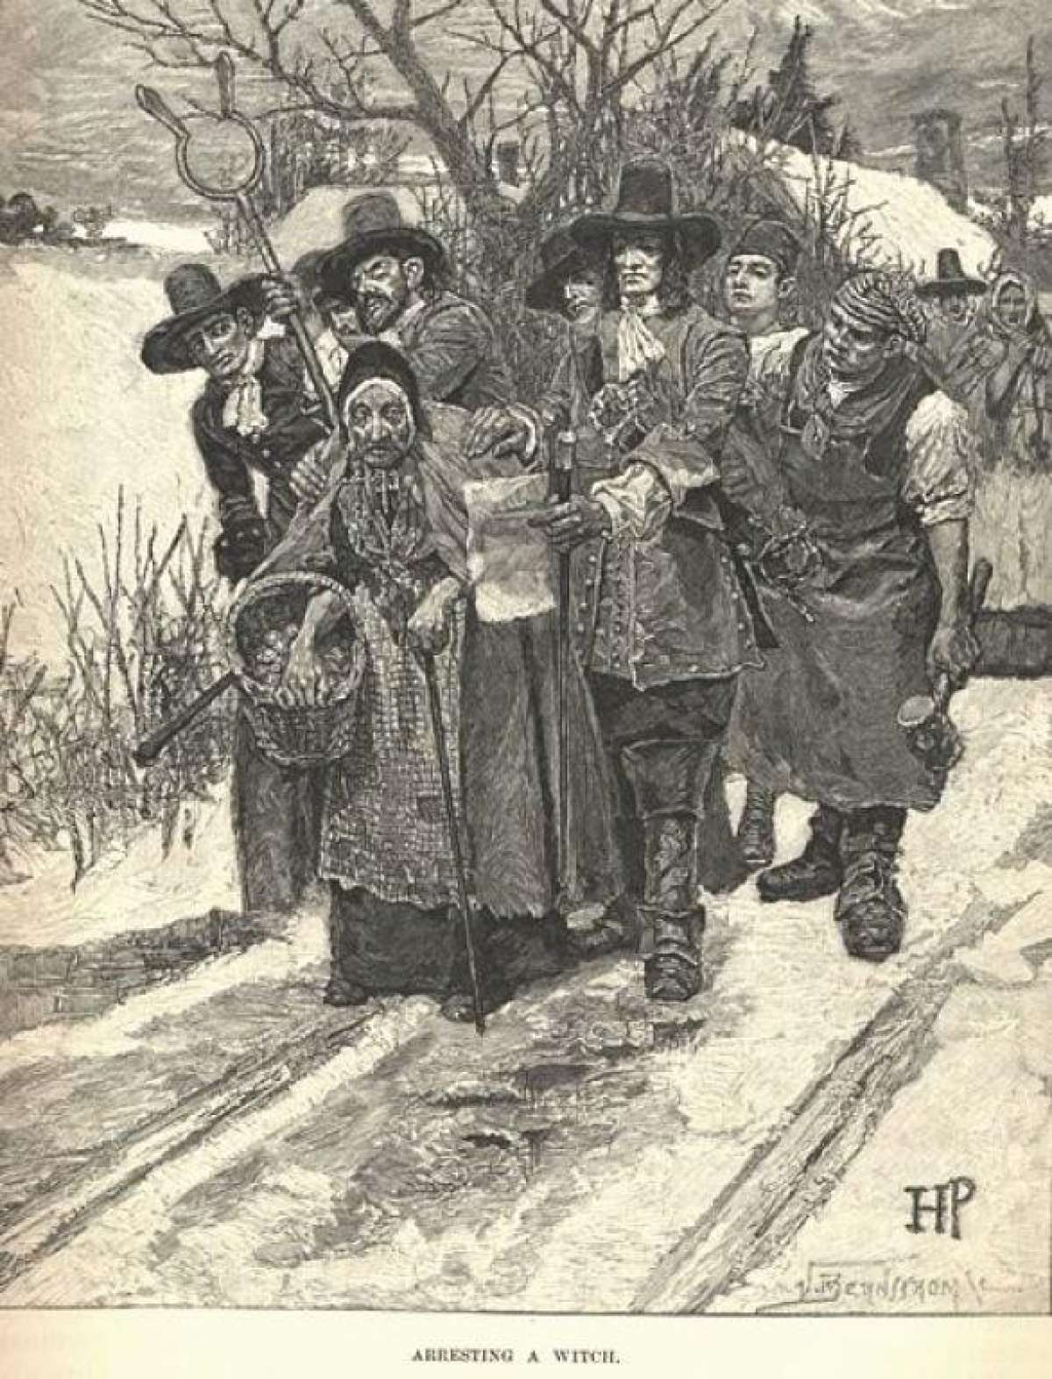

Success Criteria: students will gain a basic understanding of the events surrounding the Salem Witch Trials of 1692 in what is now Salem, Massachusetts in the United States, and how a belief in witches and demons led to the deaths of innocent people. The picture above shows an old woman who was unpopular, being accused of witchcraft. In Salem, anyone who was different was at risk of being accused as a witch.

Over the next 2 weeks we are going to look at what can happen when people believe in imaginary beings – such as the existences of witches and witchcraft. In 1692, the village of Salem was the scene of a great witchcraft fear. During the scare, at least 200 people were arrested on suspicion of bewitching others (casting spells) and put in jail to await trial. Some were tortured into confessing while waiting for their day in court; others died before ever going on trial. At least 20 residents died – 19 by hanging.

In 1692, it was widely believed that witches could take any shape or form, adding to the anxious atmosphere, as potential witches were everywhere. Two dogs were even accused and killed on suspicion of being witches. Of course, there are no such things as witches who have magical powers and can cast spells, but in Salem, local residents believed there were real witches, and they began to accuse people of witchcraft.

The Salem witch scare began in December 1691, at the home of Samuel Paris and his wife, Elizabeth. Inside the house two little girls began to act in a strange manner. Betty Parris, age 9, and her friend Abigail Williams, age 11, began to scream and twitch. The girls would appear confused, forgetful, and made animal-like sounds. Their bodies would shake, and they would speak in a language no one could understand. Before long other girls in the village were having similar fits. Soon Doc Griggs was called in to examine the girls. He concluded that the girls had been bewitched – that is, a witch had cast a spell on them, making them behave strangely.

In reality, we now know that the girls were suffering from hysteria - a condition that is triggered by stress. What would have caused the nervous excitement among the girls? Many of the girls were friends with a female slave named Tituba who would meet secretly with them at night and tell them scary tales about ghosts and voodoo. The stress from these stories were believed to have triggered their fits. If Doc Griggs had said he thought the girls were suffering from stress – the witch-hunts would probably have never happened. But because they concluded that they had been bewitched – the search was on to find the witch or witches who were believed to have caused their strange behaviours.

Targeting people who were different

Many of those who were accused of witchcraft were unpopular. The first 3 people who were arrested of being witches stood out for being unusual. Sarah Osburn frequently got into arguments with other residents and had stopped going to church. Sarah Good was a pipe smoker, rarely bathed, and was so poor that at times she was forced to beg for money. The third person, a slave woman named Tituba, was from the Caribbean islands. She dressed different to most residents and believed in voodoo. While Good and Osburn strongly protested their innocence, Tituba confessed to being a witch, sought forgiveness, was eventually let go and left the village after being sold to another master. In fact, all anyone accused had to do to go free was to confess to being a witch. The problem was, most of those accused of being witches refused to admit they were a witch even if it meant they would die. They were very religious and would rather die than tell a lie because they thought lying would hurt their changes of getting into heaven.

How to tell if someone was a witch?

These tests were used to determine if an accused person was a witch.

1. Lord’s Prayer. If a person was unable to recite the Lord’s Prayer (Our Father, who art in heaven…) without error, they were deemed a witch.

2. Spectral (ghostly) Evidence. The accused would claim to have seen the witch in their dreams at night, working with the devil.

3. Submersion. The accused was tied up and dropped into the water. If they floated, they were considered a witch. If they did not float, they drown.

4. Heavy stones were placed on the accused to force the confession out of the witch, but the person being pressed often had difficulty breathing and often could not give a confession even if they wanted to.

After reading this section, try taking the quiz at: https://quizizz.com/admin/quiz/613dcc7e9f5fe7001d48f194

Write down the correct answers to the 5 quiz questions, into your Red Books.

1. How many people were arrested on suspicion of being witches at Salem?

2. The witch scare began in December of which year?

3. Which is NOT one of the symptoms that some of the girls who were thought to be witches, were exhibiting?

4. Who was believed to have triggered the witch scare after telling the girls scary stories?

5. Those who were suspected of being witches often stood out for being different in what way?

Week 8 Lessons 2 & 3:
See Reading A in Google Classroom – and answer the following questions. Please write the full question and answer into your Red Books under the heading, ‘Week 8 – The Salem Witch-hunts.’

1. Who were the Puritans? (see page 6)

2-3. The Puritans saw the world as a struggle between __________ and __________.

4. What does the word ‘malice’ mean? (p. 6)

5-6. During the winter of 1692, several young girls in Salem would meet up at the Paris house and listen to stories about __________ and _____________. (p. 6)

7. What is the definition of a constable? (p. 6)

8. As the fear of witchcraft spread through Salem, the Reverend Paris called for a day of _________ at the church. (p. 7)

9. When the girls began to act oddly, what did Nicholas Noyes believe was wrong with them? (p. 7)

10. When the girls were asked who had taught them witchcraft, they said it was ___________. (p. 8).

11. At first, Tituba denied that she was a witch but then admitted to practicing __________, hoping it would save her life.

12-14. Tituba said that the Devil appeared to her in the shape of a man. He carried a cane and a _____ of gold. A yellow _____ flew to him and perched on his shoulder. The bird began to_______.

15. Some of the young girls began to act strangely and were thought to be possessed by demons. List some of the symptoms the girls exhibited.

16. Rebecca Nurse was hanged for being a witch. What did some of the young girls claim she had done to them?

17-20. Name at least 4 people who were thrown in jail for being witches.

21-22. Who ordered a stop to the witch-hunts and when did it happen? (p. 9)

23. Who is the only girl who accused people of being witches – to later apologise and admit that they had accused innocent people of witchcraft?

Extension exercise – Short paragraph response. In what ways can those who were hanged for being witches, be considered heroes and remarkably brave?

