Weeks 7, 8 & 9:

9M1 & 9M2

Climate Change is Here – Understanding the Threat to New Zealand
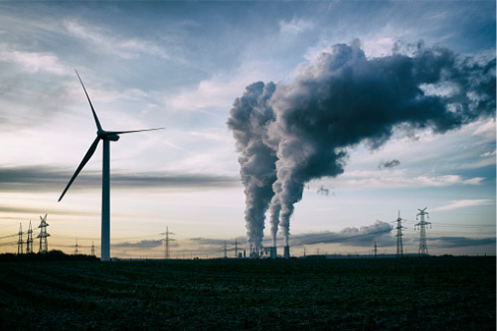

We have already completed two assessments for the year – on
1) Mobile phone addiction, and 2) racism/discrimination. There will not be a formal assessment in Global Studies for Term 3 due to the lockdown.
However, it is vital that we have a mark for Term 3. Your mark for the term will be based on two bodies of work:

1) The homework completed in your Red Books for Term 3 only;

2) A Powerpoint Project on Climate Change in New Zealand (spanning weeks 7 to 9).

You will be graded on how well you specifically address the Sections of your Project, and amount of depth you provide, and that it is written in your own words. This is not being marked like a traditional assessment due to lockdown. It is a term grade that will be based on whether you’ve done the work (the homework), and the degree of depth provided on your end of term Project. It may even take the form of a report to your parents.

The Basic Project:
I would pick the basic project if you’ve been struggling to keep up in your classes, have a low reading level, or are just finding lockdown challenging. During the Rest of Week 7 and during Weeks 8 & 9, you will create a Powerpoint on the problem of Climate Change in New Zealand. Your project will consist of the following sections:

Your Powerpoint should have 6 Sections:

Section 1. A slide with A CATCHY TITLE and an IMAGE related to the topic.
In the body of this slide, explain why you chose the title and why you chose the image.

Section 2: Introduce the topic, explain why it is important, and define key terms such as as climate change and global warming (1-2 slides)

Section 3: Describe at least 2 recent events that have happened in the past year that are believed to have been caused by global warming and have made many scientists stand up and take notice. (1-2 slides)

Section 4. How is Climate Change affecting different types of native wildlife species in New Zealand? (Minimum number of 2 slides – no maximum)
Excellent online resources for this Section can be found at:
https://www.doc.govt.nz/our-work/climate-change-and-conservation/climate-change-research/

Section 5. How is Climate Change projected to impact on the Auckland Region in the coming years? (a minimum of 2 slides)
An excellent online resource to consult is: https://environment.govt.nz/facts-and-science/climate-change/impacts-of-climate-change-per-region/projections-auckland-region/#sea-level-rise

Section 6. Outline possible solutions to global warming either in New Zealand or Globally. If you were Prime Minister, what would you do to make an impact?

*I would say that you should be looking at a minimum of 12 slides.

Advanced Project:
For the advanced – there is no minimum number of slides. The bottom line is that you address each question with moderate depth. If you can do it in one slide – great. If you can do it in 4 slides – that’s fine too. There is also no maximum number of slides. Also, make sure you write in your own words. The number of slides given at the end of each section are suggestions only.

Your Powerpoint should have 6 Sections:

Section 1. A slide with A CATCHY TITLE and an IMAGE related to the topic.
In the body of this slide, explain why you chose the title and why you chose the image. (1-2 slides)

Section 2: Introduce the topic, explain why it is important, and define key terms such as as climate change and global warming (2 slides)

Section 3: Describe at least 4 recent events that have happened anywhere in the world in the past year that are believed to have been caused by global warming and have made many scientists stand up and take notice. Here you may wish include a source or two from EPIC such as Masterfile, GeneralOnefile and Australia and New Zealand Reference Centre). (2-5 slides)

Section 4. How is Climate Change affecting different types of native wildlife species in New Zealand? (Minimum number of 2 slides – no maximum)
Excellent online resources for this Section can be found at:
https://www.doc.govt.nz/our-work/climate-change-and-conservation/climate-change-research/

Section 5. How is Climate Change projected to impact on the Auckland Region in the coming years? (a minimum of 2 slides)
An excellent online resource to consult is: https://environment.govt.nz/facts-and-science/climate-change/impacts-of-climate-change-per-region/projections-auckland-region/#sea-level-rise

Section 6. Outline possible solutions to global warming either in New Zealand or Globally. If you were Prime Minister, what would you do to make an impact? (2-3 slides)

OPTIONAL: For any student attempting the Advanced Project, I would like you to provide a list of references at the end of each section.

*For students would would like a greater challenge, place each reference citation in the APA Style, 7th edition, which is commonly used in Universities. Use the Auckland University Online APA Style Tool below:

https://www.cite.auckland.ac.nz/2_8.html

The Auckland Uni site gives you examples but the most common ones you will use will be for websites and government reports. Don’t forget, many government reports will provide you with the APA style somewhere near the beginning or end of the report.

