Mr Bartholomew & Ms. Martin Year 8 Global Studies

Current Event Analysis Week 9 -
Anti-Asian Feelings Grow in Response to Covid-19

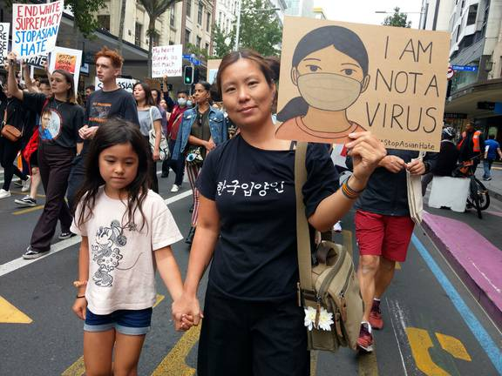
Instructions: On a blank page in your Red Book, write ‘Current Event Analysis’ at the top of a page, followed by the title of this article, “Anti-Asian Feelings Grow in New Zealand in Response to Covid-19.”

Go to EPIC and the ‘Australia & New Zealand Reference Centre’ and locate the article, “Protesters warn of growing anti-Asian sentiment” from The Press (Christchurch), April 19, 2021. Write down the following information:
Title
Author
Name of publication
Date published
Page number

Summary.
Imagine you are a newspaper reporter. Create a catchy headline, then write a one-paragraph summary of the article. Include who, what, where, when, and why. Next list several key dot-points from the article which highlight man ideas and key information.

How would you reference the article if you were citing it in a research paper using APA style? (Answer – go online to: https://www.cite.auckland.ac.nz/2_8.html and click into APA style 7th edition and select ‘newspaper.’)

