Mr Bartholomew Year 7 Global Studies

Current Event Analysis #1:

The Coronavirus and the Search for Scapegoats

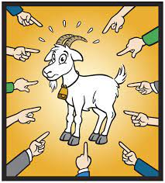

Instructions: On a blank page in your Red Book, write ‘Current Event Analysis’ at the top of a page, followed by the title of this article.

Go to Google and type in: “The Coronavirus and the Search for Scapegoats.” Here is the link: https://www.psychologytoday.com/nz/blog/its-catching/202002/the-coronavirus-and-the-search-scapegoats

Bartholomew, Robert (2020). “The Coronavirus and the Search for Scapegoats.” Psychology Today Blog Column.

Define the following words and terms, writing the word and the definition in your Red Books: anti-Semitism, the Black Death, scapegoat, shun, vile, innuendo, retaliation, stigmatize

Answer the following questions – copy the entire question into you red book, followed by the answer:

1. Write a summary of this story including the answers to who, what, where, when and why.
2. What is wrong with referring to Covid-19 as ‘The China Virus’?
3. What does the World Health Organization recommend naming the virus?
4. Where did The Great Flu Pandemic of 1918-1919 originate from – which country?

Do you think that some Asian New Zealanders have been discriminated against solely because of the pandemic? Why or why not? Defend your answer.

