“We Don’t Cut Maori or Indian Hair:”

The Forgotten History of Racial Segregation in New Zealand”

An original Teaching Unit created by Robert Bartholomew for
students at Mission Heights Junior College in Auckland, New Zealand
May 2021

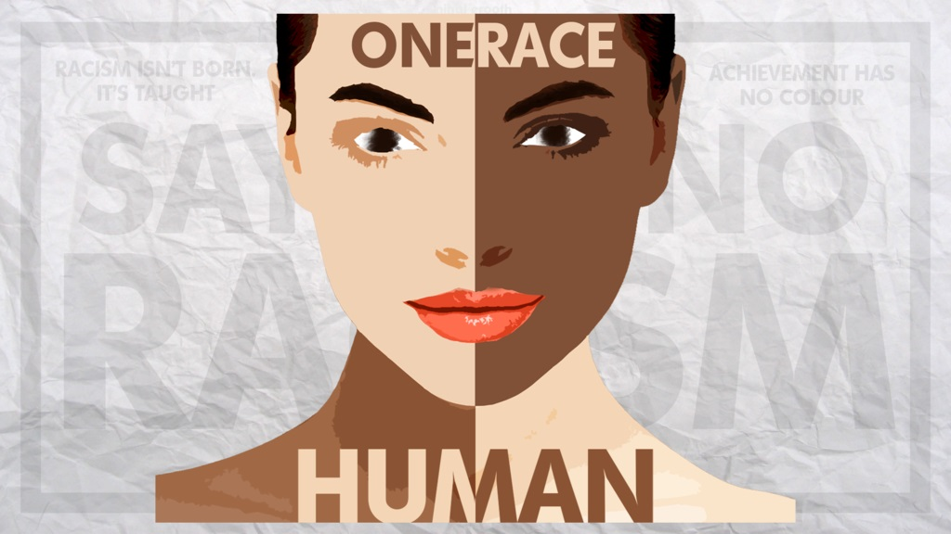

Week 1: An Introduction to Racism

Success Criteria
Students will gain a thorough understanding of the concept of race and will grasp the notion that while race is a myth, it is also a social reality.

Activities
1. Reading & Writing
2. View and respond to the documentary excerpt from ‘Race: The Power of an Illusion’

Homework
Complete Lessons 1 & 2 by Friday at 3 pm.

Lesson 1 An Introduction to Race

Students will begin this new unit in their Red Books by opening to two blank pages. At the top of the first page, draw a horizontal line about a third of the way across the page. Above the line, write the unit title: “We Don’t Cut Maori or Indian Hair: The Forgotten History of Racial Segregation in New Zealand”

Task 1: Students need to write down (in the Red books) the following definition of racism:

“Racism is the belief that a particular race is superior or inferior to another, that a person’s social and moral traits (their sense of right and wrong) are predetermined by his or her inborn biological characteristics. Racial separatism is the belief…that different races should remain… apart from one another.”
― The Anti-Defamation League

Task 2: Look up the definitions of ‘segregation’ and ‘melanin’ and write them into your Red books underneath the definition of race.

We will have a CLASS DISCUSSION on racism in New Zealand and how much of a problem students think it is. Also, what do students know about the history of racism in general in New Zealand? It is essential for students to realise that ALL groups have been the targets of racism, but some groups more than others.

Issue of Skin-Whitening in India

Task 3:

Skin whitening in India is a multi-billion dollar industry. Bleaching your skin white or using creams to lighten your skin tone, is common in many parts of the country. As a class we will watch the video (“How Obsessed Are Indians With Fair Skin?”
https://www.youtube.com/watch?v=KW7_2-snzOI) and discuss. We will then discuss the questions by writing the questions and answers into your Red Books.

1. What is the origin of the obsession with having white skin in parts of India? While no one can be certain, what are some of the explanations for looking down on darker-skinned people?

2. Some of the people interviewed said they believe fair-skinned Indians are often
treated better than darker-skinned people. Give an example that is cited in the video.

3. At the 10-minute mark, what solutions are suggested to reverse the trend of skin-
bleaching in India?

It is important to emphasise that not everyone of Indian ethnicity is preoccupied with the darkness of their skin, but it some are.

Extension Exercise (optional) Short Writing Exercise: What do you think?

“I have a dream that my four little children will one day live in a nation where they will not be judged by the color of their skin but by the content of their character.”
- Martin Luther King Jr.

Opinion – Based on the above quotation, write a paragraph that responds to the following question:
1. Do you think that a person’s skin colour is a major issue in New Zealand?
2. Have you ever had someone make negative comments about the darkness of your skin or have you observed something similar happen to someone else? How did it make you feel? (please refrain from including the names of any people involved – just refer to the incident).

Homework: Your tasks should be completed and your Red Books up to date.

Lesson 2 Race: The Power of An Illusion

Task 1: Watch the first 42 minutes of the documentary, ‘Race: The Power of an Illusion’
(Write the above title at the top of a blank page in your Red Books). The video will be placed online under this lesson.

Based on the documentary, answer the following questions:

1. Look up the definition of ‘eugenics’ and write it down.

2. Where did Adolf Hitler get the idea that there were inferior races? (around the 18-minute mark)

3. How did the Nazis explain American Jesse Owns winning 4 gold medals at the Olympics when he was supposedly inferior to ‘whites?’ (see the 19-minute mark)

4. Melanin is a skin pigment. The more you have, the darker your skin will be. There are 2 main explanations for why we have melanin. What are they?
(around the 26-minute mark)

5. Does the amount of melanin in your skin determine how good you are at sports? (see 29-minute mark)

6. It was once thought that dark-skinned people were susceptible to getting Sickle Cell Disease due to their melanin, but scientists have proven this not to be the case. Explain. (see 39-minute mark)

7. On which continent did all humans originate from before spreading around the world?

