8 M1 & 8 M2
Combined Assessment
Survival of Early European & Maori Settlers
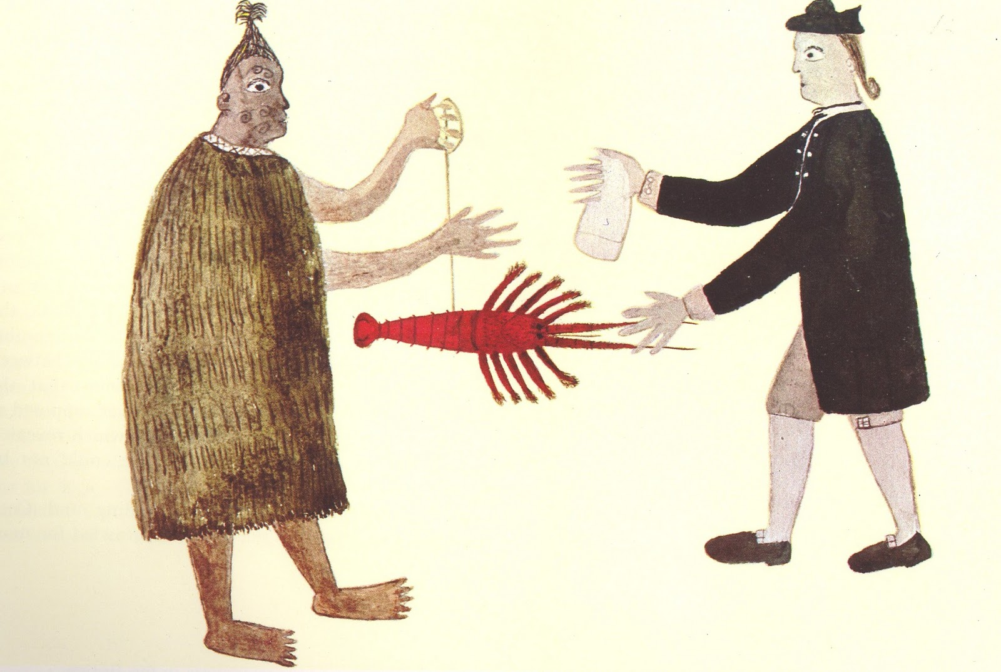

Level 4 Achievement Objective To understand how people participate individually and collectively in response to social challenge
Assessment summary:

Assessment type: Groups of 3 to 5
Issue date: Monday March 27, 2021
Due Date: Friday April 9, 2021

Assessment form:
Storybook (a booklet with a story and pictures) or a Photobook (which contains a story that only has images and captions – similar to a comic book format) aimed at a Year 7 class level. Each group is responsible for creating a single story or photobook that will be used to create a play that will be performed by each group. Part of the value of this assessment is to provide students with an understanding of how to work in groups (just like the early Polynesians and British had to cooperate to survive). The story that each group creates and presents, must be potentially true. This is known as ‘historical fiction’ where you create a story using your imagination, but it must be grounded in reality. Include real people, events, and dates. For instance, if I was to create a story of historical fiction about Mission Heights Junior College, I could tell about the day I met New Zealand Prime Minister Jacinda Ardern. While I have never met her, it’s possible I could have. However, I could not write a story in which I meet Martin Luther King Jr. because he is already dead and never visited New Zealand. Any story must be plausible – that is, reasonable, likely or probable.

Students are going to describe how each of the groups we have studied (early Polynesian settlers and early British settlers) arrived in what is now New Zealand and what they did to survive. Describe the challenges they faced and overcame. How did each group impact the landscape and what survival skills did they use. What new plants and animals were brought here and how did they impact on the land? Use the following headings:

Section 1:
How did the 1st Polynesians Arrive?
How did the 1st British Arrive?

Section 2:
What did the Polynesians do to survive?
What did the British do to survive?

Section 3:
How did each group impact on the land?

Section 4:
In what ways did the two groups cooperate or share similar ideas and survival strategies?

Section 5:
Venn Diagram
Each group will create a Venn Diagram with two overlapping circles. You will label one circle ‘Polynesian’ and the other circle ‘British.’ On the Polynesian side of the circle list the different ways that the Maori impacted the land. Do the same on the British side. In the middle of the two circles where they intersect, write down ways in which both groups overlapped.

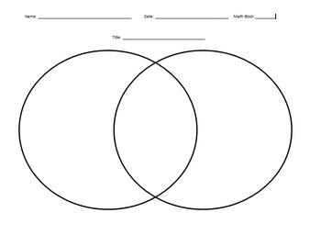

Key dates and check in points:

By Friday March 26 - students should have decided on their booklet type (chosen by the group), have decided on who is doing what section, and come close to completing the section they are responsible for.

Next Thursday April 1 - The group should have completed their role play. Remember, you will be presenting your role play to other Year 7 students later in the term.

Due date - Friday 9 April 2021 (needs to be uploaded by 3 pm) [the booklet with the name of each person next to the section they are responsible for, the Peer Review Form for each group member, and a copy of the role play].
YEAR 8
Students show understanding of how early Polynesian and British migrations to New Zealand have continuing significance for Tangata Whenua and communities
Criteria | WORKING TOWARDS Curriculum expectation | Working AT curriculum expectation | Working ABOVE curriculum expectation | Working BEYOND curriculum expectation
Migration History | You have a limited understanding of Polynesian/British migration to New Zealand | You have some understanding of Polynesian/British migration to New Zealand | You have an understanding of Polynesian/British migration to New Zealand | You have a full understanding of Polynesian/British migration to New Zealand
Historical Significance | You have described the historical significance of Polynesian/British migration to Tanagata Whenua/Communities | You have described the historical significance of Polynesian/British migration to Tanagata Whenua/Communities, using examples to support | You have described in detail the historical significance of Polynesian/British migration to Tanagata Whenua/Communities, using examples to support | You have explained the historical significance of Polynesian/British migration to Tanagata Whenua/Communities, using examples to support
Impact of Migration | You have described the continuing impact of Polynesian/British migration on Tanagata Whenua & New Zealand | You have described the continuing impact of Polynesian/British migration on Tanagata Whenua & New Zealand, using examples to support | You have described in detail the continuing impact of Polynesian/British migration on Tanagata Whenua & New Zealand, using examples to support | You have explained the continuing impact of Polynesian/British migration on Tanagata Whenua & New Zealand, using examples to support
Time management | You have yet to complete and submit your assessment…. | You have submitted your assessment late ….. | You have submitted your assessment by the date …... | You have submitted your assessment by the date …….
Overall | WORKING TOWARDS Curriculum expectation | Working AT curriculum expectation | Working ABOVE curriculum expectation | Working BEYOND curriculum expectation

Peer Evaluation Feedback Form for Group Work
Your name ____________________________________________________

Write the name of each of your group members in a separate column. For each person, indicate the extent to which you agree with the statement on the left, using a scale of 1-4 (1=strongly disagree; 2=disagree; 3=agree; 4=strongly agree). Total the numbers in each column.

Evaluation Criteria | Group member: | Group member: | Group member: | Group member:
Contributes meaningfully to group discussions.

Completes group assignments on time.

Prepares work in a quality manner.

Demonstrates a cooperative and supportive attitude.

Contributes significantly to the success of the debate
TOTALS

Feedback on team dynamics:

- How effectively did your group work?

- Were the behaviors of any of your team members particularly valuable or detrimental to the team? Explain

- What did you learn about working in a group from this project that you will carry into your next group experience?

