Title: Let’s Unpack Your Book

Lesson 2: Vocabulary & Introduction to Plot Diagram

Learner Name: …………………………………
Learner Surname: …………………………………..

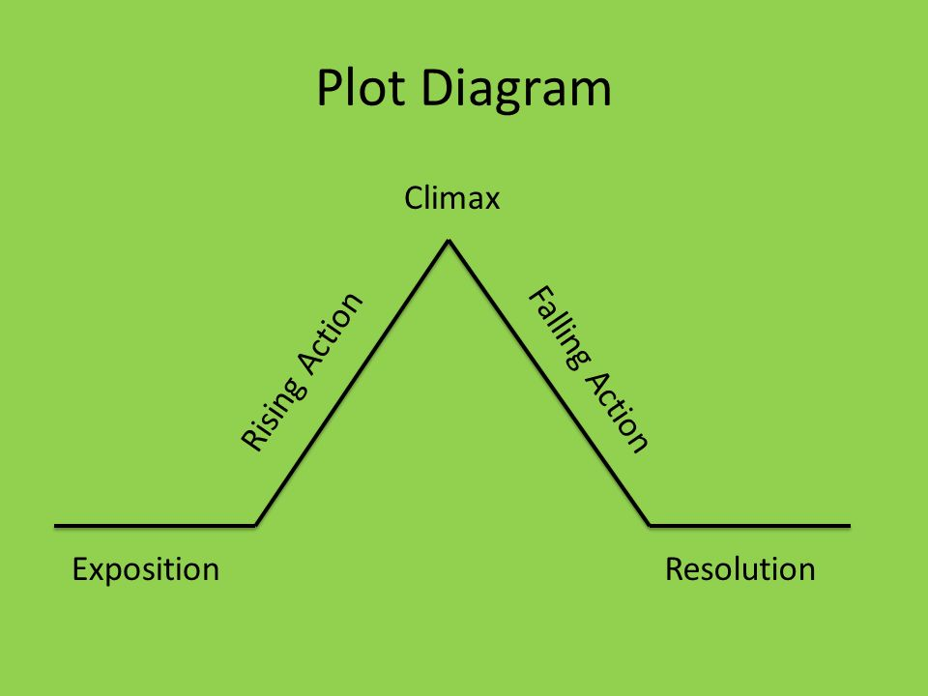

Exercise 1

WORDS | ANSWER | DEFINITION
- Protagonist |  | A The character that actively opposes or is hostile to the lead character.
- Plot |  | B. Linked events that make up the main parts of the story.
- Climax |  | C. Loose ends are tied up and story will end soon
- Rising action |  | D. The leading character in a novel. Film or play.
- Exposition |  | E. Events or conflict get resolved.
- Antagonist |  | F. The part of the story where the tension and action is at it’s highest suspense.
- Falling action |  | G. The first part of a story ‘s plot that describes the location, characters and initial problems in the story.
- Resolution |  | H. Contains events that add tension to the story and increases until the story’s climax.

Well Done!!!

