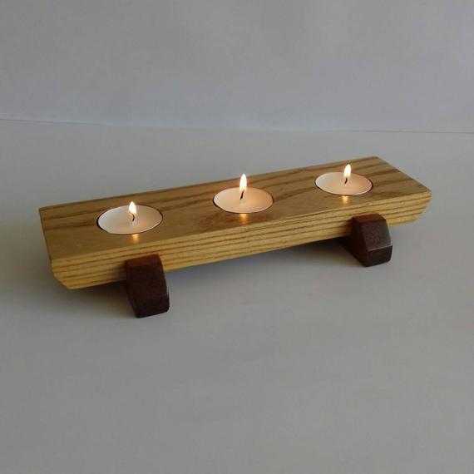
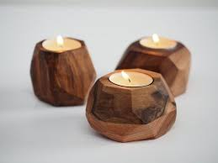
Year 10

Hard Material Technology

Wooden Tea light

Candle Holder

Student Name: Class:

The first project this year will be designing and making a wooden tea light candle holder. You will be using different types of wood, tools and machines following a technology design process.

You will use this guide to document/record your technological practice.

Download this document in to your device. Open it in google docs and start filling it as you go.

Task 1 – Need or Opportunity (Writing my Product Design Brief and Attributes):
A design brief is a document that gives an outline of a product or outcome. It contains a description of the design problem or situation as well as the specifications that the product is designed to meet. Your design brief will be centered around a wooden candle holder and your product will need to be fit for purpose.

Task 1 is where you write your design brief. Your design brief will contain these separate parts:
- The Situation (an outline of what you are making, who you are designing it for and where it will be primarily used)

- The design specifications for your wooden candle holder (use the specifications given below)

Your design brief (5Ws):

Begin by answering all these five points, this is the situation.

- What am I making?

- Why am I making it?

- Whom am I making my product for? (The main stakeholder)

- Where will the product be primarily used?

- When? (How long) do I have to complete the design and manufacture of the product?

- How will I make it? Construction steps

Your design specifications:

The design specifications are points that your product should meet when it is completed. Design specifications are important because they guide the development and manufacture of your design.
These are the design specifications for your product:

a- Teacher’s given specifications:

- Must be made of wood.
- Must have a maximum length of 25cm.
- Must be able to safely hold the tea light candles.
- Could be decorated using paint, stain or varnish.

b- Your personalized specifications:

Task 2- Research Ideas
Research online and complete the following:
- Find different images of wooden tea light candles to give you some ideas (At least 3 different images/ideas).
- Add annotation notes beside these images that describe what you like and dislike about the designs.

- Insert below:

Task 3 – Develop your Conceptual Design
- Draw 2 different conceptual design idea for your wooden tea light holder by using 3D free hand sketches on A4 paper. You need to include notes that detail the main measurements, materials, colors and design features on the sketch. (Describe and evaluate your drawing against your design brief, specifications and attributes)

- You need to communicate your ideas with the stakeholder. If you were the stakeholder then get someone like a friend, a teacher or a family members to comment on your ideas and develop/change as advised. (show the stake holder comments).

- Scan your final design and insert below:

Task 4- Produce a functional model-Prototype
Use cardboard, paper or wood to produce a model-prototype of your product. This will enable you to test the physical and functional attributes of your product and to make the final judgement about your product. (you need to include photos of the model and insert below):

Task5- Materials, Tools and Machines
List the materials, tools and machines you intend to use to make your final outcome. You need to describe the properties of the materials used and justify your selection of these materials.

You can now start making your final outcome -product.

Task6- Outcome- Product Evaluation.

Write a full evaluation for your outcome-product against the design brief and specification/attributes. Your product has to be fit for the purpose it is intend for in terms of physical and functional attributes. The following questions will assist you to evaluate your product:

- What is the project about?
- Why did you need to do it (purpose)?
- What was your design?
- What have you done?

- What materials, tools and machines you used?

- Was my design successful against the brief? How?
Fitness for Purpose. Your product has to be fit for the purpose it is intend for so that means it has to do/have physical and functional attributes so that is “fit for purpose”.

- Does your product meet your design brief and specs? Is it fit for purpose? Yes /No – explain your answer.
- I learnt about...
- I learnt how to...
- My stakeholders said...
- Next time I will.........

Insert an image of your completed product here.

